CAN SIMULATED POKER DATA HELP IMPROVE DECISION MAKING IN POKER

___________________________

A THESIS

Presented to
The Faculty of the Department of Economics and Business
The Colorado College

In Partial Fulfillment of the Requirement for the Degree
Bachelor of Arts

By
Jacob Woods
February 2021

Abstract

This paper examines how data in conjunction with game theory can be used to optimize decision making in Poker. The data used in this thesis was generated through simulation and is used as a predictive tool for poker win percentage.

KEYWORDS: (Simulation, Expected Value)

Honor Code

ON MY HONOR I HAVE NIETHER GIVEN NOR RECEIVED UNAUTHORIZED AID ON THIS THESIS

Table of Contents

Introduction 5
Literature Review 5
Game Theory 7
Data and Methods 14
Application 20
Conclusion 25
References 27
Glossary 29
Appendix 35

Introduction:
Poker is an anomaly in the gambling world due to the notion that it is more of a game of skill than other forms of betting. Poker is a complex game where players wager based on imperfect information. The strength of your own hand is always known, while the strength of opponent’s hands can only be estimated. Even the greatest poker players do not win all the time It is a game where success is dependent on being right slightly more often than being wrong.
As a player myself, the goal while playing is finding positions where the odds are in my favor. This is easier said than done, since there are hundreds of millions of different poker combinations. Always knowing when you are at an odds advantage mentally is impossible, however with data it is feasible. The goal of this thesis is to create a tool that can give odds to win a poker game at any stage of the game and be used to improve the betting decisions of players. To do this, I sought out to simulate millions of poker hands and generate win probabilities based on the results of those simulations. Use of a program like this would not be allowed in live play, however it could be easily used while playing poker online. The simulated probabilities along with an understanding of some poker game theory will give any player what they need to make more informed and better betting decisions.
Literature Review:
Poker is the world’s most popular gambling game. Its popularity can likely be attributed to the belief that Poker is not only a game of chance, but also a game of skill (Meyer, 2013). The decisions people make while gambling have always been of interest to economists, and recently efforts have been made to study decision making in poker in response to its rise in popularity.
Economists have been intrigued by what produces success in poker. Although poker is skill based, everyone playing is still at the mercy of luck. Luck being a factor of the game doesn’t deter people from having poker success over the long haul. Levitt and Miles conducted a study comparing highly skilled and lower skilled poker players to determine how much skill impacts poker success. They found that skillful players average a return of 30% on their buy in per game whilst lower skilled players averaged a loss of 15%, this shows that skill does lead to long term poker success despite luck being involved in the game (Levitt and Miles, 2012). Part of the skill gap between players lies in their ability to analyze poker hands as they get more complex. At the beginning of a hand, each player only has their two cards and their opponent’s cards to consider. However, by the end of a hand, each player must be aware of their cards, their opponent’s cards, a five card board, and all the betting action that occurred. A study was done comparing highly skilled and lower skilled players where each player played the same poker hands against a computer. In the earlier stages of a hand where little information is available, high- and low-level players display a similar estimation of hands strength. However, estimates of hand strength between low and high players at the end of a hand were drastically different (Fox and Harker, 2006). In addition to skill level, emotions are also crucial to poker success. One of major differences with poker compared to other forms of gambling is that poker is a social game. A study was done by Laakasuo, Palomäki, and Salmela measuring poker success once players began to visibly show negative emotion at the poker table. They found that players who became emotional performed drastically worse than before they became emotional and made poorer mathematical decisions in hands (Laakasuo, Palomäki, and Salmela, 2014).
Economists have searched for what some of the differences between high- and low-level skill are. One might suspect that more you play poker, the better you become at it. However, it appears experience isn’t what makes a long-term successful poker player. Linnet, Frǿslev, and Ramsgaard discovered that pathological gamblers (non-professional gamblers who were playing poker more than twice a week) were more likely to play “poor” hands and lose more money (Linnet, Frǿslev, Ramsgaard, Gebauer, Mouridsen, and Wohlert, 2011). Another study concluded that the main difference between high- and low-level skill poker players is not their experience, but rather their discipline in betting decisions (McCormack and Griffiths, 2011). In addition to this, there are many elements of poker like pot odds and deception that get neglected by low-level and are crucial to success (Harrington, 2004).
Technology is another method economists have used to try and determine what constitutes poker success. In 2002, four coders attempted to make an Artificial Intelligence to play poker games. The AI was coded to recognize the strength of its own hand while remembering patterns from opponents to estimate their hand strength. The AI showed good success against low-level players but declined against high-level players who knew how to play deceptively (Billings, Davidson, Schaeffer, Szafron, 2002). Another attempt at AI occurred in 2011. This one was more focused on predicting win probabilities for each player mid-hand, but the author concluded the AI still had a long way to go be on par with human players (Teófilo, 2011). The popularity of poker will continue to push economists to studying betting behavior and using technology to improve poker success.
Game Theory:
When playing poker, every move being made can be thought of in terms of expected value. To show how we can think of poker in terms of expected value, this section will use hypothetical scenarios to represent poker decisions. Poker has deep mathematical complexity, from every hand in every position you decide to play with, to whether you should check or not in small pots, every decision has an expected value. The goal when playing poker is for every move you make to be the highest EV given the situation. EV is calculated by the following equation.

(Probability to win) (Value of outcome) + (Probability to lose) (Value of outcome) = Expected value (1)

Poker is a game of imperfect information, so it is impossible to be right and win all the time. The goal is to put yourself in situations where, if they were done repeatedly over the long haul, you would return a profit (positive EV). In poker, there are actions and reactions. Players can try and construct moves that are positive EV for them and -EV for their opponents. Or players can try and figure out what reaction to our opponents move would be positive EV for them.
Finding expected value starts from the very beginning of a Poker hand with selecting what hand you are going to play. Below is a chart depicting hand selection for a player in the under the gun position (see glossary for poker terminology). The chart is color coded, any combination of cards in blue you keep and play with, yellow and white you fold, and green you play with on occasion.
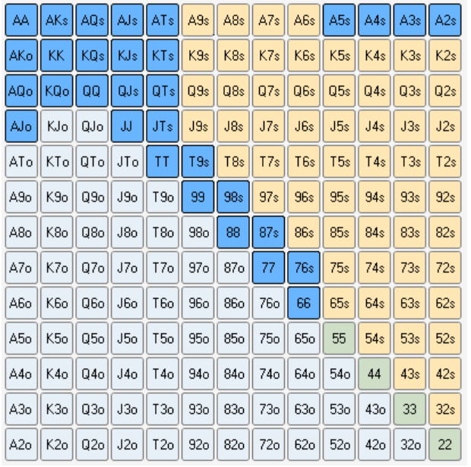
Figure 1: Under the Gun Opening Hand Selection Chart

When you have a very strong starting hand, like two Ace’s or two King’s, you are almost always going to be the heavy favorite to win the hand. The positive EV Play is to raise with them, you want as much money as possible to be injected into the pot when you are a favorite to win. However, what is not so obvious of a positive EV play is why you would play weaker hands, like 76S, or A4S. Remember that poker is a game of information, and that good opponents will try and decipher the meanings of your actions. Let’s say we only played the strong starting hands like AA, KK, QQ, AK, AQ, AJ, KQ, and JJ. If we only played the strongest starting hands and our opponents started realizing this, they would simply fold to our raises, and we would not get any value from them. In addition, this would limit the value we could get in the next stage of the game. Let’s say we are playing, and the flop looks like figure 2.
Figure 2: Hypothetical Flop 1
Ace of Hearts
7 of Clubs
King of Hearts

If we only play the strongest hands, and our opponent can recognize this, they will fold to boards like this and we would not get any value from our strong hands or be maximizing our EV. Additionally, if the flop were to come up as figure 3.
Figure 3: Hypothetical Flop 2
4 of Hearts
7 of Spades
3 of Clubs

A smart opponent would recognize a flop like this would not be helping us if we are only playing the strongest hand types. They could easily respond to boards like this with aggressive play which would put us in a tough spot. If we introduce weaker hands into the types of hands we are willing to play with, our EV goes significantly up. It introduces deception into our play leaving our opponents unsure if we are playing a premium hand or a weaker one like 87S. In addition to that, no matter what the flop looks like there is the possibility that we could have a very strong hand. If face cards come like the figure 2, our opponents need to be worried we could be playing with hands containing face cards that would have been helped by that board. If smaller cards come like figure 3, our opponents need to be worried that we could be playing with the weaker starting hands that now are very strong given the board state. Introducing a range of strong and weaker starting hands optimizes our ability to play deceptive and increases EV.
Another example of how we can optimize EV can be shown with a payoff matrix. Consider the example that on the river against a single opponent, you bet $100 into a pot of $100, meaning your opponent must bet $100 to win a pot of $200. The odds being offered by the pot to our opponent is 2-1, meaning they need to win more than 33% of the time for this to be a positive EV play for them. There is two reason why we might have made the $100 dollar bet. Either we are betting for value because we think our hand is best, or we know we are beat and are trying to win by bluffing and getting our opponent to fold.
Figure 4: Payoff Matrix 1 (Value Betting)
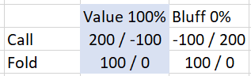

On the payoff matrix, the first number in each cell would be our EV given the move, and the second number would be our opponents EV. If we are a player who is a known value better, and 100% of the time make a bet on the river when we think we have the best hand, then our opponent has an easy decision to fold. If our opponent were to call, they would lose the game and have an EV of -100. This Nash equilibrium for them in this situation would be to always fold, giving us an EV of +100.
Figure 5: Payoff Matrix 2 (Bluffing)
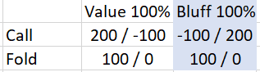

If we do not suspect we have the best hand on the river, instead of value betting we could bluff. However, if we are a known bluffer and bluff 100% of the time this gives our opponent an easy decision to call. If we get our bluff called, we have an EV of -100, because we lose our $100 bet we made on the river. In the first two examples, if we always value bet we will have an EV of +100, and always bluff we will an EV of -100. However, we can recreate this situation so that regardless of whether we value bet or bluff, and regardless of whether our opponent calls or folds, we can have an EV of +100. Instead of always betting the same, let’s use a mix of 67% value bets and 33% bluffs in this situation.
Figure 6: Payoff Matrix 3 (Combination)
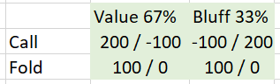

If our opponent decides to always call in this situation, our EV will be +100. Using our EV equation…
(Probability to win) (Value of outcome) + (Probability to lose) (Value of outcome) = Expected value
We get (.67)*(200) + (.33)(*-100) = 134 – 34 = EV +100
If our opponent decides to always fold in this situation, our EV would also be +100, because we would always take the $100 that is already in the pot (Upswing Poker 2019).
Poker often gets more complex than the previous example, it is not always clear whether you should be betting for value or how large the pot will be at the end of the hand. A game theory model for poker made by Michael Muskulus encompasses these additional variables.
- p = probability of you have the better hand (from simulated data)
- k = current size of the pot
- r = the maximum allowable bet on the river
A payoff matrix with the following variables is as follows.
Figure 7: Muskulus Payoff Matrix
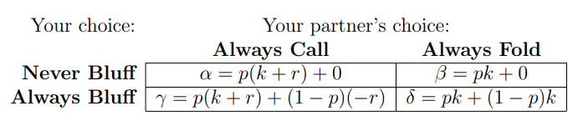

By using the simulated probabilities in place of p, we can calculate the expected value of a bet. For example, let’s use the same example from the previous paragraph where our opponent faces a $100 bet from us into a $100 pot. In this scenario we are not bluffing, and we have a hypothetical probability of a 75% chance to win (Muskulus 2007).
If our opponent always calls, using the equation from the payoff our EV would be…
.75(100 + 100) + 0 = EV +150
If our opponent always calls, using the equation from the payoff our EV would be…
.75(100) = EV + 75
In actual poker gameplay, we will not know if our opponent will always call or always fold. This too can be estimated, but not accurately. There is no data that will tell us what our opponents will do, so the best we can do is make an educated guess. If in the previous example we believe it is 50% 50% chance whether our opponent calls or folds, we can consider the scenario a 50% chance to have a EV of +150 and a 50% chance to have an EV of +75, for an average of EV of +112.5.
With the simulated probabilities and game theory models, we can estimate the expected value of a move in poker at any time. By consistently making moves with a positive expected value, we should expect to see success in poker over the long haul of playing.
Data and Methods:
The data set used was generated entirely through Excel simulations and a Microsoft access “scan”. The total data set contains 1,030,470 hands and 206,094 total games. Each game was being simulated based on a poker game with 5 players playing. The first step of generating this data set was getting Excel to generate poker hands for 5 players.
Figure 8: Generating Poker Hands in Excel
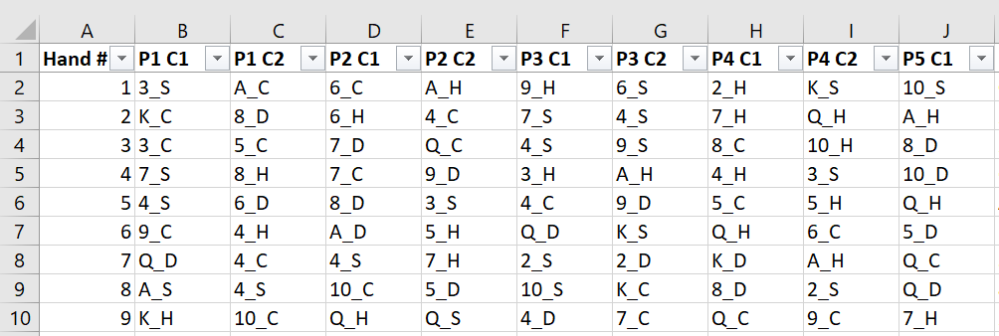
Getting Excel to distribute random and unique hands to five players required creating a macro. First, I listed the different 52 cards in a deck using the first character as the face and the second character as the card suit (ex. Ace of hearts = A_H). Using that list, code was written so that Excel would randomly assign 2 cards to each in the spreadsheet (code in appendix). If a duplicate is present, code was also written so that Excel would replace it with another random non-duplicate card.
Figure 9: Generating the Poker Board
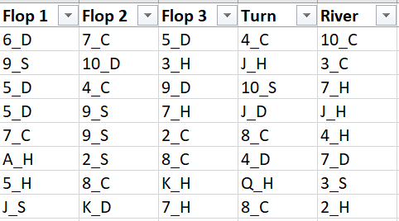

Once all players had two cards, the next step was to generate the poker board. This was done using the same method as the hand distribution. Excel was coded to assign a card to each of the 3 flop cards, the turn, and the river, and then check for any duplicates. Similar to the hand distribution, if Excel detected a duplicate card it would replace it with another random non-duplicate hard. This step concludes the card distribution for one entire game of poker. To generate a large data set from this, the macro also included code to repeat the process one row down for any given number of times. I ended up having Excel run the macro 206,094 times, so that the data set could contain over 1 million hands.
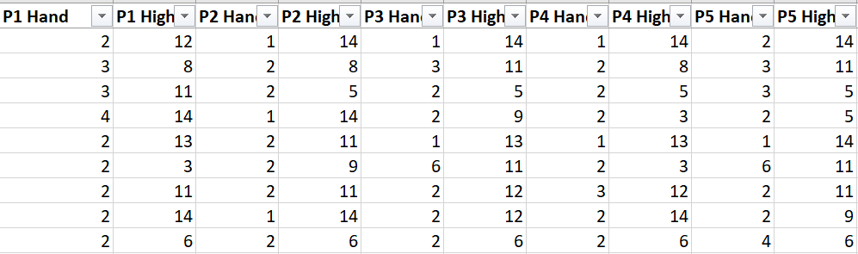
Figure 10: Poker Hand Detection in Excel

The next step for generating the data set was getting Excel to recognize what happened in the simulated games. Doing this required another macro. There are ten possible final hands in poker, and in the new macro each was assigned a number.
Royal Flush: 10
Straight Flush: 9
4 of a Kind: 8
Full House: 7
Flush: 6
Straight: 5
3 of a kind: 4
Two pair: 3
Pair: 2
High card: 1
The macro was coded to recognize each of the different types of poker hands. The macro would check in order from top to bottom of the list for what type of hand each player had. First the code would check if a player finished with a royal flush (A through 10 all of the suit). If the players “hole” cards and board satisfied the condition of a royal flush, Excel would assign that player a final hand value of 10. If the conditions of a royal flush were not met, the code would automatically move down the next hand type on the list (straight flush) and see if the conditions of that hand were met. This process would repeat until Excel was able to assign hand type to a player. To avoid any ties, Excel was also coded to recognzie what the highest card each player had involved in their hand type. For example, if a player a two pair with 10’s and 2’s, Excel would mark that player down has having hand type 3 with a high card 10. Once all players hands and high cards were recognized, determining the winner was done by the macro checking what playing in each game row had the highest number hand type, and using the high card for ties.
Once that Excel had generated a data set of poker games, hands, and who the winner was in those games the data needed to be converted into probabilities. Before doing that, I made the decision to only anaylze two different stages of the game: pre-flop and on the flop. In addition to this, I removed the suits of the cards from my analysis as well. The reasoning for these two decisions were because of a lack of smaple size. Despite having 1,030,470 hands and 206,094 total games in the data set, this was far too small to be able to analyze an entire poker game. Poker is a complex game, there are 1,326 different combinations of hole cards pre-flop and 19,600 different combinations on the flop. This means that in only the first two stages of the game there are 25,989,600 different combinations, and that number gets increasingly larger as you factor in the turn and river cards (which have 52 possible combinations each). A data set that could give accurate probabilities for the entirety of a poker game is possible but would probably need to be in the hundred-millions or billions of sample size to truly be effective. By removing the card suits from consideration, we drop the number of pre-flop combinations to 91 and the flop combinations to 455. This gives a total of 41,405 unique combinations to analyze, which is more reasonable given the current sample size.
To generate the probabilities, I received help using Microsoft Access which rapidly processed each combination of pre-flop and flop combinations. The scan looked at the Excel data and all the 91 different pre-flop combinations and 455 flop combinations. It looked at the occurrence of each of those different combinations, and then how often those combinations were the winning hand to generate win probabilities.
Figure 11: Usable Probabilities Excel Sheet
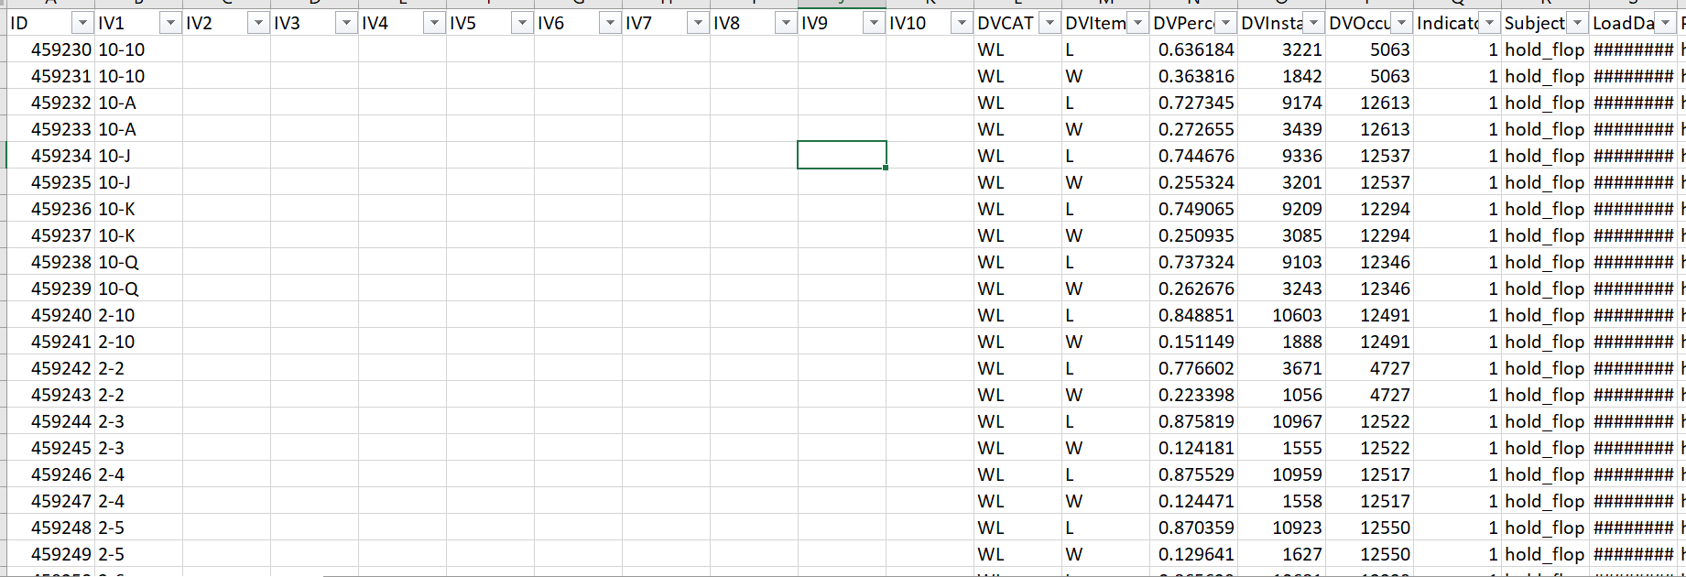

The column labeled IV1, is where you can select your two “hole cards” during the pre-flop stage of a poker game. The column has every possible starting hand in the game, and you can select a hand but using the filter drop down to select yours. In the DVItem column, you can see whether the dependent variable being predicted is a win or a loss. In the next column labeled DVPercent, you can the probability of the given dependent variable occurring. The column labeled DVOccurance, shows us how many times we saw that combination in the data set. In the very first row of the data set, the starting hand is two 10’s. In the data simulation, we saw a player start with two 10’s 5,063 times. In those 5,063 times, the two 10’s won a total of 1842 times and lost 3,221 times, meaning that two 10’s have a win probability of about 36.4% from pre-flop.
Figure 12: Probabilities from the Flop
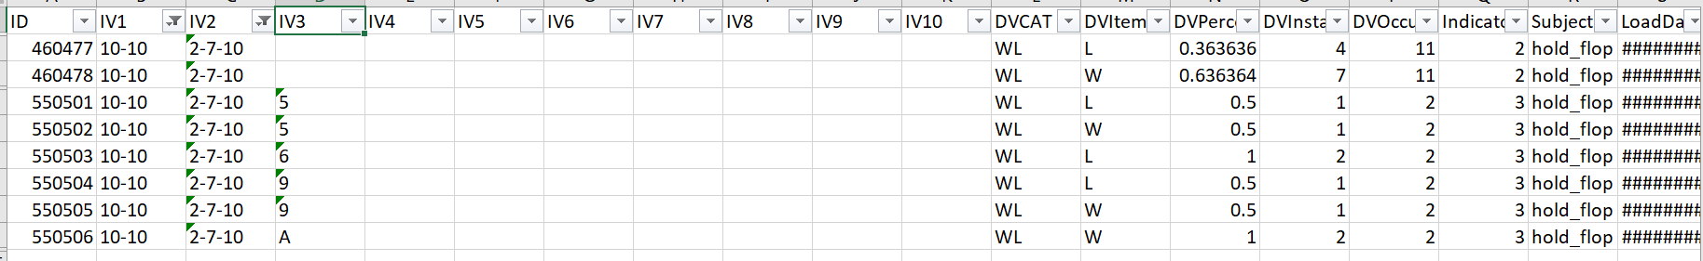
Once the pre-flop stage of a poker game has concluded, we can also get our win probability from the flop. Using the filter IV2 column, we can select any flop combination with our pre-flop hand. In this case, I selected a random flop of 2-7-10. Looking at the first two rows we can see the two 10’s which had a pre-flop win percentage of 36.4%, now have improved to a win percentage of 63.6%. Keep in mind though that this is a less reliable probability because the total occurrences for this hole card and flop combination is only 11. A notable weakness of these probabilities is that they do not account for players folding, the data always is assuming that five players are playing until the end of a game. I theorize this is not as big of a problem as it may seem though. If a player has a weaker hand, they will likely be folding it. If we have a better hand then an opponent and they fold, it should not matter very much from a data perspective because the probabilities would reflect us being ahead of those types of hands whether they fold or stay in. Although there is some margin of error, these probabilities offer a very strong benchmark for the strength of poker hands at the pre-flop and flop stages of a poker game.
Application:
The goal of this thesis was creating a tool that can be used in conjunction with poker game theory to improve betting decisions. Earlier this paper covered game theory in poker, and how it seeks to accomplish making plays with a positive expected value. The probabilities can be used to reveal whether certain decisions have a positive expected value or not by comparing the win percentage of situations to how much money is in the pot (pot odds). To show what this would look like in practice, I have gone through a hand from the televised poker show The Big Game, which originally aired on Fox in 2010 and now can be found on YouTube. On the big game, one person wins the chance to play poker against 4-5 professional poker players, they are called the loose cannon. The loose cannon gets staked by the show $100,000 to play against the poker professionals. The loose cannon only gets to keep any profits above $100,000 dollars they win, while the poker professionals are playing with their own money with the hopes their superior poker skill will give them an advantage over the lose cannon. The professionals usually buy with $100,000-$200,000, the blinds $200/$400, with a $100 ante per player which is paid for all players by the player on the button.

I will be going over a hand from season 1, week 9, episode 3 of the big game. Currently there are five players at the table.
Seat 1: Loose Cannon
Seat 2: Daniel Negreanu (professional)
Seat 3: Joe Hachem (professional)
Seat 4: William Reynolds (professional)
Seat 5: Tony G (professional)

Hand Begins:

Action: All players receive their two hole cards. Joe Hachem is in the under the gun position and is first to act. He looks down at 6_H, 4_C. The pot is currently $1,200 from blinds and antes.
Analysis: A 6 and 4 is a weak starting hand with only a 16.7% chance of winning from pre-flop, the positive EV play is to fold it.
Action: Joe Hachem folds, William Reynolds is next to act and looks down at A_D, Q_D.
Analysis: William Reynolds has a strong opening hand with a 29% chance to win from pre-flop against four opponents. There is a great chance he has the best starting hand, so the best EV play would be to raise and get more money in the pot while he is likely to best. A raise of three to five times the big blind is that standard play here, so William should look to raise somewhere in the $1200 to $2000 range.
Action: William Reynolds raises to $1500. Tony G is next to act with 3_H, 3_S. The pot is now $2,700.
Analysis: Tony G has an above average hand with two 3’s (22.5% pre-flop win percentage) and is facing a raise. A fold would certainly be acceptable here, since William Reynolds raising is representing that he has a very strong hand. A call is also reasonable since Tony G has a positional advantage of William Reynolds and a decent starting hand. Personally, I would lean more towards a fold here.
Action: Tony G actually re-raises to $5,000. The loose cannon folds 7_H, 5_H (18.1 win%) and Daniel Negreanu folds 10_C, 5_S (15.7 win%). The action is back on William Reynolds, it costs him $3,500 and the pot is $7,700.
Analysis: William Reynolds should certainly be concerned that he got re-raised pre-flop, that move is representing a lot of strength from Tony G. It costs him $3,500 to play a pot of $7.700, or pot odds of a bit better than 2-1. For this to be a positive EV play he needs to only win this hand about 30% of the time. With a strong hand like Ace Queen suited which as a pre-flop win percentage of 29% against four opponents, this is an easy call against only one opponent.
Action: William Reynolds calls the $3,500 and him and Tony G go to the flop. The flop comes J_H, A_C, 7_C. The pot is $11,200, and the action is on William Reynolds.
Analysis: William Reynolds has a pair of Aces and on this board has a win percentage of 65.2% against four opponents. He should like the spot he is in, but still have some concern since Tony G re-raised him pre-flop. I like checking here, it is better to play cautious when your opponent has represented strength and you only have a one pair hand.
Action: William Reynolds checks and the action is on Tony G.
Analysis: Tony G’s two 3’s have worsened from the board state, they only have a 13.3% chance of winning. The Ace on the board should be concerning to Tony G. A lot of the types of hands William Reynolds would raise with during the pre-flop stage would likely contain an Ace in them, so there is a very good chance he is beat. Tony has two options here, the first is he could check and see if the turn card helps to improve his hand. The second would be to bluff here, he showed a lot of strength during the pre-flop by re-raising, he could continue the story that he has a strong hand here by raising. Personally, I would prefer a check here.
Action: Tony G makes a bet of $10,000. The action is back to William Reynolds, the pot is $21,200 and it costs William Reynolds $10,000 to call.
Analysis: Tony G has showed a lot of strength in this hand, which is concerning, however a call here just has such a high expect value. William Reynolds is getting about 2-1 odds again, and his hand has a win percentage of 65.2% against four opponents. He should make the positive EV play and call here.
Action: William Reynolds makes the call for $10,000. The turn card is 3_H. The action is back on William Reynolds and the pot is $31,000. Unfortunately, due to sample size this stage of the game ends our access to probabilities.
Analysis: Tony G just had some serious good luck. He now has a three of kind and is ahead of William Reynolds. At the time the deck contains two 3’s and 39 cards, meaning Tony G only had a 5.1% chance to draw ta 3. If I am William Reynolds, I’m probably thinking that 3 did not hurt me. Pocket 3’s is a very specific hand, and it is not very likely for Tony G to have it. It is very hard to suspect that Tony would have that type of hand given how much strength he has been showing. I think Williams best play is to check here and see what Tony G does.
Action: William Reynolds checks, and the action is on Tony G.
Analysis: This is a dream situation for Tony G. He has a very disguised three of a kind and should be almost certain he is in the lead here. He should try and get as much money in the pot as possible here, I like a pot sized bet of about $30,000.
Action: Tony G bets $30,000, the pot is now $61,000 and it costs William Reynolds $30,000 to call.
Analysis: This is a very difficult position for William Reynolds. He has a strong hand with a pair of Aces, but Tony has been representing a stronger the entire game with raising and big bets. He is getting 2-1 pot odds again, but this is by no means an automatic call because of the pot odds. First he needs to wonder if Tony G is capable of bluffing three times in this hand so far. Tony G does have an aggressive reputation, but it feels unlikely he would be capable of bluffing to this degree in one hand. William Reynolds should then wonder what types of hands Tony could have. He re-raised pre-flop, which means he probably has a strong hand, maybe Ace-King, Ace-Queen, or a big pocket pair. If Tony G did have a big pocket pair like Aces or Jacks William Reynolds would be unable to win. He would also be a huge underdog if Tony G had Ace-King. I would not have been able to suspect Tony having two 3’s, a nice deceptive move by Tony G to re-raise with a weaker hand that paid off. All things considered, if I’m William Reynolds I would fold in this situation.
Action: William Reynolds calls $30,000. The river is 9_C, the action is back to William Reynolds and the pot is $91,200.
Analysis: That was a questionable call by William Reynolds on the turn. The 9 of clubs does change things however, since now there are three clubs on the board and a flush is possible. Even though William Reynolds does not have a flush, he could go all in and try and bluff Tony G by representing one. I think Tony G has shown far too much strength to try and pull off a bluff here though, in my mind a check is the only acceptable play.
Action: William Reynolds checks, the action is on Tony G.
Analysis: Time for Tony G to move all in here. He has a very good hand, and no reason to believe he is beat. The positive EV play would be to try and win the rest of William’s stack. William has been calling the whole game, no reason to think he would be folding now.
Action: Tony G bets $30,000. The pot is now $121,000, and it costs William Reynolds $30,000 to call.
Analysis: William Reynolds is getting excellent pot odds here. He is getting better than 4-1 on a call, meaning he only needs to win once every five times to be breaking even. Still given the betting action, he must suspect he is beaten here. I would fold.
Action: William Reynolds calls $30,000. Tony G shows the three of a kind and wins the pot of over $150,000.
Hand Ends
An unfortunate turn card ultimately lost William Reynolds that hand. He had been making positive expected value decisions most of the hand, but got unlucky and lost big. That is poker though, you have to make the best decisions given limited information and allow things to work in your favor over the long run.
Conclusion:

Poker success is built on making moves that have a positive expected value. With the simulated probabilities, we can always get an estimate for our chance to win. When comparing our chance to win to the odds being offered by the pot, we can find out what move has the highest expected value. The limitation of this thesis is the sample size. Initially I had theorized over 1 million sample size would be good enough to give strong probabilities across the board, however it became evident that it was not enough. The 1 million sample size was enough for analysis pre-flop and on the flop when suits were excluded.
Another weakness of the data was the fixed amount of 5 players the data was based on. Again, this is an issue of sample size. The simulation could be re-run for any number of players at the table. For example, if the game started with 7 players the pre-flop data could reflect that. Then, as the hand progresses and players fold out, the data on the flop could be used for a lower number of players. To really optimize this would take months of simulation and scanning data for every scenario imaginable in poker. It would also probably require a sample of size of 1 billion hands and games.
Creating better betting decisions relies on the ability of players to know their odds to win. With the simulated data, that was accomplished pre-flop on the flop. Further work on this project would create a predictive tool for any cards and any scenario in a poker game.

References:
- Fox, R. & Harker, S.T. (2006). Why You Lose at Poker. Pittsburgh, Pennsylvania: ConJelCo LLC.
- Harrington, D. (2008). Harrington on cash games. Quickborn: Premium Poker Publ.
- Harrington, D., & Robertie, B. (2005). Harrington on hold 'em: Expert strategy for no-limit tournaments. Henderson, NV: Two Plus Two Pub.
- How you should think about poker (but probably don't). (2019, December 10). Retrieved February 22, 2021, from https://upswingpoker.com/gto-poker-game-theory-optimal-strategy/
- Laakasuo, M., Palomäki, J., & Salmela, M. (2014). Emotional and social factors Influence Poker decision MAKING ACCURACY. Journal of Gambling Studies, 31(3), 933-947. doi:10.1007/s10899-014-9454-5
- Levitt, S., & Miles, T. (2011). The role of SKILL Versus luck in Poker: Evidence from the World series of poker. doi:10.3386/w17023
- Linnet, J., Frøslev, M., Ramsgaard, S., Gebauer, L., Mouridsen, K., & Wohlert, V. (2011). Impaired probability estimation and decision-making in pathological gambling poker players. Journal of Gambling Studies, 28(1), 113-122. doi:10.1007/s10899-011-9244-2
- Lyons, C. A., & Ghezzi, P. M. (1995). WAGERING on a large SCALE: Relationships between Public gambling and GAME manipulations in two state lotteries. Journal of Applied Behavior Analysis, 28(2), 127-137. doi:10.1901/jaba.1995.28-127
- Meyer, G., Von Meduna, M., Brosowski, T., & Hayer, T. (2012). Is poker a game of skill OR chance? A QUASI-EXPERIMENTAL STUDY. Journal of Gambling Studies, 29(3), 535-550. doi:10.1007/s10899-012-9327-8
- O365devx. (n.d.). Getting started with VBA in office. Retrieved February 22, 2021, from https://docs.microsoft.com/en-us/office/vba/library-reference/concepts/getting-started-with-vba-in-office
- Muskulus, M. (2007). Game theory for beginners: On lazy students, poker and group dynamics.

Glossary:
All in – A bet or raise of the chips you have in front of you.
Big Blind – A forced bet made by the player to left of the small blind. This forced bet occurs at the beginning of each hand and rotates clockwise to other players.
Big stack – The player with the most chips at the table.
Button – The player to the right of the small blind, who gets to act last each round after the flop. The button is marked by a white disk and rotates clockwise.
Check – The action passes to the next player without making a wager
Call – To match a bet or raise that another player made
Cut-off seat – The player to the right of the button.
Domination – When two hands share a common hole card, the player with the other lower hole card is considered dominated. For example, if one player has King-Jack and another has King-10, the player with the 10 is considered dominated.
Fold – To discard your hand and forfeit a chance at winning the pot.
Hole cards – Two cards dealt to each player at the start of a hand. No other players get to see these cards.
Kicker – Your highest card other than your strongest hand. For example, if you have a pair of Ace’s but are also holding a King, then you have a King kicker.
Out – A card which will likely give you a winning hand if it arrives.
Raise – To increase the size of an existing bet that was made. For example, if a player bets $5, another player could raise by $10, making the total amount needed to call $15.
Short stack – The player with the fewest chips at the table
Side pot – When multiple players go all in, a side pot will include the chips that cannot be covered by the smallest stack.
Small blind – A forced bet made by the player to the left of the button. This forced bet is normally ½ the size of the big blind’s forced bet. The small blind rotates to other players clockwise.
Stack – The pile of chips in front of each player
The flop – Three cards turned face up simultaneously on the table. These cards are common to all players. The flop is followed by a betting round.
The turn – The fourth card turned face up on the table. This card is common to all players. The turn is followed by a betting round.
The river – The fifth and last card to be turned face up on the table. This card is common to all players. The river is followed by a final betting round.
The nuts – A term used if a player has the best hand possible given the board.
Under the gun – A term that describes if you are the first player to act pre-flop in a poker hand.

How to play no limit Texas Hold’em poker:
The goal of no limit Texas Hold’em is to build your best five cards using a combination of the board and your two hole cards. The player with the strongest hand at the end of the betting action will take the pot. If all players but one fold out of the hand before all betting action has concluded, the remaining player will take the pot. There are ten possible final poker hands.
- Royal Flush
A, K, Q, J, 10 all of the same suit
Example - A_H, K_H, Q_H, J_H, 10_H

- Straight Flush
5 Cards in a row all of the same suit
Example - 3_S, 4_S, 5_S, 6_S, 7_S
*If there are multiple straight flushes the player with the highest card involved in the straight flush wins. If both players have the same highest card in the straight flush, it is a chop pot

- Four of a kind
4 of the same card
Example – 5_S, 5_H, 5_C, 5_D, 8_H

- Full house
3 of the same card and two of another
Example – 10_S, 10_C, 10_D, 3_H, 3_S

- Flush
5 cards of the same suit
Example – A_C, 6_C, 7_C, 2_C, J_C

- Straight
5 cards in a row
Example – 5_D, 6_S, 7_H, 8_D, 9_S

- 3 of a Kind
3 of the same card
Example – 3_S, 3_D, 3_H, 8_S, J_C

- Two Pair
Two of the same card and two of another
Example – 7_H, J_S, J_H, 7_D, A_C

- Pair
Two of the same card
Example – K_S , 8_H, 2_D, 6_C, K_C

- High card
If you don’t have any of the other hands made, your hands showdown value is the highest card you’ll holding
Example – 6_D, 7_H, 2_C, 4_S, A_D

If you have the same hand as another player, then the winner is decided by who has the highest card in that hand. For example, if a player has a two pair with Ace’s and 6’s, and another player has a two pair with King’s and Jack’s, the Ace’s and 6’s will win. If both players have the same highest card involved in the same type of hand, then the winner is determined by the kicker.

The game begins with assigning players the big blind, small blind, and button disks. The player seated directly left of the button will be the small blind, and directly left of the small blind will be the big blind. Before any cards are dealt, the small and big blind must make their forced bets. After the forced bets are made, the dealer will distribute two “hole” cards to each player face down. After each player has “hole” cards, the first round of betting begins. The first player to act will be the player directly left of the big blind. They will have the option to check the action to the next player or make a bet. If a bet is made by a player, everyone involved in the hand will either need to call the bet, fold, or raise the bet. If a raise is made, that will become the current bet that each player will need to call, fold, or raise. If enough players fold so that there is one player left in the hand, they automatically win the pot. Once everyone involved in the hand calls the current bet, the flop comes. The flop reveals three cards face up, all players use these to help build their best five cards. Another round of betting action takes place that follows the same rules as the betting pre-flop. After the flop comes an additional card face up called the turn. Another round of betting occurs. The final card is revealed on the board known as the river card, followed by a final round of betting action. If there are still multiple players involved in the hand after the final betting round, they both reveal their cards to see who has the stronger hand. The game resets, and the big blind, small blind, and button responsibilities rotate one player clockwise.

Appendix
Figure 13: Code for Generating Poker Hands
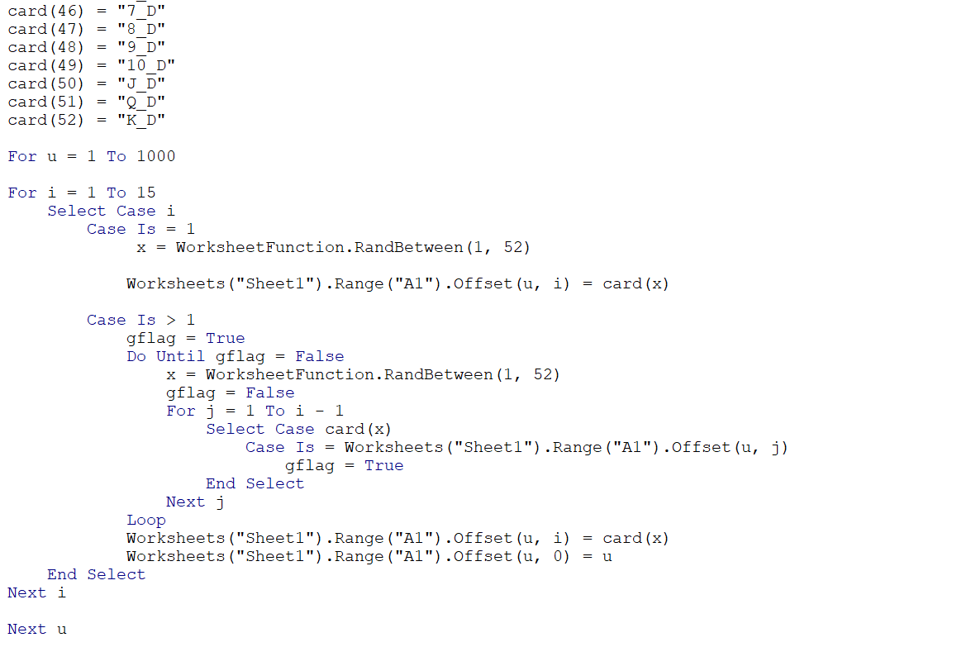

Figure 14: Code for Checking if a Player has a 3 of a Kind
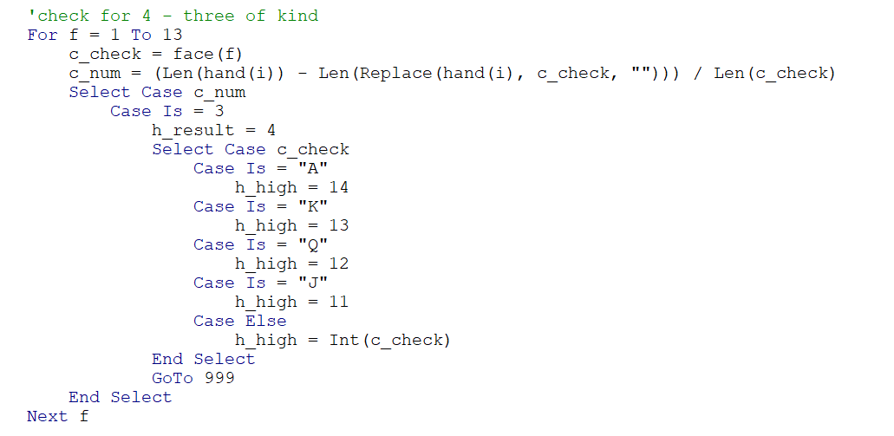

Figure 15: Code for Logging What Types of Hands Each Player Finished With
