

­

Dr. Darrell Killian

­

Dr. Olivia Hatton

Primary Thesis Advisor

**Regulation of phosphoinositide 3-kinases (PI3K) p85α by latent membrane protein 1 (LMP1) of Epstein-Barr Virus**

Senior Thesis Presented to

The Faculty of the Department of Molecular Biology

Colorado College

By

Madeline Stesney

Bachelor of Arts Degree in Molecular Biology

Submitted April 27, 2020

**Abstract**

Epstein-Barr Virus (EBV), a herpesvirus, alters expression of host B cell genes to induce transformation into B cell lymphomas such as Burkitt’s, Hodgkin’s and Non-Hodgkin’s Lymphomas. Cells become cancerous by many different hallmarks, such as evading programmed cell death, undergoing unlimited replication, exhibiting metastasis and have a heightened response to cell growth signals. Many of these dysregulations arise from activation and deactivation of essential genes. A significant regulation method is through microRNAs (miRs). miRs are small, non-coding RNAs that associate with Argonaute family proteins (AGO). miRs function by degrading or inhibiting translation of target mRNAs. While EBV cells introduce exogenous miRs, the virus primarily alters host miRs to create an ideal environment for infection. EBV+ cells express a CD40 homolog, latent membrane protein 1 (LMP1). LMP1 is a constitutively active, transmembrane oncoprotein. When virally expressed, LMP1 proteins, unlike CD40, oligomerize thus activating them. Primary targets of LMP1 are NFκB and the phosphatidylinositol 3-kinase Akt (PI3K/Akt) pathways. This results in repression of DNA repair machinery and leads to genomic instability. EBV+ cells are also effective at evading apoptosis by suppressing cell-death signals. LMP1 contains six transmembrane domains and an intracellular domain, which interacts with cellular pathways. In EBV+ B cells, PI3K p85α is among many proteins that are down regulated. Our preliminary data indicate that a primary oncogene of EBV, LMP1, upregulates miR-155 via PI3K p110α. PI3K p85α is a regulatory subunit in the PI3K/Akt pathway. The pathway leads to phosphorylation of proteins such as FOXO3a, which is responsible for inducing DNA repair. PI3K p85α is a known target of miR-155 in non-cancerous B and epithelial cells. To determine if LMP1 regulates expression of miR-155 target protein, PI3K p85α via PI3K p110α, we utilized EBV- B cell lymphoma (Burkitt’s Lymphoma) lines stably expressing inducible, chimeric LMP1 molecules. We then activated LMP1 in the absence or presence of the PI3K p110α selective inhibitor BYL719 (BYL) and measured expression of PI3K p85α by Western blot. When LMP1 is active in EBV- cells, PI3K p85α is not differentially regulated. Additionally, inhibition of PI3K p110α does not affect PI3K p85α expression. Thus, LMP1 does not regulate expression PI3K p85α in EBV and there is likely a different mechanism by which EBV+ cells regulate PI3K p85α.

**Introduction**

**Epstein-Barr Virus**

Epstein-Barr Virus (EBV) is one of the most prevalent viruses in humans, infecting around 90% of the worldwide population. Spread through bodily fluids, the γ-herpesvirus is latent in most patients with healthy immune systems, but it can cause infectious mononucleosis, Hodgkin’s and non-Hodgkin’s lymphomas, Burkitt’s lymphoma and other illnesses. The primary targets of EBV are B cells and epithelial cells[1]. Although usually present as a latent infection, a more severe result of being infected with EBV can occur after an organ transplant. Post-transplant lymphoproliferative disorder (PTLD) is a type of lymphoma that develops due to infection and a weakened immune system[2]. PTLD occurs in up to 20% of organ transplants[3]. With the significant prevalence of PTLD, it is compelling to study the role of the virus in transforming cells of the immune system because EBV is attributed to more than 90% of PTLD cases[4].

An overarching theme of EBV-related cancers is that the virus acts to prevent apoptotic signals in B cells and essentially immortalize them[5], which allows them to transform. Along with evading apoptosis, EBV has been characterized to promote genomic instability in Burkitt’s Lymphoma (BL)through clonal and non-clonal chromosome aberrations[5]. A viral protein, Epstein-Barr Nuclear Antigen-1 (EBNA-1), is the main oncoprotein conferring genomic instability by inducing double-stranded breaks and inhibiting DNA repair mechanisms, therefore allowing for a dysregulated build-up of mutations[6]. Latent Membrane Protein 1 (LMP1) is another oncoprotein of EBV attributed to destabilizing the chromosomes, but it has also been identified to have a myriad of other roles in transformation of B cells[7].

**LMP1**

LMP1 is a mimic of CD40 receptor and is necessary for EBV to transform of B-cells[8]. Although the homologs have very similar structure and function, LMP1 varies in that it is constitutively active and does not require activation by ligands[9]. The CD40 receptor is involved in immune response through T cells. When active, both proteins display similar functions. The proteins oligomerize to become active and affect essential cell survival and proliferation mechanisms[9]. Because LMP1 is a homolog of CD40, chimeric proteins can be made that produce the functions of LMP1 but are regulated by endogenous CD40 ligands [9]. LMP1 has six transmembrane domains and an intercellular domain, which regulate downstream pathways. The C-terminal activating regions, known as CTAR1 and CTAR2, interact with pathways such as NFκB and PI3k/Akt[10]. The transmembrane protein activates NFκB pathway, which is essential to the survival of EBV+ B cells[11]. In epithelial cells, LMP1 acts to prevent DNA repair through the induction of the PI3K/Akt pathway, specifically through transcription factor FOXO3a[7]. FOXO3a regulates genes that are involved with DNA repair and cell cycle modulation. Other key components of the PI3k/Akt pathway that regulate cell survival, proliferation and tumor suppression include FOXO3a, SHIP1 and PI3k p85α[12] (Figure 1).

Because LMP1 is constitutively active when expressed in EBV+ cells, there is upregulation in activity of the PI3K/Akt pathway. Activation of this pathway leads to phosphorylation of FOXO3a, a protein that induces DNA repair. When phosphorylated, the protein is inactive, and DNA is not repaired as efficiently[8]. Upon LMP1 activation, the CTAR1 region is responsible for activating PI3K/Akt pathway[13]. There are various ways a pathway is regulated such as transcription of the genome, translation of mRNAs, and protein modifications. Increasing transcription can result in upregulation of the pathway and therefore increase the microRNAs associated with it. One significant way the virus immortalizes B cells is by altering host microRNAs (miRs).

**miR-155**

miRs are short (~22 nucleotides), non-coding RNA strands that regulate genes by silencing mRNA strands complementary to themselves. miRs can either direct the mRNA for degradation or simply inhibit translation by binding to either 3’ or 5’-UTR regions. miRs are transcribed from either introns or exons from protein coding genes or from non-protein coding sequences. Once transcribed, the pri-miRs are processed in the nucleus by Drosha and DGCR8, to produce pre-miR. After entering the cytoplasm, pre-miRs are further processed with the endonuclease Dicer. Finally, the mature miR is loaded into an Argonaute protein (AGO) in the RNA-induced silencing complex (RISC) which uses the miR seed sequence to target the appropriate mRNA(s). Because miRs regulate translation of mRNA, these small RNAs also must be regulated. Alternate expression and/or function of miRs is a common precursor for diseases to modify host proteins. For example, a cancer may upregulate a miR that silences a tumor suppressor, thereby inhibiting tumor suppression. Many cancers display down-regulated miRs by inhibition of biogenesis steps like Drosha and Dicer[14]. In addition to modifying host miR, viruses can introduce their own miRs.

Virally encoded miRs were first identified in EBV, Cameron et al. identified five miRs[15]. In the last 25 years, many more virally encoded miRs have been identified. However, much of the focus has been on how viruses alter host miRs. A few host miRs were established as being upregulated in EBV+ B cells. miR-21, miR-23a, miR-24, miR-27a, miR-34a, miR-34a/bl miR-146a/b and miR-155 were all elevated in lymphocytes after EBV infection[15]. Along with total EBV+ differentially regulated miRs, it is thought that LMP1 is especially vital in the regulation of overlapping miRs[16]. The highest and most consistently upregulated miR in EBV-infected B cells that is LMP1-dependent is miR-155[17].

miR-155 is essential in progressing cells past S phase in proliferation and bypassing apoptosis[18]. It is also important to note that miR-155 is not essential in establishing EBV latency in B cells, but it is vital in activation of the virus after a latent period[18]. For these reasons, miR-155 is classified as an oncogene. LMP1 is involved in upregulating miR-155 and its RNA precursor, B-cell integration cluster (BIC), EBV- with differentially expressed LMP1 [18]. miR-155 was upregulated when LMP1 was present and active. Because miR-155 is consistently upregulated in B cell lymphomas, with and without EBV infection, it is being explored as a biomarker of the cancer[19]. Another characteristic of miR-155 in relation to LMP1 and EBV is that it targets the PI3k/Akt pathway, specifically regulating the PI3K proteins[21].

**PI3k p85α and p110α**

The phosphatidylinositol 3-kinase Akt (PI3K/Akt) pathway is a very diverse pathway that regulates many essential cellular processes such as metabolism, proliferation, growth and motility[20]. For this reason, mutations in or dysregulations of the PI3k/Akt pathway are common culprits of cancers and diseases. This pathway is becoming a more desirable target for small molecule inhibitors due to its common dysregulation in cancers[22]. A result of the pathway is the phosphorylation and activation of Akt. FOXO3a is phosphorylated by Akt and is nonfunctional as a DNA repair inducer. As previously stated, increased phosphorylation of FOXO3a leads to accumulation of mutation. A common dimerized complex that activates Akt is the PI3k p110α and p85α subunits.

PI3k p85α is a regulatory subunit of PI3k. It is encoded by *PIK3R1* and is 85 kDa. P85α functions to stabilize and negatively regulate p110α, as well as activate it under certain conditions. The inhibition of PI3k p110α prevents the pathway from phosphorylating Akt. Therefore, PI3k p85α is a tumor suppressor when it stabilizes and prevents PI3k p110α from dimerizing with itself and promoting the PI3k pathway. In addition, PIK3R1 is a proven target of miR-155[23]. Significantly, PIK3R1 is downregulated in B cells infected with EBV. Five EBV+ and two EBV- cell lines were tagged for PI3k p85α. There was a nearly 2-fold decrease of PI3k p85α in EBV+ cell lines. This reduction of PI3k p85α, which functions as a tumor suppressing protein, may be one of the ways EBV uses the viral oncoprotein LMP1 to transform B cells.

To further investigate the impact of LMP1 regulation of miR-155, it is important to analyze miR-155’s targets When PI3K pathway components PI3kα and PI3kδ are inhibited, miR-155 is downregulated. More specifically, inhibition of PI3Kα produced 3-fold reduction in expression of miR-155. As previously stated, the dimer complex of PI3k is made up of PI3k p110α and PI3k p85α. With the inhibition of PI3k p110α and decrease of miR-155, it is hypothesized that treatment with BYL would result in an increase of PI3k p85α. Finally, in the case of EBV and activation of LMP1, which increases expression of miR-155, we investigate the potential targeting of PI3K p85α.

Given the relationship between LMP1 and miR-155 and the relationship between miR-155 and PI3kα proteins, the current study examined the regulation of PI3k p85α by LMP1 via PI3k p110α. Figure 1 is a proposed schematic of the regulation of PI3k p85α by LMP1 via PI3k p110α. It has previously been shown that after 12 hours of activation of LMP1, there were decreased levels of PI3k p85α. The current project examines protein levels after 16-hour activation periods. The results indicate that LMP1 does not regulate PI3K p85α via PI3K p110α due to the lack of decrease of the protein or rescue when the pathway is inhibited.

**Methods**

**Cell lines and growth conditions**

Burkitt’s lymphoma cells (BL41), from Dr. Elliott Kieff at Harvard Medical School, were used for all experiments. BL41 are EBV- cells and used to create NGFR.LMP1 expressing lines. Cells were cultured in RPMI with 10% fetal bovine serum and 50units/mL penicillin/streptomycin antibiotic. Cultures were kept in 37˚C, 5% CO2, humidified incubator and typically subcultured to 0.5x106 cells/mL every 2 days.

**Flow cytometry for expression and functionality of NGFR.LMP1**

Six million cellswere acquired for cross-linking analysis. 0.5 mg/mL mouse anti-human NGFR was used for cross-linking wells and incubated for 30 minutes at room temperature. 1.8mg/mL Goat anti-mouse IgG was used for cross-linking and incubated for 16 hours in 37˚C at 5% CO2 humidified incubator. Cells were thoroughly mixed, and 450µL cells were acquired. Cells were spun at 1250rpm for five minutes at room temperature. The supernatant was aspirated, cold FACS buffer was added, and cells were vortexed and spun at 1250rpm for five minutes at room temperature. Supernatant was aspirated. 1.8 mg/mL Mouse IgG blocking antibody was added to cross-linked samples and incubated on ice for 20 minutes. Cross-linked samples were washed with cold FACS buffer, vortexed and spun at 1250rpm for five minutes at room temperature. After aspiration, 100µg/mL PE mouse anti-NGFR was added to uncross-linked samples, 100µg/mL PE mouse anti-ICAM was added to two uncross-linked samples and the two cross-linked samples, 200 ug/mL PE mouse IgG, k isotype was added to one uncross-linked sample, and one sample was left unstained. All samples were incubated on ice, protected from light for 30 minutes. All samples were washed with cold FACS buffer, vortexed and spun at 1250rpm for five minutes at room temperature. After aspiration, pellets were resuspended in FACS buffer. Samples were analyzed using Guava EasyCyte. Cells were selected for ICAM and NGFR expression after gating on forward and side scatter.

**LMP1 activation (cross-linking)**

Cells were acquired, pelleted and resuspended to 4x106 cells/mL. Experiments were performed with 1mL cells. Two wells received DMSO empty vessel composed of 499:1 cRMPI:DMSO. The third well received BYL inhibitor composed of 1497:3 cRPMI:BYL719. Cells were gently mixed and incubated for 30 minutes at room temperature. The well with BYL inhibitor received 0.5 mg/mL mouse anti-human NGFR and incubated for 30 minutes at room temperature. 1.8mg/mL Goat anti-mouse IgG was added to cross-linking sample and cells incubated for 16 hours in 37˚C at 5% CO2 humidified incubator.

**Lysate quantification**

Previously cross-linked and non-cross-linked samples were acquired on ice. Samples were spun at 1250rpm for five minutes at room temperature, aspirated and resuspended in cold 500mL PBS and 0.08mL sodium orthovanadate (OV). Samples were spun at 1250rpm for five minutes at room temperature and aspirated. Phospholysis buffer (PLB) and inhibitor stock, composed of 490µL PLB, 5µL 100x Halt phosphatase and protease inhibitor and 5µL OV, was added to samples and mixed. Samples were incubated on ice for 30 minutes and vortexed every 15 minutes. Samples were spun for 15 minutes at 13,000rpm and 4˚C. 1:2 lysate and PLB and inhibitor stock were used for protein assay. Pierce 660nm Protein Assay standards of 2000, 1500, 1000, 750, 500, 250, and 125mg/mL were used. Pierce 660nM Assay Reagent was added to all tubes and incubated in the dark for five minutes. Nanodrop was used to measure lysate concentrations and 1x Laemmli sample buffer in PLB and inhibitor stock was used to normalize concentrations of lysates between 1-2mg/mL.

**Western blotting**

PI3k p85α – 20µg of previously lysed samples were loaded onto one Novex WedgeWell Bis-Tris 4-20% gel with 1X tris-SDS glycine running buffer. Samples were run at 80v for 25 minutes, 100v for 20 minutes and 120v for 35 minutes. Transfer to nitrocellulose membrane occurred for 60 minutes at 12v in 1X transfer buffer. The membrane was blocked for one hour in 5% milk in 1X TBST, rocking at room temperature. Blocking buffer was removed and 1:500 anti-PI3k p85α in 5% milk in 1X TBST was added to membrane and rocked overnight at 4˚C. The membrane was washed three times with 1X TBST for five minutes each wash. 1:10,000 anti-rabbit HRP in 5% milk in 1X TBST dilution was added to membrane and rocked at room temperature for one hour. The membrane was washed three times with 1X TBST for five minutes each wash. SuperSignal West Pico PLUS chemiluminescent substrates were added to the membrane and incubated for five minutes, while rocking in the dark. The membrane was developed using the iBright imager. Blots did not need to be stripped to be re-probed for actin. Membranes were re-blocked in 5% milk in 1X TBST and rocked for 45 minutes at room temperature. 1:1000 actin-HRP in 5% milk in 1X TBST was added to blot and rocked overnight at 4˚C. The membrane was washed three times with 1X TBST for five minutes each wash and developed as previously stated using the iBright imager. Blots were analyzed by densitometry using ImageJ.

Akt and pAkt – 15µL of sample was loaded onto Novex WedgeWell Bis-Tris 4-20% gel with 1X tris-SDS glycine running buffer. Samples were run for 25 minutes at 80v and 45 minutes at 120v. Transfer to nitrocellulose membrane occurred for 60 minutes at 12v in 1X transfer buffer. Blots were blocked for one hour in 5% milk in 1X TBST, rocking at room temperature. 1:500 anti-pAkt in 5% BSA in 1X TBST was added to blots and rocked overnight at 4˚C. 1:10,000 anti-rabbit HRP in 5% BSA in 1X TBST dilution was added to membrane and rocked at room temperature for one hour. Blots were imaged using iBright. Membranes were then washed in 1X TBST for five minutes. 1:1000 Akt in 5% milk in TBST was added to membrane. The membrane was washed three times with 1X TBST for five minutes each wash. Blots were imaged using iBright (company). Blots were washed for five minutes in 1X TBST stripped for 15 minutes and washed again for five minutes. The blots we blocked for one hour in 5% milk in 1X TBST, rocking over night at 4˚C. 1:1000 actin-HRP in 5% milk in 1X TBST was added to blot and rocked for 45 minutes at room temperature. Blots were imaged using iBright and analyzed with ImageJ[29].

**RNA isolation**

mirVana miRNA Isolation Kit (ThermoFisher) was used for RNA isolation. 600µL lysis buffer was added to each sample and vortexed. Samples received 60µL miRNA Homogenate Additive, vortexed, and incubated on ice for 10 minutes. Acid-phenol: chloroform was added to samples and vortexed 30-60 seconds. Samples were spun at 10,000g for 7.5 minutes at room temperature. 400µL of the aqueous layers were transferred to new tubes. 100% room temperature ethanol was added and samples were vortexed. Samples were loaded onto Filter Cartridges and spun at 10,000g for 30 seconds at room temperature. miRNA Wash Solution 1 was added to Filter Cartridges and spun at 10,000g for 15 seconds. Two washes with miRNA Wash Solution 2/3 were performed, spun at 10,000g for 15 seconds each. With Filter Cartridges in new Collection Tubes, 95˚C Elution Buffer was added. RNA was recovered by spinning samples at max speed for 30 seconds at room temperature. Samples were aliquoted into DNase/RNase free tubes and stored at -80˚C. Concentration and purity was measured using NanoDrop.

**cDNA generation**

iScript Advanced cDNA Synthesis Kit (BioRad) was used for cDNA generation. 4µL 5X iScript Advanced Reaction Mix, 1µL iScript Advanced Reverse Transcriptase (for reverse reactions), 2µg of isolated RNA, and nuclease free water to 20µL total volume was added to 0.2mL thin-walled PCR tubes, on ice. cDNA generation occurred in the thermal cycler under the following conditions – 20 minutes at 46˚C and 1 minute at 95˚C. cDNA was stored at -20˚C

**qPCR for miR-155**

TaqMan miRNA probes for miRNAs and endogenous control and TaqMan Universal Master Mix II were used for quantitative PCR. Kit instructions were followed. Plate was sealed and run under the following conditions – 2 minutes at 50˚C, 10 minutes at 95˚C, 15 seconds at 95˚C and 60 seconds at 60˚C (40 cycles). Concentrations of miRNA were normalized to GAPDH.

**Results**

**NGFR.LMP1 is an Inducible system that mimics viral LMP1**

LMP1 downregulates miR-155 in BL and miR-155 has targets in the PI3k/Akt pathway. To analyze the effect LMP1 has on miR-155 target PI3k p85α, we needed a controllable system. Because LMP1 is constitutively active upon oligomerization, we must be able to regulate activation. A chimeric protein composed of nerve growth factor (NGFR) as the extracellular and transmembrane domain and LMP1 c-terminal tail responsible for interacting with PI3K pathway was used. NGFR.LMP1 transfection in EBV- Burkitt’s Lymphoma B cells is an established system with dependent LMP1 activation and little adverse impact on the host[24]. To confirm the expression of NGFR.LMP1 in transfected BL41 cells, expression of NGFR was analyzed by flow cytometry (Figure 4A). The NGFR peak expressing higher levels of fluorescence than a control isotype and unstained BL41 suggests that the chimera is present in our cells. The lack of expression of the mouse isotype demonstrates that the antibodies are not binding non-specifically.

Next, we determined if the NGFR.LMP1 chimera is functional after crosslinking by looking at four known outcomes of LMP1 activation after crosslinking. First, we examined production of ICAM, a protein naturally produced in B cells but upregulated by LMP1[25] (Figure 4B). ICAM expression after cross-linking is about 10x higher than basal levels. Quantitative PCR (qPCR) was also performed on ICAM to quantify the mRNA transcript expression after cross-linking (Figure 4C). A 6-fold induction of ICAM was recorded after LMP1 activation. Next, we analyzed Akt phosphorylation because PI3k/Akt pathway results in the phosphorylation of Akt[26]. A Western blot for Akt and pAkt showed a nearly 1.5x increase in Akt phosphorylation after NGFR.LMP1 crosslinking (Figure 4D). Finally, we examined the levels of miR-155 expression as a direct impact of LMP1 activation (Figure 4E). LMP1 activates PI3K/Akt pathway and increases miR-155 expression[17]. qPCR on miR-155 showed a 7-fold induction of the microRNA. Together these data strongly show that the NGFR.LMP1 chimera in EBV- BL41 cells is stably expressed and functions as a mimic of EBV viral oncoprotein LMP1.

**LMP1 does not regulate PI3k p85α via PI3k p110α**

PI3k p110α and PI3k p85α are two proteins that interact consistently in the PI3k/Akt pathway. PI3k p85α is also a protein previously shown to be downregulated in EBV+ B cells. Because miR-155 targets PI3k p85α and PI3K p110α is precursor in the pathway (Figure 1), we targeted PI3K p110α to down-regulate miR-155. First, to determine if LMP1 is responsible for regulating PI3k p85α in EBV+ cells, we activated LMP1 through cross-linking and inhibited PI3k p110α using a small molecule inhibitor, BYL719 (BYL; Figure 5). Based on densitometry analysis, there is no difference in expression of PI3k p85α after activation of LMP1. Next, we analyzed PI3K p110α role in LMP1 regulation of PI3K p85α. Treatment with BYL does not affect PI3K p85α expression. Therefore, inhibiting PI3k p110α does not affect PI3k p85α expression. Conclusively, these data show that LMP1 does not regulate PI3k p85α via PI3k p110α.

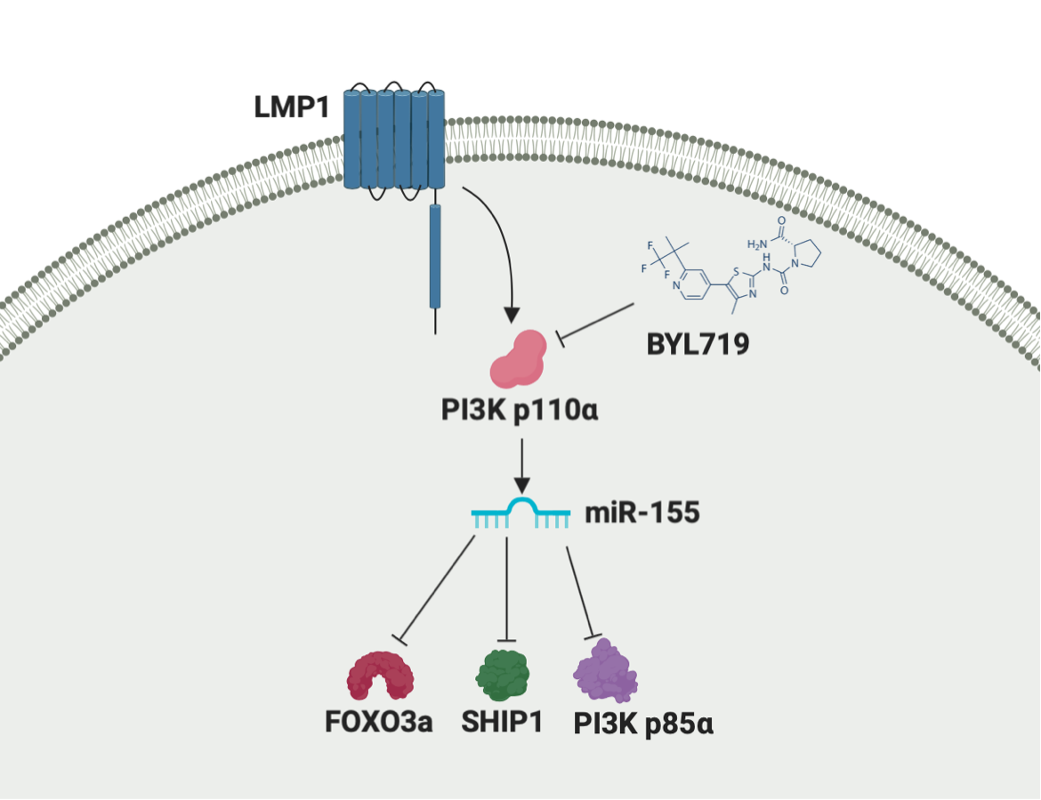**Figures**

**Figure 1. Proposed pathway LMP1 uses to regulate miR-155 and its target proteins.** Upon activation of LMP1, intracellular domain activates PI3K/Akt pathway. PI3K catalytic subunit, PI3K p110α is activated and increases miR-155 expression. Targets of miR-155 – FOXO3a, SHIP1 and PI3K p85α are subsequently downregulated.

**Figure 2. PI3k p85α is down regulated in EBV+ cells.** 30 μg protein from EBV+ and EBV- cell lysates were loaded onto 4-20% tris-glycine gel and separated by SDS-PAGE. Protein was transferred to 0.2 μm nitrocellulose membrane and blotted for PI3k p85α and actin. Azure c300 was used to image blots and ImageJ was used to analyze based on densitometry. ***p ≤ 0.0001. Figure from Hatton 2019.

**PI3K p85**

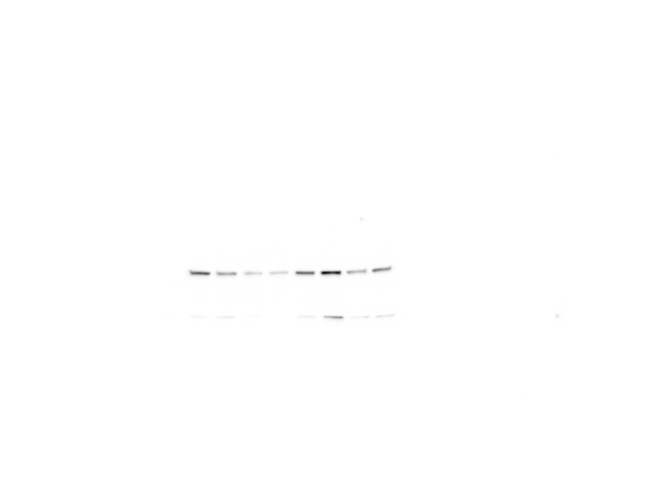

**JB7**

**JC62**

**MF4**

**VB5**

**Pfeiffer**

**Toledo**

**AB5**

***EBV +***

***EBV -***



**actin**

***B Cell Lymphomas***

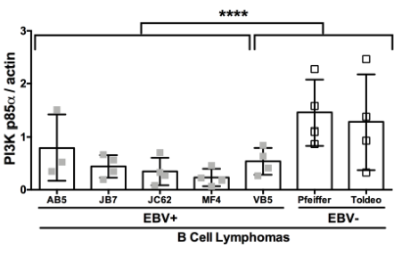

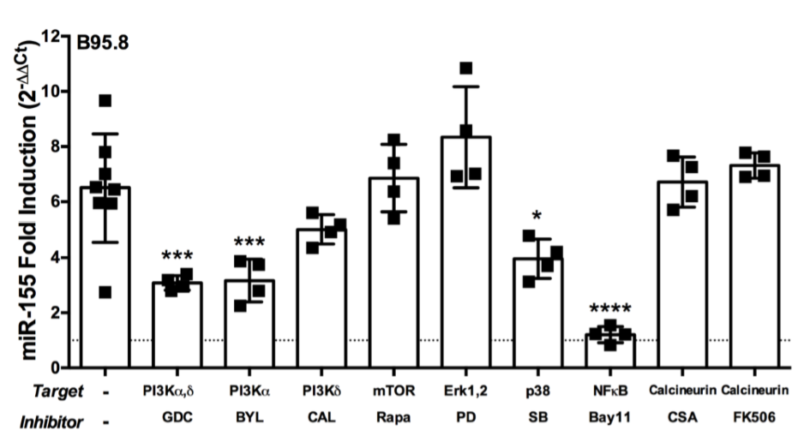

**Figure 3. miR-155 expression is down-regulated when treated with PI3K/Akt pathway inhibitors.** B95.8 cell strain from patient with mononucleosis were exposed to inhibitors for PI3kα,δ (GDC-0941), PI3kα (BLY719), PI3kδ (CAL-101), and mTOR (Rapamycin) at concentrations of 1μM, varied, 1μM, and 10μM, respectfully. Cells were exposed for 12 hours before RNA isolation. mirVana miRNA Isolation Kit was used, followed by the TaqMan MicroRNA Reverse Transcription Kit. RNA was pre-amplified to 10ug with TaqMan Pre-Amp Master Mix. The TaqMan Universal Master Mix II was used for quantitative PCR. Expression of miR-155 is relative to endogenous control, u47 ncRNA. Fold inductions of miR-155 are shown. *** p ≤ 0.001 by one-way ANOVA. Figure from Hatton 2019.

**Figure 4. NGFR.LMP1 chimeric is an inducible system in EBV- BL41 cells.** Cells were cross-linked for 16 hours in 37˚C and 5% CO2 and humidified incubator by incubating with 0.5 mg mouse anti-human NGFR and 1.8 mg goat anti-mouse IgG. Cross-linked or uncross-linked samples were then analyzed as follows. A,B. Flow cytometry was used for expression analysis A. Cells were stained for NGFR or isotype, or left unstained and stained with anti-NGFR. B. Cells were also stained for ICAM with anti-ICAM. C. RNA was isolated, and qPCR was run for mRNA of ICAM to further confirm increase in expression after cross-linking. Relative expression of ICAM was normalized to endogenous control u47(ΔCt) and control sample (ΔΔCt). Fold induction for relative expressions were calculated as 2-ΔΔCt D. 15µL of lysed samples were loaded onto 4-20% tris-glycine gel, transferred to nitrocellulose membrane and tagged for Akt pAkt, and actin. Densitometry was performed using ImageJ, and Akt levels were normalized to actin, then pAkt was normalized to normal Akt E. The final confirmation of functionality was a qPCR, performed as previously described, on miR-155. 7.5-fold-induction of miR-155 in cross-linked cells confirms that the chimera is a functional, inducible system. Relative expression of miR-155 was normalized to endogenous control u47(ΔCt) and control sample (ΔΔCt). Fold induction for relative expressions were calculated as 2-ΔΔCt

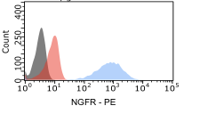

**Unstained**

**Isotype**

**NGFR**

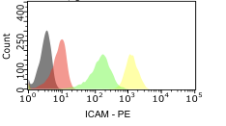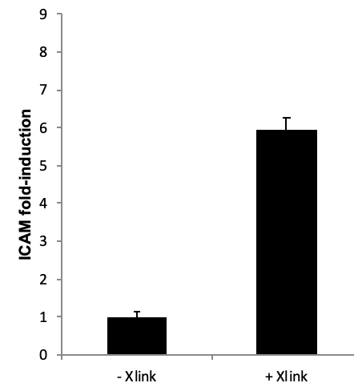

**LMP1 -Xlink LMP1 +Xlink**

**-Xlink Unstained**

**-Xlink Isotype**

**-Xlink ICAM**

**+Xlink ICAM**



**LMP1 Xlink: - +**

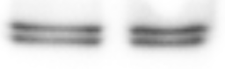

**pAkt**

**Akt**

**Actin**

**pAkt/normalized Akt 1.00 1.43**

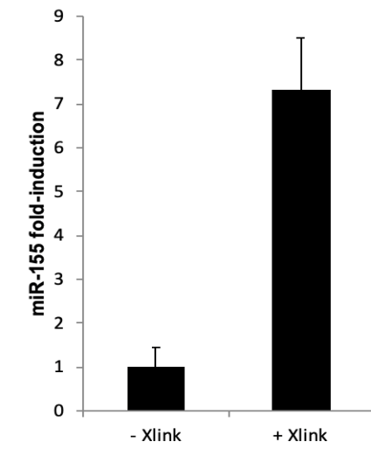

**LMP1 -Xlink LMP1 +Xlink**

**A**

**B**

**C**

**D**

**E**

**Figure 5. PI3k p85α is not down regulated by LMP1 via PI3k p110α. NGFR.LMP1-expressing** NGFR.LMP1 expressing were cross-linked as indicated, treated with PI3k p110α inhibitor BYL719 as indicated, incubated for 16 hours in 37˚C and 5% CO2 humidified incubator. Samples were lysed with sodium orthovanadate (OV) and Halt phosphatase and protease inhibitor and equalized after Pierce 660 Protein Assay. 20ug samples loaded onto 4-20% tris-glycine gel and transferred to nitrocellulose membrane. Blots were probed for PI3k p85α and actin. Blots were developed with iBright and analyzed with ImageJ. Expression was normalized to actin loading control. One-way ANOVA significance analysis performed.

**Discussion**

EBV is a wildly contracted virus that often presents with mild symptoms. However, in the cases that the infection develops into cancer, mechanisms by which the virus transforms cells is essential knowledge. Instances in which EBV+ patients develop more serious symptoms are more common in those immunocompromised and with PTLD. As with all cancers, transformed B cells show dysregulation in cell cycle progression, proliferation, evasion of apoptosis as well as other hallmarks of cancer. In Burkitt’s Lymphoma cell line (BL41), there are many miR differentially regulated due to EBV. These miRs and their targets are potential victims to therapeutic agents.

One FDA approved agent targeting these pathways is BYL719. This experiment required that BYL effectively inhibits PI3K p110α. This small molecule inhibitor has recently become a verified drug for the treatment of breast cancer[16]. Additionally, the inhibitor is in clinical trial phase for metastatic colorectal cancer and head and neck squamous cell carcinoma. This wide range of applications corresponds with the high prevalence of mutations in the PI3K/Akt pathway. To continue to find applications of this small molecule inhibitor could prove to be an incredible treatment to cancers caused by mutations occurring in the PI3K/Akt pathway, affecting the protein or downstream of PI3K p110α, such as PI3K p85α or FOXO3a.

The current study showed that the regulatory subunit of PI3K/Akt pathway *PIK3R1* is not regulated by LMP1, specifically via the PI3K p110α catalytic subunit of PI3K/Akt pathway. Although EBV+ cells show a down regulation of *PIK3R1*, EBV- cells with activated LMP1 do not. This suggests that another protein(s), either oncoprotein or host protein that is altered upon EBV infection, is responsible for the regulation of *PIK3R1* repression. This protein functions as a tumor suppressor, so restoring its function in those affected by EBV, such as patients with PTLD or HIV/AIDs, could be a treatment to these diseases.

The goal of this experiment was to attempt to solidify one potential pathway the virus takes to activate PI3K/Akt pathway by examining regulation of PI3k p85α by LMP1. Prior knowledge suggests the virally encoded protein, LMP1, is a major oncogene. The transmembrane protein regulates at least 2 pathways in the cell – NFκB and PI3K/Akt. This experiment focused on the PI3k/Akt pathway because miR-155 is upregulated in EBV+ cells. FOXO3a, PI3k p85α and SHIP1 are proteins regulated in the pathway and are targets of miR-155. This experiment specifically analyzed the observed down-regulation of PI3k p85α, with regards to its dimerization partner PI3k p110α, and miR-155. PIK3R1 is a common regulator for the PI3k/Akt pathway and when active with PI3k p110α, it can negatively regulate the pathway and prevent phosphorylation of Akt. Mutations leading to cancer often involve the Akt phosphorylation because the pathway regulates vital cellular functions such as proliferation, apoptosis and tumor suppression.

The reason this protein was chosen is because when an experiment to extrapolate the miRs that are dysregulated upon activation of LMP1 miR-155 was identified. The upregulation of miR-155 was highlighted because it is known to negatively regulate FOXO3a, PI3k p85α and SHIP1. PI3k p85α was the target chosen in this experiment due to its impact on PI3k/Akt regulation. To determine if LMP1 regulates PI3k p85α via the PI3k p110α subunit, NGFR.LMP1 inducible chimera was used and miR-155 and PI3k p85α levels were measured in respect to an inhibitor to PI3k p110α.

Referring back to Figure 3, the hypothesized pathway first requires LMP1 activation, then PI3k p110α up regulating miR-15, which then down regulates its 3 targets, FOXO3a, SHIP1 and PI3k p85α. If the first step of the pathway has no impact on targets outcome, the rest of the pathway becomes incorrect, with respect to PIK3R1.

The significance of this data is vital. Although LMP1 does not show regulation of *PIK3R1*, the protein is highly down regulated in EBV+ cells. This study eliminates LMP1 as the regulator, which allows the next experimenters to proceed to find the regulator. Next experiments could include examining the impact of either upregulated host proteins or viral proteins on PI3K p85α. EBV dysregulates many proteins in host cells and therefore there are many possibilities for which one(s) are affecting PI3k p85α. Determining how PI3K p85α is downregulated in EBV+ would shed light on the immunogenicity of the virus.

Next steps in determining how *PIK3R1* is down regulated in EBV+ cells would be to determine if another viral gene affects PI3K p85. This could mean that a different viral protein up regulates miR-155 and, in turn, down regulates *PIK3R1*. After identifying another protein regulating *PIK3R1*, mapping the pathway from the oncogene to *PIK3R1* could be the next step. The *PIK3R1* transcribes 3 regulatory proteins, p85α, p55α and p50α. While p85α is down regulated in EBV, EBNA, another viral protein, induces p55α regulatory subunit[28]. These two viral proteins appear to be affecting proteins derived from the same transcription. It would be interesting to investigate if the downregulation of PI3K p85α was due to the upregulation of PI3K p55α. If EBNA was causing p55α to be preferentially transcribed over p85α, this would result in the inherent downregulation of p85α without an unidentified protein directly acting on PI3K p85α.

Independent of miR-155, Protein Kinase A (PKA) phosphorylates PI3K p85α in thyroid cells[27]. Phosphorylation of PI3K p85α activates the protein and increases the downstream activity. PKA-cAMP-stimulated cell growth is a ubiquitous process used in many cell types. It is intriguing that EBV downregulates PI3K p85α in B cells when its phosphorylation leads to cell-cycle progression in thyroid cells.

Understanding the impact of PI3K p85α down regulation in EBV+ cells and the mechanism by which its expression is decreased is vital in finding a treatment to EBV-caused various b cell cancers such as Burkitt’s lymphoma, Hodgkin’s and Non-Hodgkin’s lymphoma. PTLD is a common outcome for transplant patients, largely due to EBV infection. Other situations in which EBV can be activated after latency are in patients with auto-immune diseases or significantly impaired immune systems due to infections such as HIV/AIDs *PIK3R1* is a tumor suppressor, so when it itself is down regulated, the cells have less defense against transformation. It is of high importance to develop a treatment for EBV+ cancer.

EBV infects almost the entire population. The virus is so prevalent, yet it usually produces mild symptoms. However, for the few that develop adverse complications, the virus can be life threatening. Mechanisms by which EBV evades tumor suppression and increase genomic instability in B cells and epithelial cells are not completely known. We know LMP1 and EBNA are important transformation proteins. We also know pathways they activate – PI3K, NF-κB and MAPK. Additionally, proteins and miRs that are dysregulated in EBV+ cells have been identified. Notably widespread, miR-155 is consistently upregulated and PI3K p85α is downregulated upon EBV+ infection. This study demonstrates that in B cells, PI3K p85α is not regulated by LMP1.

**References**

1. Hatton OL, Harris-Arnold A, Schaffert S, Krams SM, Martinez OM. The interplay between Epstein–Barr virus and B lymphocytes: implications for infection, immunity, and disease. Immunologic Research. 2014Dec;58(2-3):268–76.
2. Taylor AL, Marcus R, Bradley JA. Post-transplant lymphoproliferative disorders (PTLD) after solid organ transplantation. Critical Reviews in Oncology/Hematology. 2005;56(1):155–67.
3. Fink SEK, Gandhi MK, Nourse JP, Keane C, Jones K, Crooks P, et al. A Comprehensive Analysis of the Cellular and EBV-Specific MicroRNAome in Primary CNS PTLD Identifies Different Patterns Among EBV-Associated Tumors. American Journal of Transplantation. 2014Apr;14(11):2577–87.
4. Gruhne B, Kamranvar SA, Masucci MG, Sompallae R. EBV and genomic instability—A new look at the role of the virus in the pathogenesis of Burkitts lymphoma. Seminars in Cancer Biology. 2009;19(6):394–400.
5. Gruhne B, Sompallae R, Marescotti D, Kamranvar SA, Gastaldello S, Masucci MG. The Epstein-Barr virus nuclear antigen-1 promotes genomic instability via induction of reactive oxygen species. Proceedings of the National Academy of Sciences. 2009Dec;106(7):2313–8.
6. Vaysberg M, Hatton O, Lambert SL, Snow AL, Wong B, Krams SM, et al. Tumor-derived Variants of Epstein-Barr Virus Latent Membrane Protein 1 Induce Sustained Erk Activation and c-Fos. Journal of Biological Chemistry. 2008May;283(52):36573–85.
7. Chen Y-R, Liu M-T, Chang Y-T, Wu C-C, Hu C-Y, Chen J-Y. Epstein-Barr Virus Latent Membrane Protein 1 Represses DNA Repair through the PI3K/Akt/FOXO3a Pathway in Human Epithelial Cells. Journal of Virology. 2008Apr;82(16):8124–37.
8. Rastelli J, Hömig-Hölzel C, Seagal J, Müller W, Hermann AC, Rajewsky K, et al. LMP1 signaling can replace CD40 signaling in B cells in vivo and has unique features of inducing class-switch recombination to IgG1. Blood. 2008Jan;111(3):1448–55.
9. Hatton O, Smith MM, Alexander M, Mandell M, Sherman C, Stesney MW, et al. Epstein-Barr Virus Latent Membrane Protein 1 Regulates Host B Cell MicroRNA-155 and Its Target FOXO3a via PI3K p110α Activation. Frontiers in Microbiology. 2019;10.
10. Liljeholm S, Grundstr√∂M T, Hughes K, Brodin P. NF-kappaB only partially mediates Epstein-Barr virus latent membrane protein 1 activation of B cells. Journal of General Virology. 1998Jan;79(9):2117–25.
11. Pfeffer S. Identification of Virus-Encoded MicroRNAs. Science. 2004;304(5671):734–6.
12. Edwards RH, Marquitz AR, Raab-Traub N. Changes in Expression Induced by Epstein-Barr Virus LMP1-CTAR1: Potential Role of bcl3. mBio. 2015;6(2).
13. Paul P, Chakraborty A, Sarkar D, Langthasa M, Rahman M, Bari M, et al. Interplay between miRNAs and human diseases. Journal of Cellular Physiology. 2017;233(3):2007–18.
14. Cameron JE, Fewell C, Yin Q, Mcbride J, Wang X, Lin Z, et al. Epstein–Barr virus growth/latency III program alters cellular microRNA expression. Virology. 2008;382(2):257–66.
15. Cameron JE, Yin Q, Fewell C, Lacey M, Mcbride J, Wang X, et al. Epstein-Barr Virus Latent Membrane Protein 1 Induces Cellular MicroRNA miR-146a, a Modulator of Lymphocyte Signaling Pathways. Journal of Virology. 2007May;82(4):1946–58.
16. Linnstaedt SD, Gottwein E, Skalsky RL, Luftig MA, Cullen BR. Virally Induced Cellular MicroRNA miR-155 Plays a Key Role in B-Cell Immortalization by Epstein-Barr Virus. Journal of Virology. 2010;84(22):11670–8.
17. Crepeau RL, Zhang P, Usherwood EJ. MicroRNA miR-155 Is Necessary for Efficient Gammaherpesvirus Reactivation from Latency, but Not for Establishment of Latency. Journal of Virology. 2016;90(17):7811–21.
18. Rahadiani N, Takakuwa T, Tresnasari K, Morii E, Aozasa K. Latent membrane protein-1 of Epstein-Barr virus induces the expression of B-cell integration cluster, a precursor form of microRNA-155, in B lymphoma cell lines. Biochemical and Biophysical Research Communications. 2008;377(2):579–83.
19. Solé C, Larrea E, Pinto GD, Tellaetxe M, Lawrie CH. miRNAs in B-cell lymphoma: Molecular mechanisms and biomarker potential. Cancer Letters. 2017;405:79–89.
20. PI3K / Akt Signaling [Internet]. Cell Signaling Technology. [cited 2020Feb7]. Available from: <https://www.cellsignal.com/contents/science-cst-pathways-pi3k-akt-mapk-signaling/pi3k-akt-signaling/pathways-akt-signaling>
21. Huang X, Shen Y, Liu M, Bi C, Jiang C, Iqbal J, et al. Quantitative Proteomics Reveals that miR-155 Regulates the PI3K-AKT Pathway in Diffuse Large B-Cell Lymphoma. The American Journal of Pathology. 2012;181(1):26–33.
22. Huang X, Shen Y, Liu M, Bi C, Jiang C, Iqbal J, et al. Quantitative Proteomics Reveals that miR-155 Regulates the PI3K-AKT Pathway in Diffuse Large B-Cell Lymphoma. The American Journal of Pathology. 2012;181(1):26–33.
23. Kim S, Lee E, Jung J, Lee JW, Kim HJ, Kim J, et al. microRNA-155 positively regulates glucose metabolism via PIK3R1-FOXO3a-cMYC axis in breast cancer. Oncogene. 2018Dec;37(22):2982–91.
24. Gires O. Latent membrane protein 1of Epstein-Barr virus mimics a constitutively active receptor molecule. The EMBO Journal. 1997;16(20):6131–40.
25. Mehl AM, Floettmann JE, Jones M, Brennan P, Rowe M. Characterization of Intercellular Adhesion Molecule-1 Regulation by Epstein-Barr Virus-encoded Latent Membrane Protein-1 Identifies Pathways That Cooperate with Nuclear Factor κB to Activate Transcription. Journal of Biological Chemistry. 2000;276(2):984–92.
26. Breuleux M, Klopfenstein M, Stephan C, Doughty CA, Barys L, Maira S-M, et al. Increased AKT S473 phosphorylation after mTORC1 inhibition is rictor dependent and does not predict tumor cell response to PI3K/mTOR inhibition. Molecular Cancer Therapeutics. 2009Jan;8(4):742–53.
27. Gregorio GD, Coppa A, Cosentino C, Ucci S, Messina S, Nicolussi A, et al. The p85 regulatory subunit of PI3K mediates TSH–cAMP–PKA growth and survival signals. Oncogene. 2006Sep;26(14):2039–47.
28. Spender LC. Cell target genes of Epstein-Barr virus transcription factor EBNA-2: induction of the p55 regulatory subunit of PI3-kinase and its role in survival of EREB2.5 cells. Journal of General Virology. 2006Jan;87(10):2859–67.
29. Schneider, C.A., Rasband, W.S., Eliceiri, K.W., 2012. NIH Image to ImageJ: 25 years of image analysis. Nat. Methods. https://doi.org/10.1038/nmeth.2089.

**Acknowledgments**

I would like to express my gratitude toward my mentor, Dr. Olivia Hatton and my lab mates, Madeline Smith, Melanie Mandell, Madie Alexander and Carissa Sherman. Finally, I thank The Colorado College Department of Molecular Biology for providing the resources for this research.