HIDDEN CURRICULUM:
HOW WHITENESS IN AMERICAN INTERNATIONAL SCHOOLS EFFECTS CULTURAL IDENTITY

A Thesis
Presented to
The Faculty of the Department of Sociology
The Colorado College
In Partial Fulfillment
Of the Requirements for the Degree
Bachelor of Arts

Lora Yip Spring 2021

ABSTRACT
My project addresses the issue of White Supremacy in international schools with special attention to the testimonies of students themselves, and the long-term effects of their schooling on their cultural identity. As the international schools sector rapidly expands scholars have argued that these institutions uphold and extend White Supremacy. However, previous literature studying the impact of international schools has lacked data generated by students themselves. White Supremacy has therefore been primarily identified on an institutional level, without an analysis of the embodied experiences of the students subject to the white gaze in their own country (Gardner-McTaggart 2018). Data was collected through visual self-portraits and written interview questions from four Chinese students who attended an American International school in China. My study revealed that attending AIS produces painful disconnections from participants' cultural identity that must be gradually reconciled through the process of cultural reconnection. In conclusion, this project closely examines American International Schools under a lens of critical whiteness to validate the under-explored feelings of double-consciousness and racial melancholia as lived by Chinese international students.

Defining International Schools
Although international schools (IS) can be traced back to the 1920s, IS have been experiencing rapid demand and growth in the past 20 years. In 1999 there were 1,000 English-speaking international schools worldwide. Two decades later ISC Research reported that there were 9,605 English-speaking IS with this number expected to double in the next 10 years (Wechsler 2017). ISC reports that IS have grown the most in the Middle East, Southeast and Eastern Asian regions due to increasing wealth invested into international education. Cities such as Dubai, Shanghai, Abu Dhabi, Beijing, Singapore, and Kuala Lumpur have the highest number of schools (Curphey 2019). This study seeks to contribute to, and in some ways reconsider the question of why IS are important sites for study. The analysis of self-portraits and written answers provided by four Chinese students reveals how IS uphold White Supremacy in ways that deeply affect their students.
Originally a system of schooling established for the families of expats and diplomats to access Western education while abroad, IS have found a new purpose in educating the children of high, upper, and middle class locals. In this study, I focus on a particular subset of IS: American International Schools (AIS).
AIS are defined as: “American schools in foreign countries...designed to provide a core curriculum that prepares students to enter schools, colleges, and universities in the United States” (Teach Away 2020). In order for AIS to be compatible with the U.S. education system they adopt American programs, such as: the Scholastic Aptitude Test, American College Testing, and the Advanced Placement system. International schools are mostly English-speaking while others are bilingual with English as the main language of instruction (Curphey 2019). AIS boasts small class sizes, and participation heavy, collaboration-based learning settings that reflect democratic values. Popular motivations for attending IS are the perceived advantages of learning English and pathway to Western colleges and multinational companies (Wechsler 2017).

The Current Study
This research project will unpack the experiences of students through a lens of Critical Whiteness studies to understand how Chinese students at an AIS live under White Supremacy. As previously mentioned, my sample is composed of students from China who speak on increasingly commonplace experiences due to popularity and development of AIS in this region. Therefore, the research question that guides this study is: How do AIS students in China experience Whiteness and how does this affect their cultural identity? Data was collected through self-portraiture and written questions. The following section of this paper will review the concepts guiding my research then existing literature on Whiteness and cultural dissonance in IS. This will be followed by a discussion of methods, presentations of finding, discussion, and finally my conclusions.

CONCEPTUAL FRAMEWORK
The concept of Whiteness supremacy is central to the research question that asks how students recognize and experience its power in an AIS. White supremacy is the “a political, economic, and cultural system in which whites overwhelmingly control power and material resources, conscious and unconscious ideas of white superiority and entitlement are widespread, and relations of white dominance and non-white subordination are daily reenacted across a broad array of institutions and social settings” (Gillborn 2005 : 491). In this way, Whiteness is a structure of power “normalized and taken for granted” and must be investigated through the experiences of non-white people through to understand how White supremacy exercises its power (Gillborn 2015). The second part of my research question asks how Whiteness is internalized by international students. National Museum of African American History & Culture describes internalized racism as a process in where nonwhite people believe and act what society communicates as true as a product of discrimination and oppression over time. A related concept is internalized dominance, which is the belief of privileged groups to believe and accept their social superiority as true.
Gilborne and the Alberta Civil Liberties Research Centre identify education as a crucial site where institutional and structural racism operates due to their production of capital. Cultural Capital is the accumulated forms of noneconomic forces such as class, family, language, physical objects, qualifications, that allows an individual to understand and access the culture of success (Bourdieu 1986). Marx and Engles identify the “exploitative nature of capital” mined through a “western model (based around exploitation and profiteering” that further entrenched “inequalities and Eurocentrism”. These concepts allow us to identify the mechanisms through which Whiteness is reproduced as capital on an institutional level and why racism is internalized by AIS students over time.

LITERATURE REVIEW
IS have been problematized for upholding White supremacy and causing cultural dissonance in multiple forms amongst students. Most previous research has collected data through parents, AIS staff, and analyzing internal policies (Gardner-McTaggart 2020, Wettawa 2016). Although these sources provide insight into how Whiteness is built into AIS, they lack insight into the personal and complex narratives of how Whiteness is embodied by students themselves. The literature can categorized in three broad themes: why AIS are institutions of White supremacy, and how IS creates a “western bubble” resulting in “cultural dissonance” between IS, host culture, and amongst students (Engel 2020, Wettewa 2016, Wurf 2018, Ng 2012, Gardner-McTaggart 2020, Drake 2004, Poosanmy 2018).

IS as Institutions of White Supremacy
Literature has revealed why IS are inherently products of White supremacy and must therefore be examined under a framework of Critical whiteness studies. Engel (2020) writes that the “upbringing and success [of international students] has been contingent on the maintenance of global White supremacy, demonstrated through our ability to assimilate in Western countries, privileging their cultures, languages, and educational systems before our own.” To understand how IS uphold White supremacy in the present the origins of IS must first be contextualized in colonialism.
Ng (2012) and Wettewa (2016) focus on Hong Kong and Sri Lanka as previously colonized countries affected by “postcolonial emotionalism.” Many IS were established during and after colonial occupation, as rich families enrolled in IS because they perceived an “English medium of instruction” as a superior means for achieving higher education and further prospects (Ng 2012). Because IS exist as monuments to colonization these historical legacies cannot be separated from understanding the power and effects of IS, further demonstrating the need to examine IS as sites of White supremacy at the individual level to understand the processes through which “post-colonial emotionalism” is internalized (Watteta 2016).

How Cultural Capital is Transferred
Other studies examine how Whiteness is produced as Cultural capital (Bourdieu 1986). Bourdieu and Thompson (1991) understand educational institutions as crucial sites for creating and reproducing hierarchies “via agents of regulation and imposition” (Wettewa 2016: 68).
Gardner-McTaggart’s concept of the imperial gaze is helpful in understanding why students must accumulate white capital as a form of adaptation (Gardner-McTaggart 2016: 5). The imperial gaze “ belittles everything it falls upon that is now transformed into the international gaze in a neoliberal world.” As subjects of the imperial gaze, international students “must know how to speak like, look like, act like, and think like the empowered” (Gardner-McTaggart 2020: 470) in order to adapt to sites that operationalize Eurocentric standards of success. All of Gardner-McTaggarts’ studies are conducted from the top down, speaking with IS authority figures and examining policy. Instead, this study seeks to push this critique further by acting on Gillborne’s call to examine the daily experience of nonwhite people to truly understand how “imperial gaze” affects its subjects.

Cultural Dissonance between IS and Local Culture
Understanding how IS are landmarks of White supremacy sets the basis for understanding the dynamic between IS and local cultures. Studies reveal that cultural dissonance becomes especially pronounced in host countries that are very different from the “eurocentric milieu” of IS (Drake 2004).
Authors Wettewa (2016) and Wurf (2018), examine how IS creates culturally isolated environments that are “predominantly mono-cultural in nature, and the consequent difficulties in adjustment which face students from other cultures.” Wurf (2018) problematizes the overwhelmingly white staff, western curriculum, and the dominance of English as a mode of instruction as factors creating a western bubble. Wettewa adds that this bubble is reinforced by a lack of education of the local history, language and culture thus restricting assimilation into host culture. Cultural isolation is inevitable in institutions built on western values promoting “‘individual talents’, ‘responsible citizenship’, ‘critical thinking’ and ‘informed participation” (Drake 2004: 191) that may be they can be incompatible with host cultures that value high power–distance relationships” and collectivism.
The ultimate effect of a “disregard of local culture” is the assertion of “superiority” of Whiteness (Wettewa 2016). This literature contributes an understanding of how Whiteness creates dissonance on an institutional level but lacks data created by AIS students themselves that experience this dissonance.

Cultural Dissonance experienced by International Students
In reaction to the displaced nature of AIS, students also experience cultural dissonance in themselves as they lose a sense of belonging (Wettewa 2016, Caffyn 2010, and Poosanmy’s 2018). A lack of interaction with and knowledge of host culture creates a lack of stability, interrupting “an individual’s sense of belonging” (Wettewa 2016: 79). Wettewa (2016) and Poosanmy (2018) both find that the emphasis on being a global citizen means that that they have “more in common with people beyond their national borders, to the point that sometimes they have not had any physical connections with than those within their immediate vicinity” (Wettewa 2016). Caffyn (2010) establishes the nature of “transience” as characteristic of AIS which consist of traveling expat communities. Poosanmy (2018: 208) agrees that the entire experience of AIS students is thus founded in instability and the concept of “home is a multi-faceted, constantly evolving philosophical entity.” This literature reveals the sad reality of living in a “‘not-at-home’ [that] could mean ‘anxiety and alienation’ for the non-Western third culture kids, in the realms of ‘nothing and nowhere, as too much absorbed by the world’” (Poosanmy 2018: 224). This is a stressful process in which students are pushed to sacrifice their roots and a sense of static belonging for an unseen social imaginary.
Central to this study is the question of how the displaced nature of AIS has a similar effect on personality and identity (Poosanmy 2018). Students are not only subjected to a “psychic prison… of distance, frustration and emotional tension” causing them to “fragment them from within” (Gardner-McTaggart 2019: 74). Students are also left to struggle with reverse culture shock as “ a sense of belonging to their home country that is deeply challenged when they return.” (Poonoosamy 2018: 209) Although Wettewa (2016), Gardner-McTaggart (2019), and Poosanmy (2018) do not analyze their findings through a Critical Whiteness Lens and rely heavily on data generated by parents, teachers, and administrators do not reveal how the White gaze is truly lived by students; these authors help us understand that this isolation is not only cultural or linguistic - but a deep seated melancholia that mourns belonging.

METHODOLOGY
This study used two methods for data collection. Participants were asked to submit a self-portrait and answer qualitative written questions. The prompt for the self portraits were: “provide a visual representation of how attending an American International School has impacted your cultural identity.” Written questions were used to triangulate visual data and gain further insight on how students experienced and were affected by Whiteness. A think-aloud was conducted with a colleague to get feedback on recruitment materials, interview protocol (Appendix A) and the survey instrument before they were sent.In this section, I will explain my rationale for the methods I chose, describe the data collection process and its limitations, and address positionality as the researcher.

Self-portraits as Data
Tim Gorichanaz (2019:1) “conceptualized the self-portrait as a kind of document” that can be studied as data. This method can be used in sociological studies to understand patterns of culture and behavior. Visual documents supply that which narrative data might not reveal, and the two often complement each other in qualitative research.
Artist Holly Marie Armishaw (2021) unpacks the philosophy behind the contemporary self-portrait and the core elements that make them autobiographical. There is an element of control in which signifiers are excluded and chosen to present an intentional portrait of the self, which is dependent on the process of self-consciousness.
Not only is the self-portrait a reflection of the self, it can be also a conscious presentation to the outside world using established signifiers. W. Ray Crozier and Paul Green (1988: 30) quote Hallowell’s argument: "the individual's self-image and his interpretation of his own experience cannot be divorced from the concept of self that is characteristic of his society.” This simultaneous conversation between the self and society is then telling of culture and relationality. Self-portraits are an effective way to answer the question of how individuals experience their cultural identity as an internal and external process. Although the prompt requires retrospective reflection as to how the AIS specifically impacted their identity, I am also using the self-portrait to understand the ongoing formation of their cultural identity. As important as it is to understand how students have experienced cultural identity in the past, so is how they have made sense of it since and what they are still struggling with. Ultimately, the self-portrait is an exploration of the “I” from which the portrait declares “I exist”; as well as how do they “exist” in a larger context (Armishaw). In this sociological study, the space between the “I” and context becomes an incisive tool through which to study power. The self-portrait can act as a document as to how White supremacy as a specific matrix of power is enacted onto an individual, how it is received, and responded to.

Methods and Rationale:
All participants were required to submit a self-portrait in response to the prompt: “provide a visual representation of how attending an American International School has impacted your cultural identity”. This research method is based largely off Anna Bagnoli’s work on the self-portrait as a visual method. Bagnoli (2009: 547) describes self portraits as an Arts-based projective technique, meaning that they are minimally structured in order to reflect the participants honest emotions and motives . Self-portraits in research can also be guided by a prompt or accompanied by an interview. Words, settings, and props also add valuable layers of meaning.
Due to their reflexive nature, self-portraits are useful for understanding one’s self-perception, identity, processes of socialization, and have thus been used in studies on immigration (Esteban-Guitart et al. 2017). Self-portraits are valuable sources of information as they are able to communicate multiple layers of experience, use metaphors, demonstrate associations, and elicit empathetic understanding on topics that may be difficult to express verbally.

Data Collection Procedures:
Data were collected from January of 2021 until April 2021. The think-aloud, recruitment, and submission process took place online. A think-out-loud session was used to solidify the qualitative research questions. I asked a friend to read through recruitment materials, participant guidelines (Appendix B), and they gave suggestions as to how to encourage participation.
After receiving IRB approval I distributed participant recruitment materials through email and Instagram. An email (Appendix C) was sent via third-party email distribution to Colorado College International students through the International Student Services department. This was done to directly reach a group of international students. I then contacted the Instagram pages @callonconcordia @ccasianvoices and @thelotus.cc to post recruitment graphics on their stories (Appendix D). These instagram pages were chosen because their content appeals to a following which mostly consists of international students, Asian students, and Asian American students. Finally, I recruited participants using snowball sampling as well as by reaching out directly to students fromAIS in East Asia to participate in the study and repost the recruitment graphics. I reached out to people I knew directly because I knew the theme of cultural identity requires trust for it to be shared.

Limitations
The main limitation of this study was the small sample size recruited through my personal connections. This recruitment process generates two forms of potential bias being selection bias and researcher bias. These limitations were accounted for by supplementing visual prompts with written questions allowing participants to independently elaborate on their self portraits and word maps. Only analyzing themes that appeared across both data sets allowed me to triangulate findings. The previous trust established with participants allowed me to receive honest information accounting for some bias. Although my findings are not generalizable, they reveal the experiences of students as confirmed by previous literature on Whiteness in AIS and theories of double-consciousness and racial melancholia. This study fills the gap in literature that does not focus on student experience, especially through visual means. My study also reveals the tension between Chinese identity in an Christian American institution amongst literature that largely focuses on British IS.

Positionality Statement:
Although I grew up in Hong Kong and Shanghai I have learned to identify with the label “Asian American” as a political marker. At first I was hesitant to accept this label for fear that it would diminish roots that already felt more vague with each return from college. This hesitancy disappeared after taking classes in the Asian Studies department and I developed a deep interest in the space that Asian American identity inhabits, and the unique critiques that this allows the community to make. Asian American literature, film, art, music is at once rich in distinct sensory imagery and nostalgia while underlied by a tangible and familiar sense of loss. I later learned to call this dissonant feeling “racial melancholia” (Eng & Han, 2019).
My positionality as an AIS student provides several strengths as a researcher. Firstly, my relationship with the participants fosters a trusting relationship and encourages them to submit honest and vulnerable work. Secondly, my 13 years spent in the environment participants talk about provide me valuable context and information regarding the structure and function of this institution. As an individual sharing to my population my lived experiences provide context to the specific intersections of identity discussed in this study. Lastly, my positionality gives me confidence in the importance that this research paper tries to answer. My own feelings lead me to the concept of racial melancholia which allows me to theorize why these feelings are produced and who do I share them with.
My positionality as an insider informs this research project. In particular, I attended the same school at the same time with the participants of this study.

FINDINGS
I received submissions from 4 individuals: Wang, Li, Zhang and Liu. All participants attended the same AIS in Shanghai and identified racially as Asian and ethnically Chinese, belong to the upper-middle class, and identify as female or non-binary. All participants completed the written interview questions. For the visual portion of the submissions two participants created word maps while the other two submitted drawn self portraits.
All data was analyzed using the same method of thematic coding. The codes reported in this section were found in all the data sets, meaning only findings that have been triangulated are presented in this paper.
Thematic codes were created using an inductive method as I read through individual interviews to identify themes, then compared these across all four interviews and eliminated themes not commonly shared. The visual data analyzed the visual data in a similar way. I chose themes that arose in both data sets to be the final set of codes.
Findings revealed four main codes: Double-consciousness, disconnection, reconnection, and the colors red and green. Table 1 provides a list of these codes and their definitions.

Table 1. Code and descriptions
Double-consciousness | Participant is aware of how they are viewed under white gaze / imperial gaze in an AIS. Participants measure themselves by these means and internalize the white gaze.
Disconnection | Participant feels disconnected from their cultural identity while attending an AIS. Portraits show the fragmentation of the individual.
Reconnection | Participants reconnect with Chinese culture and become more comfortable in their identity. Portraits contain symbols that represent connection to their Asian culture.
Red and Green | The colors red and green are frequently used.

Double-consciousness
The theme of double-consciousness was found across all four submissions. This code was identified if the participant described how they felt they were viewed under the white-gaze. Visual and written data was codified when participants wrote about how they believe they were perceived by white peers, internalized their beliefs, measured themself against the standard of Whiteness, as well as feelings of insecurity and two-ness.
Image 1. “Things Said”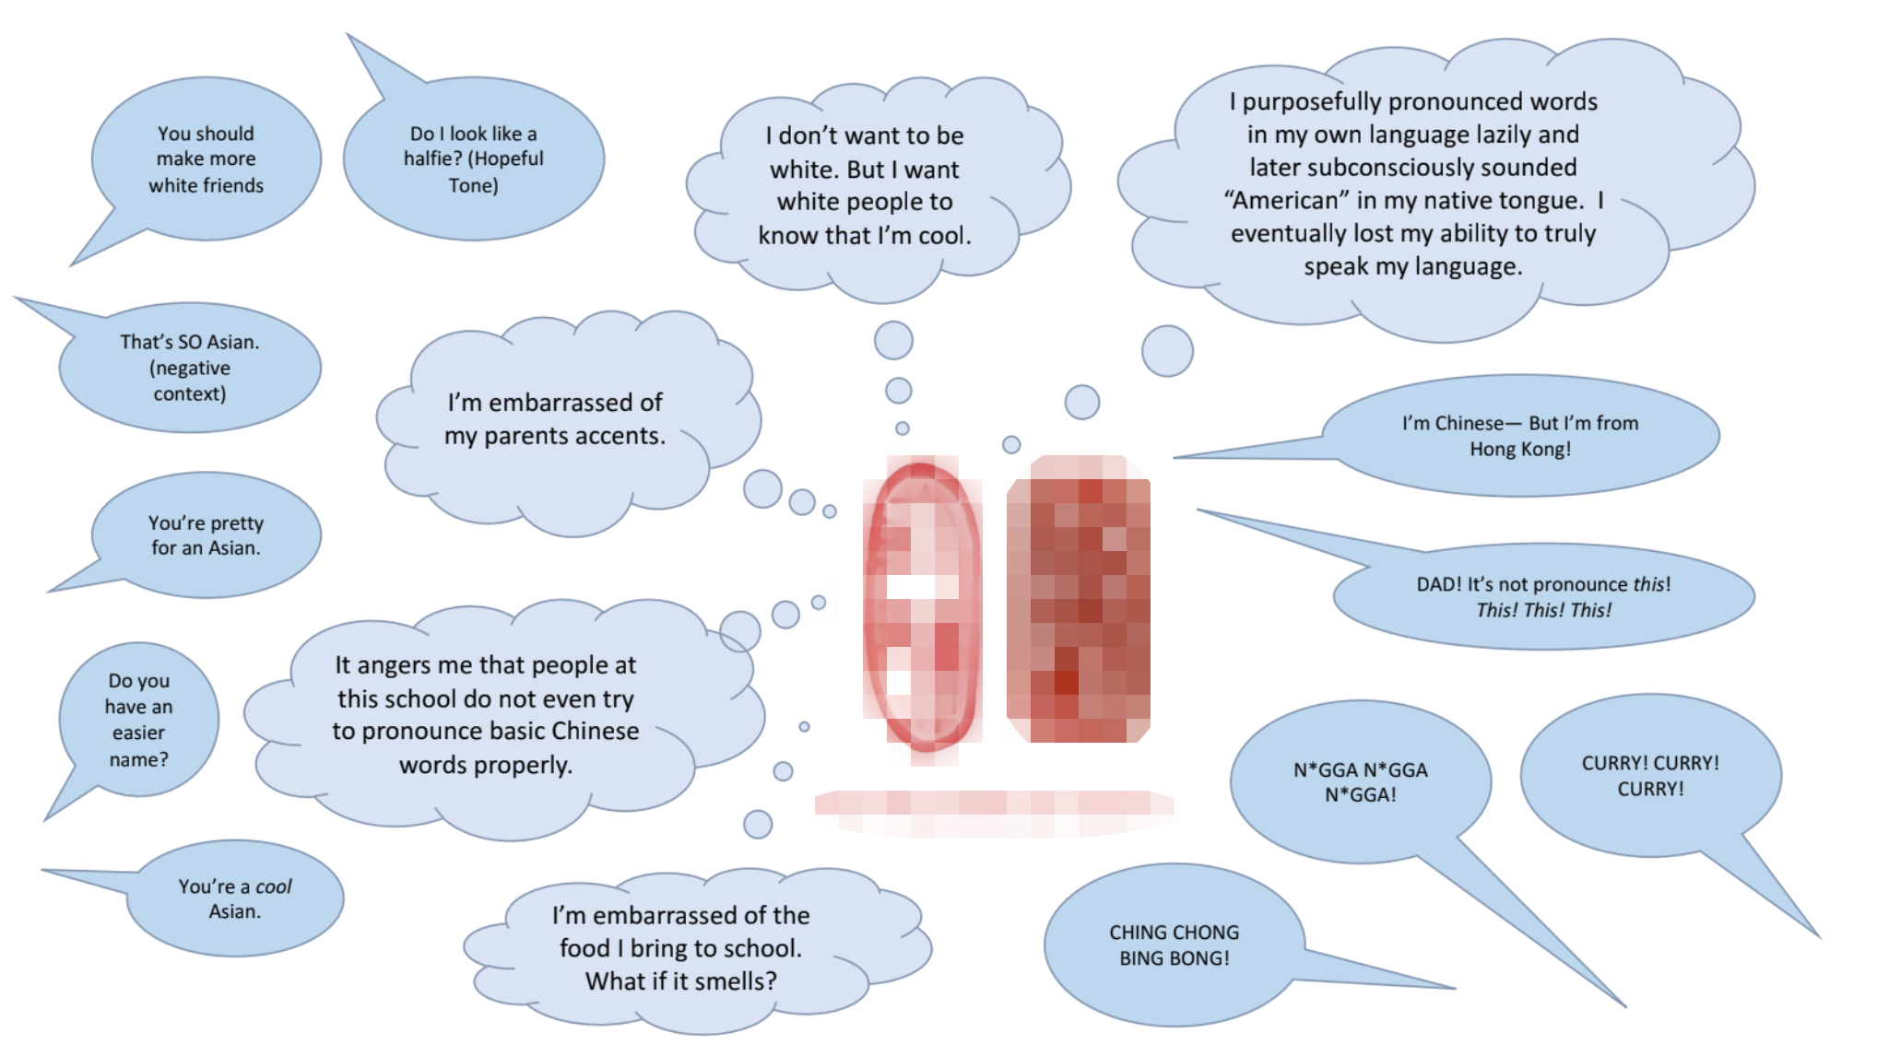
Wang’s submission “Things Said” (Image 1) clearly represents how they experience double-consciousness. At the center of the word map are two Chinese name seals that say their first and last name. Underneath the name seals Wang translates their name to english. Already Wang shows the pressure to translate their Asian identity for an outside viewer, presumably Western, to understand. The name seals are surrounded by an inner circle of thought bubbles which are then engulfed by an outer layer of dialogue bubbles directed towards the name seals. This layout demonstrates their feeling of “two-ness” as between their individual dialogue inseparable from their Chinese identity, and the external forces that interact with them.
All participants were strongly aware of how the white gaze viewed them, and, more importantly, they lived with this uncomfortable awareness. For example, The speech bubbles in participant Wang’s wordmap contain racist messages like “CHING CHONG BING BONG!”, “N*GGA! N*GGA! N*GGA!” and “CURRY! CURRY! CURRY!” that their White peers and Asian peers commonly used in their AIS. Backhanded compliments such as “You’re pretty for an Asian” and “you’re a cool Asian” are directed towards the individual. Wang writes that they were told they “should make more asian friends”. Asian peers asked “Do I look like a halfie?” in hopes that “white people would respond more eagerly”. Because these bubbles illustrate how the individual believes they were perceived by and compared to white peers double-consciousness was identified.

Image 2. “World Map”
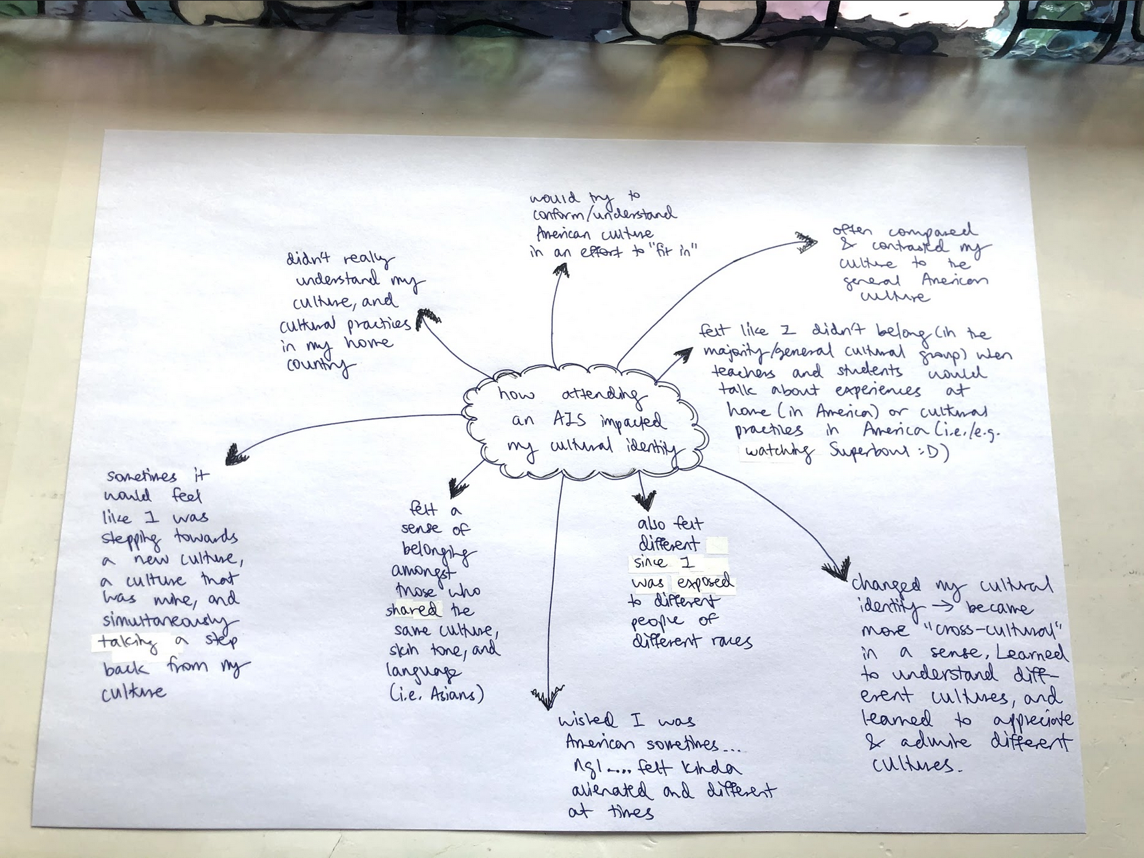
Similarly, Li’s submission titled “World map” (Appendix F) describes the way they “often compared & contrasted my culture to the general American culture.” Despite the population of AIS students being Asian, words such as “majority” or “general cultural group” suggests that the participant felt that whiteness was the standard. Li observes a pervasive “segregation” between those “from an Asian background and those from a ‘white background.’” This participant felt alienated from the dominant culture because they lacked the knowledge of “experiences at home (in America) or cultural practices in America (i.e. / e.g. watching Superbowl :D).” The exclusion from these conversions were a disadvantage as faculty were “more likely to engage in conversations with caucasians than with Asians, and would also show unfair treatment to Asians.”

Image 3. “两角形”
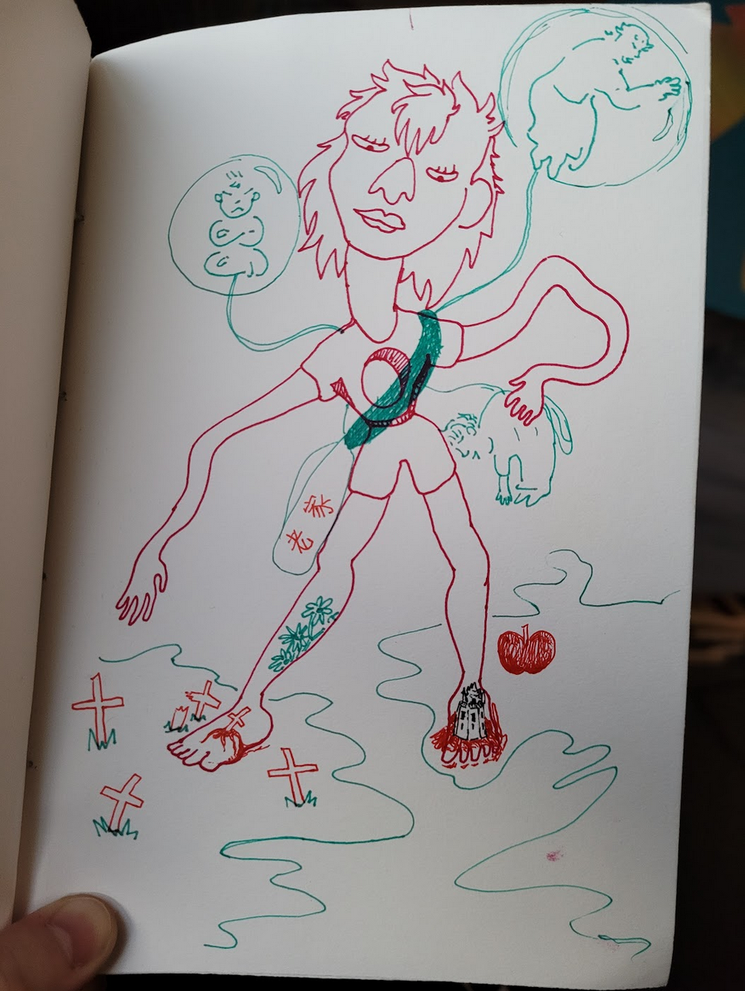
Zhang directly connects their experience to this code in the quote: “my childhood was lived in a particular dissociative fugue, much akin to James Baldwin's concept of double-consciousness but experienced as a living dream.” Zhang also writes of the “‘us’ versus ‘them’” dynamic. Due to their race, Zhang understands that they were “always going to be in the ‘them category’.” Immediately, Zhang’s portrait communicates the two-ness of their identity. The title “两角形” (Image 3) translates to “Two Angled Being.” The biggest central figure is drawn in red and is surrounded by three more figures depicted in green suspended in orbs. The central figure seems unsteady, with their oversized head tilted over a crooked body and flailing its long arms. The green figures are connected by cords to the red figure as if they are pulling the red figure in three different directions. Widely used in and associated with China, the depiction of self in red suggests the participant feels they will always be viewed through their Asianness. Their race thus becomes the center from which all other aspects of their identities are understood, such as “lesbian” and “a gender-nonconforming person.”
Image 4. “Untitled”
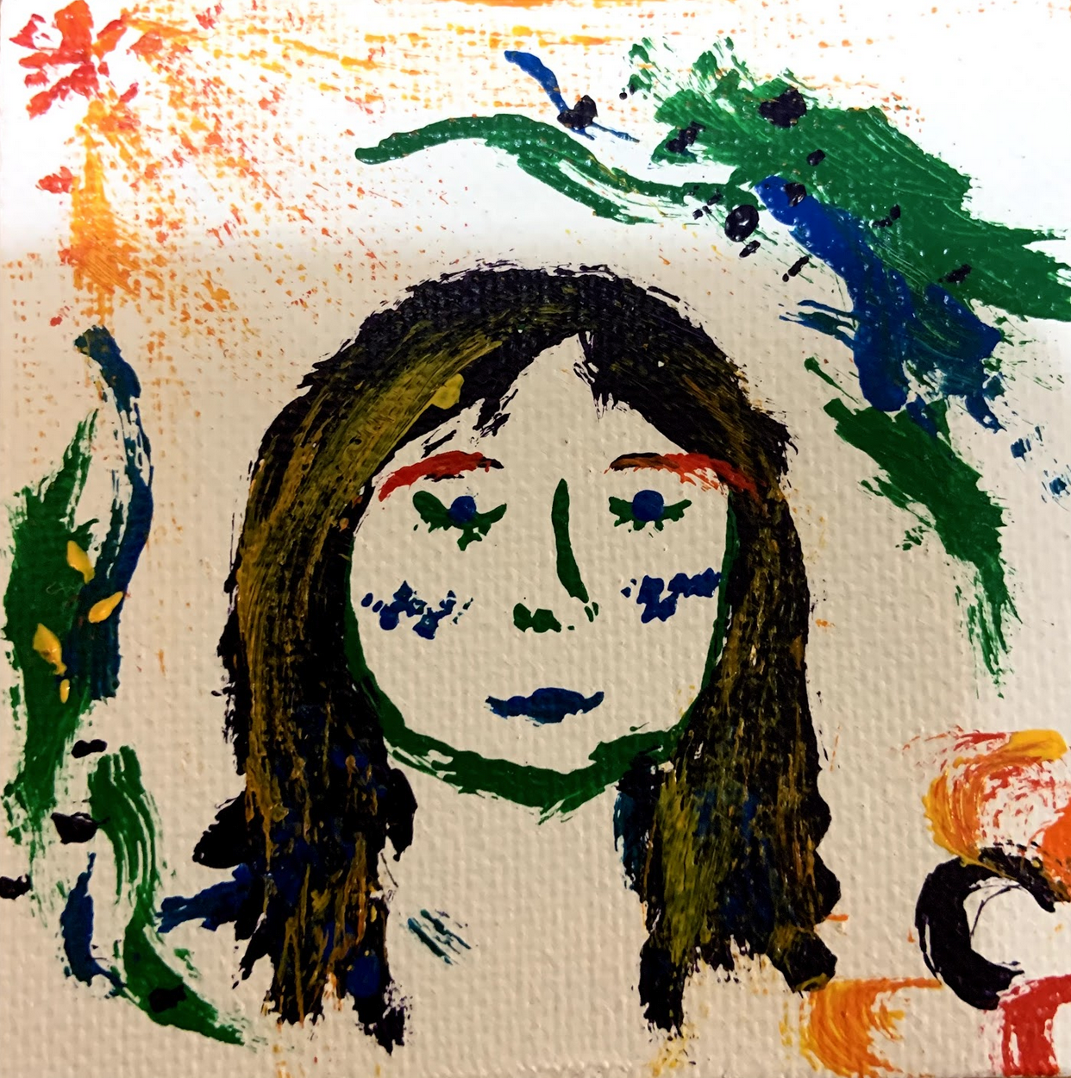
Liu’s experience in an AIS is relatively different from other individuals. Having grown up in the U.S., it was in America that Liu felt most aware of how they “stood out.” However Liu is still critical of the racial hierarchy in an AIS, writing that “so many interactions and social perceptions were still dependent on whiteness and proximity to whiteness.” Unlike the other three participants, Liu does not explicitly describe themself under the white gaze, suggesting that Liu was more accustomed to this feeling of being a racial and cultural minority. Liu’s self portrait provides a clearer understanding of how they experienced double-consciousness. Liu’s portrait “Untitled” (Image 4) is surrounded by contrasting swatches of color. In the upper right and lower left corner dark green and blue are layered heavily underneath scattered dots of black and and green. These are contrasted with swirls of yellow and red in the opposite corners emanating like sunbeams from the left and bubbles in the right. These dark cool colors symbolize Liu’s described feelings of “insecurity” under the white gaze, while the bright warm symbolize how they begin to feel more “comfortable” in their Asian identity. In this way, Liu is still surrounded by two opposing, unreconciled forces that simultaneously exist outside of the self while projected upon the individual.

Disconnection
Disconnection from a student's Chinese identity is the second thematic code that ran through every submission. Disconnection was codified whenever participants mentioned losing linguistic abilities, cultural knowledge, or devalued certain cultural symbols such as food. Feelings such as insecurity, anger, rejection, and sadness were also considered indicators of disconnection. This theme was identified in portraits when they depict a fragmented individual through contrast and imagery pulling away from the central representation of self.
Wang experienced disconnection to multiple aspects of their identity while attending the AIS for 12 years and after graduating in 2017. She writes: “I was made increasingly aware by my peers and teachers that being Chinese was a bad or dirty thing and that to be liked or perceived as ‘good’, I needed to be ‘less Chinese’” In their word map, Wang highlights the feeling of embarrassment about her parents' accents and their food.
Wang’s embarrassment turned into a rejection of their culture. She described how they “pronounced words in my own language lazily and later subconsciously sounded ‘American’ in my native tongue. Wang’s embarrassment also turned into anger at her parents as they would “constantly correct their English… I thought I was better or smarter than them because of the way I laid my tongue and shaped my lips when speaking.” On reflection, Wang mourned some of the long-term effects of rejecting her culture as they “eventually lost my ability to truly speak my language.” Wang’s portrait illustrates how disconnection was experienced between internal thought and external action. In a sea of thought bubbles, only two speech bubbles stem from her name seals. While the thought bubbles mostly convey feelings of insecurity, Wang’s speech bubbles only convey anger and defiance as she corrects her father and tries to “distinguish” herself from being Chinese.
A 2018 high school graduate, Li attended the AIS for 10 years and also reported losing an understanding of her culture such as cultural practices. Li attributed this to her attempts to “fit in” with American culture by doing things such as consuming American media. Li described the sacrifice of “stepping towards a new culture, a culture that was mine, and simultaneously taking a step back from my culture”. It is clear that Li felt this disconnection very strongly and wrote that their AIS experience ultimately “tarnished my relationship with my home culture.”
Zhang’s portrait and written answers communicate a strong sense of grief. They attended AIS for 4 years in Hong Kong and 8 years in Shanghai, graduating high school in 2017. The central character’s downcasted gaze and unsmiling mouth reflects their mourning: “I grieved for the connection to my own culture that I had given up to experience this liminal space of being a hyphenated citizen.” The central figure’s feet straddle two continents. The left is punctured by a crucifix and the right is punctured by a tower. The significance of the crucifix is elaborated on in writing: “I feel very attached to postcolonial narratives of missionary children and their uneasy existence of the edges of both cultures, colonizer and colonized.” Both wounds flow with blood, illustrating how intensely and physically this pain was felt. The “years of pouring over AP exams and writing complicated, jargon-filled think pieces that essentially amount to convincing white people that racism exists” came at the price of disconnection. Zhang wrote, “ I feel disconnected from my family, race, ethnicity, land, and history.” They “grieved for the connection to my own culture that I had given up to experience this liminal space of being a hyphenated citizen” as symbolized by the gaping hole in their chest.
Liu only attended the AIS for two years and returned to the US for senior year in 2017. Liu reports disconnection to her cultural identity as experienced most strongly while living in the U.S., writing that she “projected my insecurities and anger towards my home culture.” Unlike the others, Liu did not explicitly report disconnection with her cultural identity while attending an AIS. Yet amongst the bubbling yellow and red representing her reconnection to Chinese identity lies one dark bubble, suggesting that disconnection was continually experienced as feelings of insecurity were never completely resolved.

Reconnection
The third theme found across all datasets was the theme of reconnection. Data was codified whenever participants wrote about re-establishing a sense of pride, increased confidence, and comfort in their cultural identity. The acceptance of cross-cultural labels was also considered reconnection. Reconnection was identified in visual data when portraits contained symbols that referenced their Chinese identity.
The centrality of Wang’s name seals indicates that she has reclaimed aspects of her cultural identity. Previously “made fun of by peers and teachers for my anglicised Cantonese name,” Wang chose to use her name seal as the central depiction of self. Wang felt empowered by educating themselves and seeing media representation: “Social media gave me vocabulary to talk about racism, it gave me POC role models and also showed me truer reflection of history that did not cater solely to the white ego. I did not truly embrace being Chinese until I went to college in the US, where social media continued to be a large influence in how I perceived my culture and people.” Wang was only able to reconnect with her culture after leaving highschool, suggesting how powerful the AIS was in suppressing her Chinese identity.
Similarly, Li highlights the role that social media played in reconnecting to her Chinese identity. Li “began to understand my cultural identity more and more, and began to consume forms of media from my own culture.” This process was “weird at first,” but she eventually “felt more empowered” and “understood my cultural identity a lot more...It felt good to observe my own culture being represented and admired by other cultures, and I became increasingly happy and proud of my cultural identity.” As Li reclaimed their Chinese identity she also settled into becoming “more cross-cultural.”
Zhang writes that their “proximity” to “the cruelty of whiteness...engendered disdain” and “tied me strongly to my race.” This quote provides another explanation as to why the central figure is depicted in red. Zhang is proud to be Chinese. The central figure wears a banner reading “老家” which translates to “old home” worn proudly for readers readers to see. This banner lays on top of the gap in their chest suggesting that this reconnection to Chinese identity is a way of soothing the emptiness.
Zhang portrays themself straddling two continents. Their left foot rests on what can be assumed to be China and their right foot on America. This is suggested by the drawing of an apple referring to New York City. Zhang writes that they: “definitely feel at odds with the dominant ‘Chinese-American’ identity....it's not technically inaccurate to say I am Chinese-American. Instead of a melded education of ‘both’ cultures or worlds or however people conceptualize it, I feel like I have really spotty and specific knowledge about each. In a way I don't feel like I am either.” Similar to Li, they have claimed a cross-cultural identity that occupies a third space.
Liu was able to actively experience this reconnection while attending the AIS that “functioned as a bridge to my home culture.” Liu reports relief and happiness as she “started to shed my misguided rage and reconnect with my home culture.” The beams and bubbles of yellow and red allude in the upper left corner illustrates this to this “development of my self-confidence” and a sense of “peace.”

Red and Green
This section will discuss the significance of the colors red and green. Three out of the four visual submissions used the color red, with two being dominated by the contrasting color scheme of red and green.
As previously mentioned, Wang’s name seals are depicted in red. In China, this color is considered auspicious and is popularly used, thus commonly associated with China. Universally, the color red evokes power, energy, confidence, desire, and is linked to primal desire for self-preservation (Bourn 2011). These culturally constructed color associations affirm that participants' use of red across all portraits becomes an informed artistic decision that proudly signifies their connection to their Chinese identity.
In color theory, red and green opposite colors that result in a sharp contrast when placed together (Decker 2017). Zhang and Liu’s portraits both utilize this color scheme to create duality. Zhang uses thin lines of bright red and green beside and on top of each other, almost giving the effect of an image with two layers. Wang and Zhang depict both depict their central self in red. In both portraits that use red and green color schemes, green exists outside of the centrally depicted self, while Liu separates red and green into opposite corners of her portrait. Understanding these colors as opposites provides insight into the significance of green. If red is established as participants' connection to their Chinese identity then green must stand as an external contrast to their Asian-ness. Universally, the color green is symbolic of growth and rebirth (Bourn 2011). Perhaps, the use of green symbolizes something participants feel they must reach for and grow into while the external has also grown into them.

DISCUSSION
Double-consciousness
The first code emerged from the data and the analysis of their significance applies W.E. Du Bois’s concept of double-consciousness. Originally used to describe the experience of Black people, this concept is defined as,
“ a peculiar sensation, this double-consciousness, this sense of always looking at one’s self through the eyes of others, of measuring one’s soul by the tape of a world that looks on in amused contempt and pity. One ever feels his two-ness, an American, a Negro; two souls, two thoughts, two unreconciled strivings; two warring ideals in one dark body, whose dogged strength alone keeps it from being torn asunder.” Despite this violence under the white gaze, one does not wish to fully assimilate but simply wishes “merge his double self into a better and truer self. In this merging he wishes neither of the older selves to be lost... without having the doors of opportunity closed roughly in his face” (Du Bois 1930: 2,3).
Since AIS have already been established as sites that create and maintain White supremacy, this concept can also be used to examine students' feelings of double-consciousness under the white gaze. Under the White gaze participant’s felt that their Chinese identity was a dirty thing to be avoided. Two participants report that their distance from American standards of beauty and lack of cultural knowledge became a source of insecurity. These negative external forces were internalized by two participants who felt pressured to conform. It is clear that participants took to looking at and measuring themselves to a world that considered them less.
All of the participants described an unspoken hierarchy in the AIS where white peers and faculty were at the top. Participants were aware that they would always be “other,” leaving them in an uncomfortable and unreconciled space of a dual-being.
Despite the pressures of their environment, participants never stated that they were dedicated to full assimilation, but simply as a wish that has since changed. Participants strongly recognized that acceptance into Whiteness depends on rejection of their Chinese identity. Every participant alluded to a “better and truer self” (Du Bois 1930: 3) that could only be embodied by being more comfortable in their cultural identity in this environment. All participants therefore undergo the emotional labor of reconciling their Chinese identity with the influence of AIS, in order to keep themselves “from being torn asunder” (Du Bois 1930: 3).
This theme commonly emerged in answer to the written question “How did you experience whiteness at an AIS?” Instead of speaking of the academic environment and Christian values, all participants described themselves outside of Whiteness. This is one major place at which the findings of this study differs from previous literature. Instead of highlighting how Whiteness is enacted through academic environments and value systems, this study revealed that participants experienced Whiteness mainly through social dynamics amongst peers. The difference in these findings can be attributed to the population of this study. Collecting data from AIS students who directly experienced these nuanced social dynamics thus provided unique information that differed from data collected through directors and policies (Gardner-McTaggart 2020).
This study contributes to how we conceptualize double-consciousness by reconsidering what it means to inhabit a White space. DuBois writes of double-consciousness as experienced in the US, while this study takes place in a country in which participants are the racial and cultural majority. This study illustrates how isolated institutions that maintain White supremacy can also produce the White gaze in spaces where individuals are still the majority. The psychological effects of double-consciousness and feelings characterizing their assimilation can be explained by the concept of Racial Melancholia as explored in the next section.
Racial Melancholia
The analysis of these four submissions also relies heavily on the concepts of Racial Melancholia as developed by David L. Eng and Shinhee Han. Described as a depathologized “structure of feeling” experienced across Asian Americans, it is one of the “psychic mechanisms by which racialized immigrant subjects process problems of discrimination, exclusion, loss, and grief” (Hung 2020). The melancholic are caught in a perpetual state of mourning as they are unable to resolve the loss of objects or ideas that assimilation causes. To the participants this loss is experienced in their linguistic abilities, cultural knowledge, sense of belonging, and weakened relationships. By focusing on the violence of assimilation racial melancholia becomes a useful lens to understand the feelings of AIS students.
Participants felt a deep seated emptiness that resulted in grief, isolation, frustration, and self hate — similar to the symptoms that Eng and Han (2019) have attributed to racial melancholia. Someone experiencing racial melancholia “identifies with this emptiness, and thus participates in his or her own self- denigration and ruination of self-esteem” (Eng and Han yr). In the present study, participants tried to reject their Chinese identity in response to embarrassment and insecurity, by consuming American media, making American friends, learning about American culture, and adhering to American standards of beauty. The disconnection from one’s Chinese identity would be understood by Eng and Han (2019: 672) as “a non-physical suicide - an attempt to erase aspects of ones identity.”
Eng and Han (2019) emphasize that this pain does not end. Even though Asian Americans can strive for the ideals of Whiteness, they will never be truly accepted into Whiteness. This is a painful truth that all participants recognize, with more than half participants attempt to assimilate nonetheless. Eng and Han (2019: 35) write that assimilation is thus perpetually suspended, leaving individuals in an irresolvable melancholic state, or a “a mourning without end.” Participants report this suspended state as reconnection remains a complicated ongoing process as they work towards reclaiming their identities or accepting a cross-cultural label.
This study reveals how racial melancholia can be used as a framework to understand assimilation outside of immigration. Understanding participant’s experience through the lens of racial melancholia becomes an important way to validate participants' experience as testimony to the violence of assimilation amongst institutions of White supremacy.

CONCLUSION
This study was used to understand how Chinese students experience Whiteness in an AIS and how this was internalized to affect their cultural identity. The data was collected directly from AIS students through submissions of visual self portraits and written interview questions. Both the method and population of this study yielded unique results that contribute to the literature on AIS, double-consciousness, and racial melancholia. Findings showed that students felt disconnected and worked to reject their Chinese identity under the White gaze. However, the findings also showed that students were also able to form a critique of Whiteness and work towards reconciling their cultural identity.
This study provides several points of intervention and brings awareness to the structure of complex, shared, and unending feelings deeply impacting AIS students. Although this study largely focuses on the feelings of disconnection that AIS produces, it is my intention to also emphasize the ability of participants to form a critique of Whiteness and reconnect with their Chinese identity. Eng and Han (2019: 65) reiterate this importance and say what must continue to be done:
“It is the naming of these losses that transforms difference into a politicized identity. Indeed, it is our refusal to view identities under social erasure as individual pathology or permanent damage lies in the reappropriation of melancholia, its refunctiong as the structure of everyday life. This appropriation annuls the multitude of losses an unforgiving social world historically enacts and enables”.

REFERENCES

Allan, Michael. 2002. “Cultural Borderlands.” Journal of Research in International Education 1(1):63–90.
Alberta Civil Liberties Research Centre. n.d. “Forms of Racism.” Retrieved February 17, 2021 (http://www.aclrc.com/forms-of-racism).
Armishaw, Holly Marie. n.d. “The Philosophy of Self-Portraiture in Contemporary Art - Essay.” HOLLY MARIE ARMISHAW - CONTEMPORARY ARTIST. Retrieved February 9, 2021 (http://www.hollyarmishaw.com/the-philosophy-of-self-portraiture-in-contemporary-art---essay.html).
Bagnoli, A. (2009). Beyond the standard interview: The use of graphic elicitation and arts-based methods. Qualitative Research, 9(5), 547-570. doi:10.1177/1468794109343625
Bourdieu, P. 1986. The Forms of Capital. Handbook of Theory and Research for the Sociology of Education.a NYC: Greenwood. 241-258.
Bourn, Jennifer . 2011. “Color Meaning: Meaning of The Color Green.” Retrieved April 1, 2020. (https://www.bourncreative.com/meaning-of-the-color-green/).
Bourn, Jennifer . 2011. “Color Meaning: Meaning of The Color Red.” Retrieved April 1, 2020. (https://www.bourncreative.com/meaning-of-the-color-red/).
Caffyn, Richard. 2010. “‘We Are in Transylvania, and Transylvania is Not England’: Location as a Significant Factor in International School Micropolitics.” Educational Management Administration & Leadership. 38(3) 321-340
Crozier, W. Ray and Paul Greenhalgh. 1988. “Self-Portraits as Presentations of Self.” Leonardo 21(1):29.
Curphey, Marianne. 2019. “Numbers of International Schools Continue to Rise: Festival of Global People: Relocate Magazine.” Festival of Global People | Relocate Magazine. Retrieved February 14, 2021 (https://www.relocatemagazine.com/articles/education-numbers-of-international-schools-continue-to-rise-curphey-0519).
Decker, Kris. 2017. “The Fundamentals of Understanding Color Theory.” Retrieved April 1. 2020. (https://99designs.com/blog/tips/the-7-step-guide-to-understanding-color-theory/).
Drake, Barry. 2004. “International Education and IB Programmes Worldwide Expansion and Potential Cultural Dissonance.” Journal of Research in International Education. 3(2) 189-205
Eng, D. L., & Han, S. (2000). A Dialogue on Racial Melancholia. Psychoanalytic Dialogues, 10(4), 667-700. doi:10.1080/10481881009348576
Engel, Rachel. 2020. “An Open Letter to the International School Community: Our Role in the Black Lives Matter Movement...” Medium. Retrieved February 14, 2021 (https://medium.com/@rachel.engel/an-open-letter-to-the-international-school-community-our-role-in-the-black-lives-matter-movement-c92ba725d93c).
Esteban-Guitart, M., Monreal-Bosch, P., Perera, S., & Bastiani, J. (2017). Schooling and Identity: A Qualitative Analysis of Self-Portrait Drawings of Young Indigenous People from Chiapas, Mexico. Frontiers in Psychology, 7. doi:10.3389/fpsyg.2016.02083
Gardner-McTaggart, Alexander Charles. 2020. “Washing the World in Whiteness; International Schools’ Policy.” Journal of Educational Administration and History 53(1):1–20.
Gardner-McTaggart. 2016. “International Elite, or Global Citizens? Equity, Distinction and Power: The International Baccalaureate and the Rise of the South”. Globalisation, Societies, and Education. 14(1) 1-29
Gardner-McTaggart. 2019. “International Schools’ Leadership and Christianity, Globalization, Societies and Education.” Globalisation, Societies, and Education. 17(4) 458-472
Gillborn, David. 2005. “Education Policy as an Act of White Supremacy: Whiteness, Critical Race Theory and Education Reform.” Journal of Education Policy. 20(4) 485-505
Gorichanaz, Tim. 2019. “Self-Portrait, Selfie, Self: Notes on Identity and Documentation in the Digital Age.” Information 10(10):297.
Heyward, Mark O. 2002. “From International to Intercultural: Redefining the International School for a Globalized World.” Journal of Research in International Education. 1(1) 9-32
Hung, Natalie C. 2020. “Review of Racial Melancholia, Racial Dissociation: On the Social and Psychic Lives of Asian Americans.” Psychoanalytic Psychology 37(4):350–53.
Mahfouz, Julia, Erica Sausner, and Mindy Kornhaber. 2018. “US International Schools Overseas and the Common Core.” International Journal of Leadership in Education 22(4):406–20.
Nagrath, Cynthia. 2011. “What Makes a School International?” The International Educator (TIE Online). Retrieved February 14, 2021 (https://www.tieonline.com/view_article.cfm?ArticleID=87).
National Museum of African American History and Culture. 2020. “Whiteness.” National Museum of African American History and Culture. Retrieved February 17, 2021 (https://nmaahc.si.edu/learn/talking-about-race/topics/whiteness).
Ng, Vinci. 2012. “The Decision to Send Local Children to International Schools in Hong Kong: Local Parents’ Perspectives.” Asia Pacific Educational Review. 13: 121-136
Poonoosamy, Mico. 2018. “Third culture kids’ sense of international mindedness: Case studies of students in two International Baccalaureate schools.” Journal of Research in International Education 17(3) 207-227
Teach Away. 2020. “International Schools.” Retrieved February 9, 2021 (https://www.teachaway.com/international-schools).
Wechsler, A. (2017, June 16). How Demand for a 'Western' Education Reshaped International Schools. Retrieved January 22, 2021, from https://www.theatlantic.com/education/archive/2017/06/the-international-school-surge/528792/
Wettewa, Virandi. 2016. “Postcolonial Emotionalism in Shaping Education: An Analysis of International School Choice in Sri Lanka.” The International Education Journal: Comparative Perspectives 15(1) 66-83
Wurf, Gerald C. 2018. “Culture and Personality in International Schools: Are Trait Differences in Students’ Personalities Attenuated or Amplified?” Intercultural Education 29(3):418–33.

APPENDIX

Appendix A. Interview Protocol

The qualitative written questions were used to have the participant elaborate upon their self-portrait. The first survey question asks participants to verbally describe their cultural identity that they are asked to visually portray in their self portrait. The rest of the survey questions focus on answering the first part of the research question: How do students experience whiteness while attending an AIS? These three questions continue to ask of the participants self-perception while grounding these feelings in specific observations and personal narratives. The third survey question asks: How did you experience whiteness at an AIS?. Participants are asked directly to think specifically about how they would define and recognize whiteness retrospectively. The second question reads: “What has the process of understanding your cultural identity been like?” In this question I hope to understand participants' internal conflict and critiques. This leads into the fourth question: Please provide an anecdote of how attending an AIS impacted your relationship with your home culture. This question builds on the second by asking participants to reflect on the points of tension participants may have experienced externally while interacting with their culture.

Appendix B. Participation Guidelines

Lora Yip
Dr. Figueroa
Colorado College Department of Sociology
719-323-8563
l_yip@coloradocollege.edu

Thank you for taking interest in this research project! This study explores how attending US International Schools in East Asia affected students' cultural identity. To participate in this study, I am asking you to submit a self portrait reflecting on your cultural identity as well as answer four open-ended questions. Please feel free to email me (l_yip@coloradocollege.edu) if you have any questions or comments.

In order to participate:
- You must be 18 years or older
- Have attended an American International School in East Asia
- Submit a self-portrait (20-30 minutes)
- Answer four written survey questions (10-15 minuets)

Your self-portrait will provide a visual representation of how attending an American International School has impacted your cultural identity. You can use any medium such as: collage, drawing, painting or photography. You will be asked to upload your self-portrait in the form below in png, jpg, pdf format.

In addition, you will be asked to answer the following questions:

- How would you describe your cultural identity?
- What has the process of understanding your cultural identity been like?
- How did you experience whiteness at an AIS?
- Please provide an anecdote of how attending an AIS impacted your relationship with your home culture.

The goal of this research study is to write a thesis that will be shared with the department of Sociology of Colorado College. Your participation is voluntary, and with your consent your
self-portrait will be made public for viewing online anonymously or under the given pseudonym.

Submission are due by January 8th at 12pm MST through the forms below:

- Survey / Submission form: *Acceptable file formats: png, jpg, pdf* https://docs.google.com/forms/d/1gYQ9tAmNMQL7v-Yq6pZBTebfDeipuGXSOdq-qf0GqBc/edit

- If you are trying to upload a file larger than 1 GB please upload your file(s) to this google drive: https://drive.google.com/drive/folders/1eLXdlUTiWmvhKsq8YJSzJ2CFlD3NdE8j?usp=sharing

Appendix C. Recruitment Email

Hi international students! Hope this message finds you well.

My name is Lora Yip and I am a senior from Shanghai, China. I am looking for individuals (18+ years) who have attended American international schools in East Asia to reflect on how this experience has affected their cultural identity for my thesis.

Participants would be required to create and submit a visual self portrait in response to a prompt and answer 4 written survey questions by January 30th. Mediums such as drawing, collage, or photography are welcome. The self portrait should take around 20-30 minuets and the survey portion should also take around 10-15 minuets. Feel free to go under or over these given time estimates. You can find more information about the project and the submission guidelines here: https://docs.google.com/document/d/15rWe-96rzAoQ72_fKxRxQz3dSLYqlYxtGEaEgzpGx30/edit?usp=sharing Please note that participation in this study is completely voluntary. Your self-portrait and survey responses will be submitted anonymously or under a pseudonym, and all other identifying information will be kept private. Only with your permission will your self-portrait be made public for viewing online.

I truly hope that this is an enjoyable and meaningful process for you, and I am confident that receiving your work will be deeply invaluable to me.

If you would like to know more about this project or ask questions, you can email me at l_yip@coloradocollege.edu. Please share my message with friends who might be interested (not limited to CC students), thank you for your time and help!

Be well,
Lora Yip

Appendix D. Recruitment Flyers
