DECIPHERING EXECUTIVE COMPENSATION: EXPLORING PATTERNS, DISPARITIES, AND ECONOMIC FORCES

A THESIS
Presented to
The Faculty of the Department of Economics and Business
The Colorado College

In Partial Fulfillment of the Requirements for the Degree
Bachelor of Arts

By
Kalyanne Neel
May 2024

DECIPHERING EXECUTIVE COMPENSATION: EXPLORING PATTERNS, DISPARITIES, AND ECONOMIC FORCES
Kalyanne Neel

May 2024

Mathematical Economics Major

Abstract

Executive compensation is more than just a means of retaining talent; it embodies signals of success, equity, and disparity, igniting discussions on workplace fairness and inclusivity. This thesis explores the complexities of executive compensation, utilizing publicly available filings with the Securities and Exchange Commission (SEC). Drawing parallels between the persistent gender wage gap and executive compensation intricacies emphasizes the need for deeper inspection within corporate hierarchies. Through analyzing data from Vice Presidents (VPs), Chief Financial Officers (CFOs), and Chief Executive Officers (CEOs), this study uncovers significant associations between compensation, executive background, and economic disturbances. Key empirical findings demonstrate that gender and age sensitivity vary across positions, with VPs demonstrating a greater gender significance than CFOs and CEOs, and VPs and CFOs demonstrating greater age sensitivity. Years with the company was significant across all positions. The Housing Market Crash influenced compensation dynamics across all levels of the corporate hierarchy. Conversely, the post-Market Crash/pre-COVID period presents challenges only for CFOs and CEOs due to lingering economic uncertainty. Lastly, the COVID-19 pandemic period shows minimal impact on executive compensation.

KEYWORDS: (Executive Compensation, Wage Gap, Economic Disturbances, Fair Pay)

ON MY HONOR, I HAVE NEITHER GIVEN NOR RECEIVED
UNAUTHORIZED AID ON THIS THESIS

Signature

ACKNOWLEDGEMENT

I would like to thank my wonderful academic and thesis advisor, Esther Redmount, for her unwavering guidance, encouragement, and support throughout the journey of completing this thesis and my academic career in the economics department. Her patience and knowledge have been vital in shaping my research and goals for this paper. I am truly fortunate to have a mentor who consistently challenged and believed in me to reach new heights. Thank you, Esther Redmount, for inspiring me to strive for excellence.

TABLE OF CONTENTS

ABSTRACT
ACKNOWLEDGEMENTS

1 INTRODUCTION………………………………………………………….. 6

2 LITERATURE REVIEW……………………………………………………. 8

3 THEORY……………………………………………………………………. 19
3.1 Managerial Talents................................................................................... 19
3.2 Incentives.................................................................................................. 20
3.3 Performance-Based pay............................................................................ 21

4 DATA & METHODOLOGY………………………………………………... 22
4.1 Data Overview.......................................................................................... 22
4.2 Representation of Gender in Data ............................................................ 24
4.3 Model …………........................................................................................ 25
4.4 Summary Statistics.................................................................................... 26

5 RESULTS & ANALYSIS……………………………………………………. 29
5.1 Regression Outputs..................................................................................... 29
2.2 Model Disadvantages.................................................................................. 30
2.3 Summary of Results.................................................................................... 31
2.4 Analysis of Results...................................................................................... 32

6 CONCLUSION………………………………………………………………. 36
7 REFERENCES………………………………………………………………… 39
8. APPENDIX…………………………………………………………………... 41

Introduction

In the modern corporate landscape, executive pay has evolved past its fundamental means of retaining top talent and incentivizing great work within a corporation. Executive pay has developed into a signal of both success and disparity, becoming a focal point in discussions of fairness, equity, and inclusivity within the workplace. All executive compensation information can be accessed in public filings with the Securities and Exchange Commission (SEC). However, beneath the surface of the reported figures lies a complex web of considerations and potential biases among each executive. Inequities represent a deep-rooted societal issue across industries, shaping corporate culture in a system that may impact economic stability. Revealing and understanding these disparities is critical for correcting the inherent injustice and establishing an economy of genuine equality even within the highest rankings of organizational leadership.
The gender wage disparity has been thoroughly explored and confirmed for numerous decades, yet it persists as an area of active and dynamic research. The pay gap has remained relatively stable in the U.S. over the past 20 years. In 2022, women earned an average of 82% of what men earned. These results are similar to the pay gap in 2002 when women earned 80% as much as men. Despite this extensive examination, the persistence of the gender wage disparity emphasizes the issue's complexity. The multifaceted nature of this disparity, shaped by socio-cultural dynamics, organizational structures, and systemic biases, presents an ever-evolving opportunity for research and correction. As society progresses, emerging factors, such as the intersectionality of gender with age, ethnicity, or occupational roles, continuously shape and redefine this disparity. Therefore, while the groundwork has been laid through decades of inquiry, the ongoing and dynamic research in unraveling the intricate layers of this issue remains indispensable.
Drawing parallels between the persistent gender wage gap and the intricacy of executive compensation reveals a potential need for deeper inspection within corporate hierarchies. The gender pay gap is one of the leading factors of biases in executive compensation. Similar to how the gender wage gap proves to be an enduring challenge that requires ongoing research, the complexities of executive compensation show similar dynamics and discrimination specific to a niche realm of the professional sphere. Overall, C-suite executives (those who run an organization) pay at S&P companies rose 24 percent from 2012 to 2020. Men have taken home most of those gains, with a 27 percent increase in pay versus a 10 percent increase for women. During the 2020 pandemic, C-suite women earned 75 percent of what their male counterparts took home, down from the 2018 high of 88 percent. While SEC filings offer a surface-level view of executive compensation, these values' underlying intricacies and potential biases reflect societal inequalities.
By analyzing the complexities of executive compensation, this paper seeks to explore discrimination at the highest corporate level, considering gender, age, and time invested with the company. This discrimination and other pay patterns will be analyzed among Vice Presidents, CFOs, and CEOs, representing various positions of power and responsibility in the corporate world. Along with pay discrimination, this paper considers the effects major economic events have on an executive's pay among different levels of the corporate hierarchy.
This study is organized as follows: The subsequent section gathers and examines pertinent literature. Following the literature review is an overview of the theory and methodology, which includes the model, data, limitations, and hypothesis. Details of the analysis and results are then explored. Lastly, the paper concludes with a summary of the results and conclusion.
Literature Review
The literature examined in this chapter includes articles, research papers, and case
studies relevant to supporting the exploration of the intricacies of executive compensation.
Gender Wage Gap
In the realm of economic and social injustices, few topics have gathered as much attention and controversy as the gender wage gap. Prior research has shown that women in the U.S. earn less than their male counterparts and face challenges in advancing their careers. In 2021, women were paid 82 cents for every dollar men earned. This gender pay gap is more prevalent among positions of greater authority; full-time female managers earn an estimated "77 cents for every dollar earned by full-time male managers.” This underpaid trend continues to hold despite the fact that, over the last decades, millions of women have joined the workforce and made considerable gains in their educational attainment, actively reversing the education gap and significantly reducing the experience gap.
It is noted that the topic of the gender wage gap is controversial and, at times, disapproved of. Many claim the wage gap is not solid evidence of economic discrimination against women because it is unadjusted for characteristics outside of gender that can affect earnings (i.e., years of education, work experience, and location). Many skeptics argue that the gender wage gap is driven not by discrimination but rather by voluntary choices—specifically, the choice of occupation in which they work (occupation and industry account for roughly half of the overall gender wage gap). However, Gender pay gaps within occupations persist, even after accounting for education, hours worked, and years of experience. Within the past 20 years, trends have shown a steady decrease in the pay gap. However, when looking at the gender gap among various wage percentiles, the gap between men's and women's pay decreased the least for those earning higher wages than those in the other pay scales. By 2010, the difference in pay was considerably more pronounced among higher earners.
This gender wage gap also appears on different levels depending on the state. As of 2023, Utah led the states with the most significant gender wage gap, with women only earning 60 cents to every dollar their male counterparts earned. Vermont, which has the smallest gender wage gap, has female workers making 85 cents to every dollar their male counterparts earn. Legislation and policies, each regional economy, labor market conditions, education, workforce composition, and many more can explain these regional differences. On average, women employed in the United States lose over $1.6 trillion yearly due to the wage gap. Women, their families, businesses, and the economy suffer.
Women typically begin their careers closer to equal wages with men, but they lose ground as they age and progress through their work lives, a pattern that has remained consistent over time. One of the main reasons for this increasing gap is parenthood. Mothers in their mid-twenties to mid-forties are less likely to be in the labor force than their female counterparts of the same age who do not have children at home. Mothers also tend to work fewer hours each week when employed, which can reduce their earnings. Fathers, however, show the opposite pattern. Fathers are more likely to be in the labor force and work more weekly hours than men without children at home. This is linked to an increase in fathers' pay, frequently known as the "fatherhood wage premium."
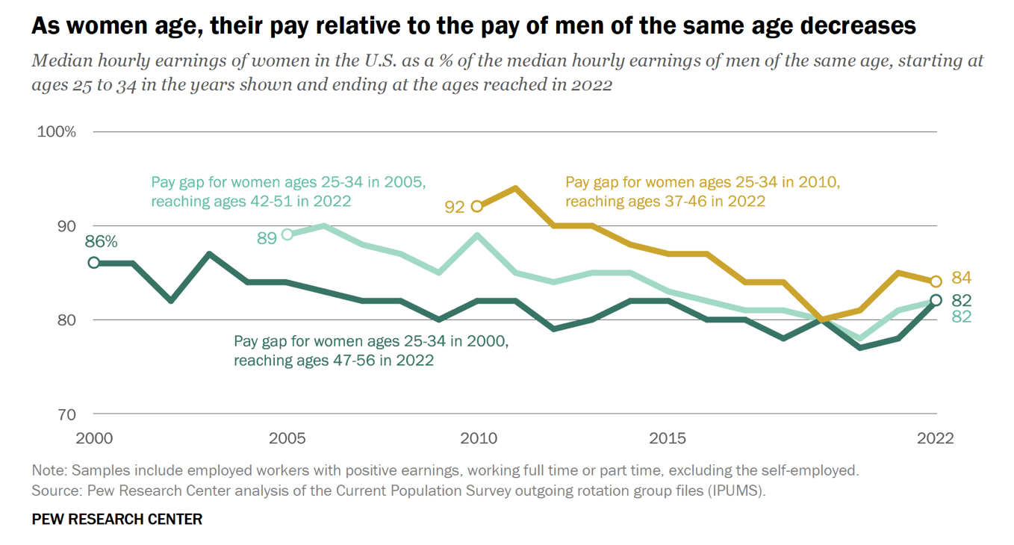
Source: Pew Research (2023)
In addition to age and motherhood, there is an emphasis on the systemic roots of the wage gap from educational attainment. While educational attainment is a critical factor influencing career earnings, data shows that women cannot educate themselves out of the gender wage gap. The pay gap persists even though women today are more likely than men to have graduated from college. The pay gap between college-educated women and men is similar to that between women and men who do not have a college degree. Men earn more than women across all education levels. Recognizing that educational attainment alone cannot eliminate this disparity emphasizes the need for holistic accountability and interventions to achieve genuine pay equity and ensure fairness for all individuals in the workforce.
While educational attainment does not ease the existence of the gender wage gap, the introduction of various ethnicities exacerbates the issue. Women of every race and ethnicity make less than their male counterparts. Of these women, Black and Hispanic women experience the most significant pay gaps. In 2016, relative to a White man, a White woman took home $4.00 less per hour, Black women took home $7.31 less per hour, Hispanic women took home $8.91 less per hour, and Asian women took home $2.15 less per hour. Foreign-born women are also widely disadvantaged. Native-born workers of either gender are paid more per hour than (non-naturalized) foreign-born workers. However, non-naturalized foreign-born women—like their native-born counterparts—experience a wage gap that further reduces their earnings.
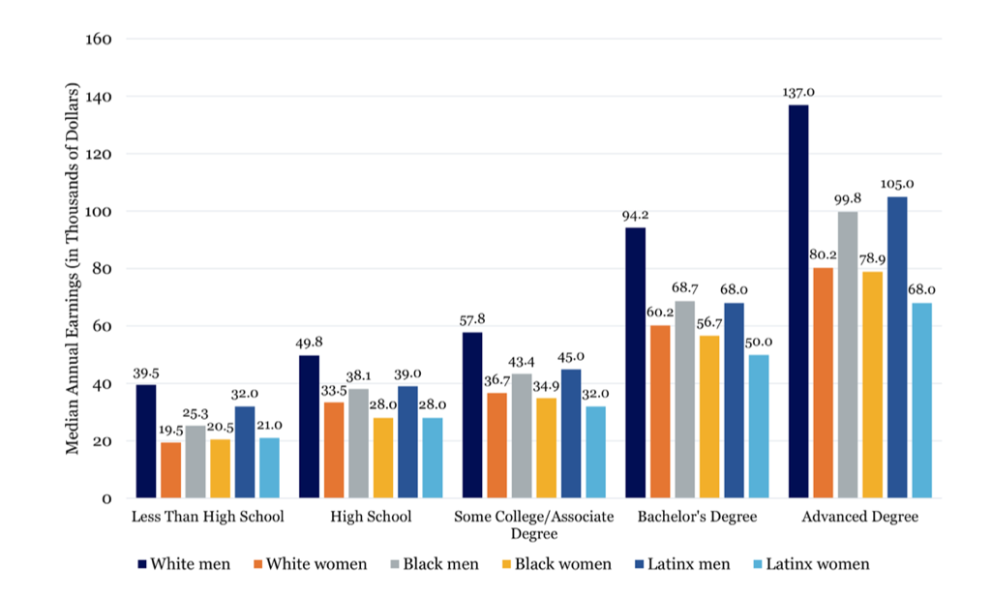
Source: Syracuse University
Overall, White adults typically have higher annual earnings than Black and Latinx adults at all education levels. Notably, Black and Latinx adults must obtain at least one additional degree to earn as much as White adults at the next lowest level of education. Similarly, across all racial/ethnic groups, women must obtain at least one additional degree to earn as much as men with less education. For example, White women with an advanced degree earn more than White men with some college education but less than men with bachelor’s degrees. In contrast, Latinx women would need two additional degrees to earn as much as Latinx men with lower levels of education. Generally, the gender pay gap increases with higher educational attainment regardless of race/ethnicity. However, the extent of this gender pay gap varies substantially across different racial/ethnic groups.
Gender Pay Gap Explanation
By 2010, the female shortfalls in wages were more prominent for the highly skilled and the higher earners than for others, suggesting that developments in the labor market for executives and highly skilled workers especially favored men. Exploration of the gender wage gap and overwhelming data supporting its existence necessitates defining what has made this disparity. The traditional explanations are still accepted in understanding the gender wage gap and changes in the gap. However, the importance of these factors has continuously shifted, and new explanations have arisen.
While traditional human capital factors (education and experience) once played an important role in narrowing the gender wage gap, these factors, taken together, explain relatively little of the wage gap now that women exceed men in educational attainment and have significantly reduced the gender experience gap. Outside of this outdated explanation, gender differences in skills and location in the labor market (industry/occupation/firm) remain highly relevant. Women’s workforce interruptions and shorter hours remain significant in highly skilled occupations, possibly due to compensation differences.
Another essential cause highlighted in traditional analyses is the gender division of labor and differences in gender roles. Current research continues to find evidence of a motherhood penalty for women and a marriage premium for men, and research based on experimental evidence strongly suggests that discrimination cannot be discounted. Psychological attributes or noncognitive skills are one of the newer explanations for gender differences in outcomes. While these factors account for a portion of the existing gap, it is difficult to explore these physiological gender differences, and further research is necessary.
While many potential variables discussed above can contribute to the gender wage gap, its existence remains undeniable. This disparity not only reflects systemic inequalities but is a massive barrier to women’s ability to participate in the economy equally and fully. Outside of apparent financial limitations, the gender pay gap limits women’s access to resources, opportunities, and career advancement, creating issues with job security, financial security, and economic empowerment.

Lack of Women within Leadership Positions
Within the last decade, the concern and consideration for biases in executives has boomed. These studies have emphasized the complexity and uncertainty behind the issue and produced conflicting conclusions. Historically, women have experienced what is known as a leadership gap. Despite being a majority of the U.S. population, women considerably lag behind their male counterparts regarding their representation in leadership positions. While the growth of women in leadership positions has steadily been increasing, equality has yet to be reached. “The share of women CEOs of Fortune 500 companies reached an all-time high of 10.6% in 2023, with 53 women heading major firms. The share of women sitting on the boards of Fortune 500 companies has gradually increased from 9.6% in 1995 to 30.4% in 2022.” While this progress is significant, it has not been sufficient progress. There have long been significant racial and ethnic differences in the rate of women’s advancement. This has roots in many factors, including discriminatory governmental policies, generational wealth transfers, and the racial wage gap, which is fueled in large part by occupational segregation.
The lack of women in leadership positions holds immeasurable economic and social significance beyond the representation imbalance. Without the female population holding these roles, organizations lose potential leadership diversity benefits, role model/mentorship relationships for other aspiring employees, and overall long-term organizational health. Companies with more diverse leadership, even gender alone, tend to be more successful and resilient, while those lacking are more prone to turnover and company disapproval among employees. Economically, this lack of representation threatens market responsiveness (with women being a large part of consumer decision-makers), causes loss of productivity and innovation, and perpetuates the gender wage gap.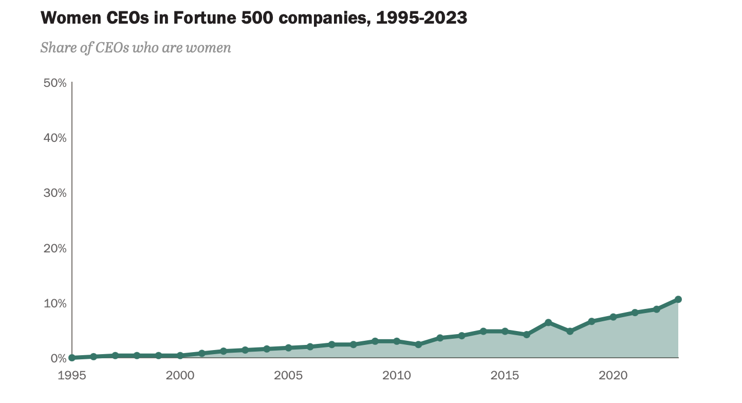
Source: Pew Research
Volatility of Pay Certainty
The structure of CEO compensation introduces a layer of complexity beyond the conventional wage gap analysis. Total compensation can be defined by two main components: cash, which is fixed and specific, and equity, which varies and is often linked to performance. This composition reveals significant disparities faced by women: gender biases in reservation wages and bargaining dynamics contribute to women's disadvantage in the CEO labor market.
Female CEOs typically receive a lower proportion of their total compensation in cash, particularly in contexts where CEOs negotiate their pay terms, such as in the U.S. This difference aligns with research indicating gender-related disparities in bargaining power and compensation expectations, with women often having lower reservation wages—thus entering negotiations with lower wage anchors (lowest salary that an individual may be willing to accept). This trend likely stems from women CEOs having fewer alternative opportunities to their male counterparts and negotiating with predominantly male boards. This situation coined the term “sticky floors” and suggests that females negotiate from a disadvantaged position, with their reservation wage seemingly "stuck" at lower levels accepted for CEO roles.
Furthermore, the strength of the company's negotiation tactics influences the composition of the CEO's compensation package. In cases where negotiation power is weaker, as may be the case for women CEOs, the proportion of cash-based salary tends to be lower. A more gender-diverse board correlates with a higher proportion of fixed compensation than bonus compensation for women CEOs. This finding reinforces existing research indicating that increased board gender diversity positively impacts the compensation of women executives.
Female friendly culture
Over the last quarter century, the female share of top business executives averaged 6%. Women who work in these executive professions earn 8% less than otherwise similar male colleagues in the same positions. There is evidence that the female executives’ share is higher at firms with more temporal flexibility and firms with a more female-friendly culture. While there is evidence that women chose to work for firms with these amenities, this does not lead to a gender pay gap. Notably, when looking at compensation differences within firms, female-friendly firms display a smaller gender pay gap, indicating that corporate culture is critical for equity.
Female executives possess distinct and different backgrounds and experiences compared to their male counterparts. Despite this, women tend to demonstrate greater sensitivity to pay-for-performance, given their rank, background, and experience. Women are promoted more quickly internally; however, women display similar rates of external promotion to men and have comparable demotion rates. Due to their accelerated promotion at higher hierarchical levels, female executives accrue less job experience than males. Additionally, female executives show a higher exit rate, with the possibility of a female executive rising to CEO being less than half that of their male counterparts at any given age. Similarly, male executives' survival rate doubles that of females. Despite earning lower average career compensation than male counterparts, female executives surpass males when accounting for comparable initial experience, rank assignments, or career experience.
The gender gaps documented in the executive realm could be driven by a combination of factors: gender differences in characteristics like competitiveness and negotiation, discrimination in promotion or salary determination, or differences in how male and female leaders are evaluated. Gaps generated by these differences could be mitigated by greater exposure to female leadership, supporting the existence of smaller gaps in female-friendly firms.

Theory
To fully understand executive pay’s structure, growth, and suitability, it is necessary to delve into the economic theories that construct its existence. Overall, executive compensation can be summarized into three ideas: managerial talent, incentives, and entrenchment.
Managerial Talent
Managerial talent focuses on the importance and necessity of the CEO’s skills for the firm’s successful performance. It is the observable and unobservable characteristics of a manager that allow an organization to maximize not only performance but also operate efficiently. Managerial talent can be seen and measured through many attributes, including but not limited to education, work experience, leadership and communication skills, adaptability and flexibility, and even emotional intelligence. A CEO with a doctorate, ten years of relevant work experience, and aligning values with the firm will likely be selected over and paid more than a candidate with a bachelor’s degree, no prior work experience, and lacking necessary social and intellectual skills. Specific skills and qualities sought out vary among organizations depending on their needs and priorities.
The CEO holds a pivotal role in shaping the direction and performance of the firm. The efforts, abilities, and decisions impact not only the other ranks of the corporate hierarchy but also stakeholder relations, organizational culture, and overall financial performance. Any changes in these efforts can have an immense impact on a firm. Therefore, any shifts in the CEO position trickle down to create significant effects on a firm. A successful and high-achieving individual who can perform all the tasks necessary as a high-ranking executive is a rare asset. Therefore, the high salaries reflect the required price of this limited resource in a well-functioning labor market for executives.
In an article exploring the lasting increase in CEO pay, Gabaix and Landier investigate the allocation of scarce managerial talent within a competitive assignment framework, where the resulting equilibrium is characterized by positive assortment matching. Meaning that, the most qualified manager works for the firm that places the most value on their talent. This pattern remains the same for the second most talented person at the firm with the firm holding the second highest value, and so on. The size of large firms explains many of the patterns in CEO pay; as market capitalization and demand for labor rise, so does the compensation received by executives. In an article by John E Garen, he explains this theory simply using the model:
Yj = βo + β1Ri
where Yj is the CEO's compensation from firm i and Ri is a measure of the firm’s income. The coefficient β indicates the sensitivity of CEO pay to firm performance.
Incentives
The ideology behind incentivizing executives does not lie in urging an executive not to stay at home and avoid work; instead, the concern is the CEO will not act in the best interests of the shareholders. A CEO may act against their shareholders' interests in many ways, including choosing projects that benefit their career progression (selfish motives), selecting projects that are either too risky/safe, or even using resources for their own wants/needs. As anticipated, these two parties have a fundamental conflict of interest. The relationship between shareholders and the CEO can be mapped through a classic principal-agent problem, with the principal being the group of shareholders and the agent being the CEO. Through incentives, the interests of both the executive and shareholders can be aligned. These incentives can be seen at many executive levels through promotion tournaments. All executive workers may be urged to optimize their performance with the potential to reach the CEO position. Once that top position has been met, a high level of CEO pay is the next step in the corporate ladder. This incentive bonus is seen through all levels of executive power. Incentive pay can become problematic, especially at the CEO level, when providing an answer to “how much?” or giving a means of indicating pay. Therefore, performance-based pay comes into the picture.
Performance-based pay
At its base, performance-based pay can persuade a CEO to choose short-term profit-maximizing projects that not only boost the performance of the firm but also the compensation the CEO receives. Most incentive models rely on the firm’s market valuation. A simple model can explain this process:
$W= βo + β1 * $V
Where $W represents the CEO’s pay, $V represents the firm’s stock market valuation, and βo and β1 are optimally chosen coefficients. The value of β1 will decline the greater the CEO’s risk aversion and the greater the riskiness of the stock market valuation. In a Performance pay and top management incentives article, Jensen and Murphy reveal that, in fact, the value of β1 is minimal. So minimal that for every $1,000 increase in shareholder wealth ($V), the CEO pay only raises by $3.25. Despite this seemingly small coefficient, the model is not invalidated.

Data & Methodology
Data Overview
The executive compensation data used for this model is proprietary data obtained from the Compustat ExecuComp data set through Wharton, available through a business school subscription. This dataset is based on filings with the U.S. Securities and Exchange Commission (SEC) and covers the top executives within each Standard & Poor (S&P) firm. The data was accessed and used solely for the purpose of this thesis. The data spans from 2006 to 2023, end-of-year filings.
Total compensation, or TDC1, is the total compensation for the individual year, comprised of the following: Salary, Bonus, Other Annual, Total Value of Restricted Stock Granted, Total Value of Stock Options Granted (using Black-Scholes), Long-Term Incentive Payouts, and All Other Total. Gender is categorized as either male or female, and executive age is the age at the time of the filing. Date (simplified to year) joined company for each executive is used and deducted from the fiscal year to calculate how long an executive has been with the company for that year’s filing. Fiscal year is also used to measure how executive pay is impacted through pivotal economic disturbances such as the Housing Market Crash and the COVID-19 pandemic. As the data runs through nearly 20 years, it is grouped into four subgroups defined by these events. Group 1 is from 2006-2011, holding the 2008 Market Crash dates. Group 2 is from 2012 to 2018, after the market crash and pre-COVID. Group 3 is 2019-2021, during the pandemic. Group 4 is 2022-2023, after the pandemic. ExecuComp also provides the titles of each executive at the time their compensation is reported. For the sake of this study, the titles considered are CEOs, CFOs, and VPs. The Vice President title includes but is not limited to VP, VP of marketing, VP of operation, senior VP, executive VP, and other VP subcategories. The motivation behind these positions was to test the model on three levels within the corporate hierarchy: the CEO being the highest, the CFO falling in the middle, and the VP being the lowest level of consideration.

Table 1: Variables
Dependent Variables | Independent Variables
Total compensation (measured in thousands of USD) | Executive Age
 | Gender
 | Years with Company
 | Market Crash (2006-2011)
 | Post-Market Crash / Pre-COVID(2012-2018)
 | COVID (2019-2021)
 | Post-COVID (2022-2023)

Representation of Gender in Data
Considering the literature previously mentioned by Schaeffer, it is necessary to look at a breakdown of the representation of females at each level of VP, CFO, and CEO.

Source: Generated by Author
Similar to Schaeffer’s findings, it is apparent that women are underrepresented at each level of the corporate hierarchy, especially in the CEO position. From our data, 89.4% of Vice Presidents are male, 90.2% of Chief Financial Officers are male, and 95.5% of CEOs are male from 2006-2023 positions held. The disparity increases as the executive power rises.
Model
The model for this study will be applied using the same independent variables to all three executive positions separately to consider how the variables influence income by different rankings. The formal hypothesis this model aims to address is:
H0: Pivotal economic events and executive demographics have an impact on executive pay
Ha: Pivotal economic events and executive demographics do not have an impact on executive pay
The original model is as follows:
Total Compensation (CEO, CFO, VP) = β0Age + β1Gender + β2YearsWithCompany + β3YearGroup1+ β4YearGroup2 + β5YearGroup3 + β6YearGroup4
Further adjusting and consideration of the output of our model led to the incorporation of a log transformation on the dependent variable (total compensation). The log transformation of the dependent variable adjusts for people on different points of the pay scale, corrects for any skewness in our variables, and improves any issues with heteroskedasticity. Through this transformation, our new and final model is:
Ln (Total Compensation (CEO, CFO, VP)) = β0Age + β1Gender + β2YearsWithCompany + β3YearGroup1+ β4YearGroup2 + β5YearGroup3 + β6YearGroup4
Summary Statistics
The following summary statistics provide insight into the distribution and variability of the dependent and independent variables used in this dataset. The summary statistics tables outline the relationship between variables without incorporating coefficients. Instead, they establish basic trends within the dataset regarding the characteristics of Vice Presidents, CEOs, and CFOs.
A multitude of patterns and relationships arise from the outputted tables. In summary of what the model is considering, our VP data has 6,886 observations, 3,167 for CFOs, and 4,231 for CEOs. On average, CEOs invest the most time in the company and receive the highest compensation (as expected, as it is the highest ranking in the corporate hierarchy). The average age is roughly the same among all levels, ranging from 52 to 55. As recognized in our previous analysis of gender representation, we can see the most significant gap in female executives in CEOs, followed by CFOs and then VPs.

Table 2: VP Summary Statistics (See Appendix A)
Variable | Observations | Mean | Std. Dev. | Min | Max
Gender | 6,886 | .1057218 | .3075035 | 0 | 1
Total Comp | 6,886 | 1,584.664 | 2103.818 | 0 | 85,540.64
Age | 6,886 | 53.26329 | 7.288929 | 29 | 90
Years at Company | 6,886 | 11.2113 | 9.332723 | 1 | 60
Market Crash | 6,886 | .7327912 | .4425344 | 0 | 1
Post Market Crash | 6,886 | .2348234 | .4239197 | 0 | 1
Covid | 6,886 | .0264304 | .1604232 | 0 | 1
Post-Covid | 6,886 | .0059541 | .0769384 | 0 | 1
Table 3: CFO Summary Statistics (See Appendix B)
Variable | Observations | Mean | Std. Dev. | Min | Max
Gender | 3,167 | .0978844 | .2972053 | 0 | 1
Total Comp | 3,167 | 1928.504 | 2538.471 | 17.708 | 56,616.99
Age | 3,167 | 51.89833 | 6.995831 | 29 | 77
Years at Company | 3,167 | 9.001895 | 7.494955 | 1 | 42
Market Crash | 3,167 | .6258289 | .4839846 | 0 | 1
Post Market Crash | 3,167 | .3252289 | .4685343 | 0 | 1
Covid | 3,167 | .0378907 | .1909622 | 0 | 1
Post-Covid | 3,167 | .0110515 | .10456 | 0 | 1
Table 4: CEO Summary Statistics (See Appendix C)
Variable | Observations | Mean | Std. Dev. | Min | Max
Gender | 4,231 | .0449066 | .2071236 | 0 | 1
Total Comp | 4,231 | 6171.271 | 9959.764 | 0 | 377,996.5
Age | 4,231 | 55.53912 | 7.700899 | 31 | 92
Years at Company | 4,231 | 18.05814 | 11.4116 | 1 | 59
Market Crash | 4,231 | .5722052 | .4948174 | 0 | 1
Post Market Crash | 4,231 | .3429449 | .4747494 | 0 | 1
Covid | 4,231 | .0765776 | .2659515 | 0 | 1
Post-Covid | 4,231 | .0082723 | .0905858 | 0 | 1

Results and Analysis
Table 5: Regression outputs (See Appendix D-F)
 | VP | CFO | CEO
Gender | P-value: 0.000  Coefficient: -.1685 | P-value: 0.310  Coefficient: .0546 | P-value: 0.603  Coefficient: .043
Age | P-value: 0.000  Coefficient: .0077 | P-value: 0.000  Coefficient: .0124 | P-value: 0.239  Coefficient: .0032
Years at Company | P-value: 0.002  Coefficient: -.0038 | P-value: 0.018  Coefficient: -.0058 | P-value: 0.023  Coefficient: .0041
Market Crash | P-value: 0.000  Coefficient: -.4688 | P-value: 0.000  Coefficient: -.6967 | P-value: 0.000  Coefficient: -.8989
Post Market Crash Pre Covid | P-value: 0.384  Coefficient: -.1164 | P-value: 0.013  Coefficient: -.3835 | P-value: 0.000  Coefficient: -.3557
Covid | P-value: 0.969  Coefficient: -.0057 | P-value: 0.506  Coefficient: -.1137 | P-value: 0.619  Coefficient: -.0493
Post Covid | ***Omitted | ***Omitted | ***Omitted
F Value | F(6, 6875) = 53.38  Prob > F = 0.000 | F(6, 3160) = 29.54  Prob > F = 0.000 | F(6, 4206) = 62.95  Prob > F = 0.000
Observations | 6,882 | 3,167 | 4,213
Model Disadvantage
This study faced several limitations, which are essential to discuss. One of the critical steps and barriers in constructing this regression model involved assessing multicollinearity among the independent variables. Multicollinearity occurs when predictor variables are highly correlated with one another, which can lead to inaccurate parameter estimates and inflated standard errors. During the development of the model, it was identified that our post-COVID years exhibited strong collinearity with other predictor variables in the model, which was therefore omitted by Stata. The issue persisted despite attempting various approaches, including combining/removing variables or gathering additional data. Consequently, it was decided to leave the variable omitted as it consisted of the smallest amount of available data and was of the most minor importance with respect to the other predictor variables. While acknowledging the importance of post-COVID years in the context of the research question, its removal was deemed necessary to ensure the integrity and stability of the regression model.
In terms of accessible data, Compustat ExecuComp lacked a variety of demographics and sector specificity, which may have led the model and analysis to be more comprehensible in understanding and addressing issues related to fair pay and equity. Race and education, for example, would have allowed for a more well-rounded approach to the observed pay discrepancies rather than potentially overlooking disparities existing in the data's background. Different industries may exhibit varying compensation practices and norms influenced by market demand, skill requirements, and regulation factors. Failing to account for industry-specific variations in compensation may conceal essential patterns and trends, limiting the model's ability to provide insights for specific sectors.
Summary of Results
The regressions for this model generated statistically significant results for each level of executive power. Considering the F-values and the Prob > F, we see that Prob > F= 0.000 across the board. This means that at our chosen significance (0.05), we would reject the null hypothesis that pivotal economic events and executive demographics do not have an impact on executive pay.
Our Vice President regression showed statistical significance at the 95% confidence level for gender, age, years at the company, and the years of the Stock Market crash. A one-year increase in age is associated with a 7.7 dollar increase in total compensation, a one-year increase in years with company surprisingly is associated with a 3.8 dollar decrease in pay, and a 1 unit increase in gender (moving from male to female) is associated with a 168.5 dollar decrease in compensation. Lastly, there is a negative association between the Vice President’s pay and the years involved in the market crash.
Our CFO regression showed statistical significance at the 95% confidence level for age, years at the company, the years of the Stock Market crash, and the post-Market Crash/pre-COVID years. A one-year increase in age is associated with a 12.4 dollar increase in total compensation, and a one-year increase in years with the company is associated with a 5.8 dollar decrease in pay. Lastly, a negative association exists between CFO pay, the years involved with the Market Crash, and the years before COVID-19.
Our CEO regression showed statistical significance at the 95% confidence level for years at the company, the Stock Market crash, and the post-Market Crash/pre-COVID years. A one-year increase in years with the company is associated with a 4.1 dollar increase in pay. Lastly, a negative association exists between CFO pay and the years involved in the Market Crash and before COVID-19.
Analysis of results
The produced regression provides intriguing and crucial results for compensation across the various levels of the corporate hierarchy. From our model, the impact of gender on compensation varies significantly across our three positions, with Vice Presidents showing a greater gender sensitivity compared to CFOs and CEOs. This unique significance may stem from the broad scope of the Vice President’s roles and responsibilities. From our dataset, the Vice President category included the most individuals with specialties ranging from marketing to operations, encompassing a diverse range of job functions and skill sets compared to the more specialized roles of CFOs and CEOs. In addition, the scarcity of individuals with the necessary experience and qualifications for CEO positions may diminish the significance of gender and age in determining compensation. However, despite the variance in gender significance for the amount of pay, it is crucial to acknowledge the persistent underrepresentation of women in all executive roles.
The role of Human Resources (HR) is a hidden yet pivotal player in laying the foundation for the observed compensation patterns. While executive decisions and market conditions/dynamics are often the focal point of causation, HR crafts the job descriptions, recruits the individuals, and influences the promotion criteria. HR indirectly assigns value to the various roles within an organization, with the more demanding positions being associated with higher compensation. Job descriptions for a CFO or CEO require substantial experience, specialized expertise, and necessary vision. On the other hand, Vice President roles typically encompass a more comprehensive array of responsibilities, creating variations in compensation based on individual qualifications and performance. Moreover, Human Resources has an immense influence on recruitment and promotion processes, where they play a primary role in creating the composition of the workforce. By establishing the criteria for hiring and advancement, HR may perpetuate biases that contribute to disparities in compensation. For example, subtle preferences for candidates with specific backgrounds or characteristics may result in underrepresentation or unequal treatment of particular demographic groups, further magnifying existing disparities.
Public scrutiny and compliance with national labor laws serve as essential checks on fair compensation practices. They may explain the absence of patterns that were anticipated before running the model (particularly with gender). With the foundation of the EEOC (Equal Employment Opportunity Commission) in 1965, employees and applicants are protected from discrimination based on race, color, religion, sex (including pregnancy, sexual orientation, or gender identity), national origin, age, and disability. With executive pay as a public resource and government programs monitoring fairness, it is doubtful that major organizations would outwardly discriminate within their hiring and pay process. Outside of simply abiding by the law, public scrutiny is a powerful force shaping executive compensation practices, influencing both internal decision-making and external perceptions of the company. This scrutiny comes from various stakeholders, including media, employees, shareholders, and advocacy groups concerned about income inequality, corporate governance, and social responsibility. Public scrutiny can impact a corporation’s reputation and perception, ultimately affecting the firm’s ability to attract and retain talent, secure investments, and maintain consumer trust. This backlash and potential for extreme reputational damage is a powerful deterrent in and of itself for companies to avoid discriminatory practices and promote fair pay practices.
The Market Crash was the only group of years in our dataset that significantly impacted compensation across all corporate levels. This significance emphasizes that the Market Crash had enough influence to surpass the long-implemented roles and responsibilities that dictate pay at each executive level. During the market crash, companies faced unprecedented economic challenges and market volatility, leading to necessary adjustments in compensation practices to mitigate/relieve financial risks, maintain competitiveness, and ensure business continuity. The negative coefficients observed with compensation and the years of the stock market crash reflect the measures companies took to align executive pay with the poorly evolving market conditions. As organizations struggled with declining revenues, shrinking profit margins, and increased uncertainty, executive compensation became a source for cost-cutting measures and strategic realignment.
For CFOs and CEOs, the post-Market Crash/pre-COVID period may present challenges for compensation due to lingering economic uncertainty and market instability. The aftermath of a financial disaster this extreme involves a period of recovery with slow economic growth and heightened volatility. During this time, companies may exercise caution in their spending, including executive compensation, to navigate uncertain market conditions and preserve financial resilience. The Vice President position likely was not heavily influenced by the post-market crash/pre-COVID period because their position operates at a level that is arguably more shielded from direct market influences. While the VPs in an organization are powerful leaders, their responsibilities are more focused on day-to-day operations rather than overall corporate strategy or financial decision-making.
The lack of importance of the COVID-19 period across all of the considered positions could be a result of granted support and preparation by the firms. Firstly, government support programs and stimulus measures implemented in response to the pandemic likely provided great financial relief to companies, a relief that was not as active or present during the housing market crash. These measures, such as payroll protection programs and stimulus packages, may have eased the financial impact of the pandemic on companies and their executives, further aiding the stability of executive compensation during this period despite economic challenges. Along with these measures, companies likely also implemented adaptive measures in response to the pandemic, such as adjusting performance incentives or restructuring compensation packages to align with changing business priorities. Considering the data used, the lack of significance could have resulted from fewer observations and an inability to consider how compensation was influenced across industries. The pandemic had much more significant impacts on industries such as travel or hospitality, which were struck much harder than the technology industry. Overall, the absence of substantial observed effects on executive compensation during the COVID-19 period in the regression model reflects the complex nature of the pandemic's effects on compensation dynamics and the limitations of the data and analytical approach used for the model.
Conclusion
This paper contributed to the sparse literature covering the pay disparities within executive compensation and the influence of economic downfalls on pay security. While a multitude of academic literature exists on pay inequity and lack of representation from specific demographics outside of the executive level, the deep dive into the intricacies of fair executive pay with consideration of significant economic disturbances is rarely touched on. The data considered in this paper is extremely new and has yet to be considered in existing documents as it considers filings until 2023. By understanding the dynamics between compensation, executive background, and economic disturbances uncovered in this paper, it is imperative to use these findings to create a more inclusive and just corporate environment. The availability and continuing growth of executive pay will continue to draw the attention of scholars, activists, and the everyday person. However, it is the action that this information spurs that shapes the ways of executive compensation in our evolving economy and corporate world. This information may be leveraged through policy development, corporate governance reform, investor engagement, consulting services, and advocacy groups. Looking forward, these results can be questioned and applied to the introduction of elements such as the growing presence of AI in the corporate world and the possibility of future economic turmoil.
The impact of events, such as the explored 2008 Market Crash, stresses the importance and need of strategic planning and readiness to navigate future catastrophes. The future of the economy is unpredictable and faces threats without warning. Events as recent as the collapse of the Silicon Valley Bank in 2023 stand as an example of unanticipated turmoil. Organizations can use the results in this paper to develop contingency plans, adjust compensation packages, and mitigate potential risks. Leveraging data-driven results and scenario analysis, firms have the potential to expand their resilience and adaptability.
Artificial intelligence is a newly introduced player that will inevitably impact the future of executive compensation. AI poses both benefits and implications to existing executive roles. While AI has the potential to streamline operations, boost efficiencies, and enhance decision-making, it also creates a question about the need for humans in many positions and even the value of leadership. As roles and responsibilities are bound to shift with rising technological capabilities, these shifts should also evolve with the consideration of equity and fairness. Additionally, artificial intelligence allows executive pay to rise beyond the pattern we have witnessed in past decades. AI advancements will likely reduce lower-level roles, consolidate responsibilities, and leave more monetary capital to be distributed to the executives with existing positions.
Our results have highlighted not only the background features that influence executive pay but also the lack of female representation, even in positions where a pay disparity may not be present. Where pay gaps exist by executive demographics, firms should be corrected and held accountable by the forces that maintain the checks of these outcomes. For female executive presence, there is a critical and ongoing need for greater gender diversity within corporate leadership. Achieving this equal gender representation is necessary not only for ethical reasons but also, as discussed in the literature review, as equal female representation builds firms up to be more successful and sustainable in the future. Diverse leadership teams experience enhanced innovation, improved financial performance, smaller employee turnover, and better decision-making. Considering this, addressing this gender imbalance is a matter of social justice and an approach to maximizing organizational performance and competitiveness in an increasingly evolving economy.
Moving forward, efforts must be made to challenge systemic barriers and create accessible routes for women to rise to leadership roles like their male counterparts. This may be attained by implementing proactive DEI (diversity, equity, and inclusion) initiatives, establishing mentorship/sponsorship programs, and establishing a culture that empowers and guides women to thrive and excel in their careers.
This thesis aims to emphasize the importance of understanding and addressing disparities in executive compensation. As filings continue to be made, it is essential for individuals, including shareholders, policymakers, and advocacy groups, to scrutinize compensation patterns, recognize discrepancies, and hold companies accountable for promoting and retaining fairness. By launching regular reviews and assessments of compensation practices, organizations can actively address disparities and strive toward creating a more equitable playing field for all employees.

References
Aragão, C. (2023, March 1). Gender pay gap in U.S. hasn’t changed much in two decades. Pew Research Center. https://www.pewresearch.org/short-reads/2023/03/01/gender-pay-gap-facts/
Baltrunaite, A., Bovini, G., & Mocetti, S. (2023). Managerial Talent and managerial practices: Are they complements? Journal of Corporate Finance, 79, 102348. https://doi.org/10.1016/j.jcorpfin.2022.102348
Bisesti, E., & García, M. (2022, October 18). How race and education affect the gender pay gap. Syracuse University . https://surface.syr.edu/cgi/viewcontent.cgi?article=1194&context=lerner
Blau, F. D., & Kahn, L. M. (2017, September). The gender wage gap: Extent, trends, and explanations. Journal of Economic Literature. https://www.aeaweb.org/articles?id=10.1257%2Fjel.20160995
Gabaix, X., & Landier, A. (2006). Why Has CEO Pay Increased so Much? https://doi.org/10.3386/w12365
Garen, J. E. (1994). Executive compensation and principal-agent theory. Journal of Political Economy, 102(6), 1175–1199. https://doi.org/10.1086/261967
Gayle, G.-L., Golan, L., & Miller, R. A. (2012). Gender differences in executive compensation and job mobility. Journal of Labor Economics, 30(4), 829–872. https://doi.org/10.1086/666615
Gould, E., Schieder, J., & Geier, K. (2016, October 20). What is the gender pay gap and is it real?: The Complete Guide to how women are paid less than men and why it can’t be explained away. Economic Policy Institute. https://www.epi.org/publication/what-is-the-gender-pay-gap-and-is-it-real/
Jensen, M. C., & Murphy, K. (2001). Performance pay and top management incentives. SSRN Electronic Journal. https://doi.org/10.2139/ssrn.94009
Keller, W., Molina, T., & Olney, W. (2020). The gender gap among top business executives. NBER. https://www.nber.org/system/files/working_papers/w28216/w28216.pdf
Kochhar, R. (2023, March 1). The enduring grip of the gender pay gap. Pew Research Center’s Social & Demographic Trends Project. https://www.pewresearch.org/social-trends/2023/03/01/the-enduring-grip-of-the-gender-pay-gap/
LAING, D. (2011). Labor Economics: Introduction to classic and the new Labor Economics. W.W. Norton & Company.
Miller, S. (2023, December 21). Gender pay gap for executives grew during pandemic. SHRM. https://www.shrm.org/topics-tools/news/benefits-compensation/gender-pay-gap-executives-grew-pandemic
National Partnership for Women & Families. (2023, September). America’s women and the wage gap. National Partnership. https://nationalpartnership.org/wp-content/uploads/2023/02/americas-women-and-the-wage-gap.pdf
Schaeffer, K. (2023, September 27). The data on women leaders. Pew Research Center’s Social & Demographic Trends Project. https://www.pewresearch.org/social-trends/fact-sheet/the-data-on-women-leaders/
Schieder, J., & Gould, E. (2016, July 20). “Women’s work” and the gender pay gap: How discrimination, societal norms, and other forces affect women’s occupational choices-and their pay. Economic Policy Institute. https://www.epi.org/publication/womens-work-and-the-gender-pay-gap-how-discrimination-societal-norms-and-other-forces-affect-womens-occupational-choices-and-their-pay/
Tani, M., Valentine, A., & Kieran Sharpe, K. (2022, December). The gender pay gap in the Ceos’ labor market. IZA Institute of Labor Economics. https://docs.iza.org/dp15781.pdf
U.S. EEOC. (n.d.). 3. who is protected from employment discrimination?. US EEOC. https://www.eeoc.gov/employers/small-business/3-who-protected-employment-discrimination
U.S. Government Accountability Office. (2022, December 15). Women in the workforce: The gender pay gap is greater for certain racial and ethnic groups and varies by education level. Women in the Workforce: The Gender Pay Gap Is Greater for Certain Racial and Ethnic Groups and Varies by Education Level | U.S. GAO. https://www.gao.gov/products/gao-23-106041
Wilson, V., Miller, E., & Kassa, M. (2021a, June 8). Racial representation in professional occupations: By the numbers. Economic Policy Institute. https://www.epi.org/publication/racial-representation-prof-occ/
Wilson, V., Miller, E., & Kassa, M. (2021b, June 8). Racial representation in professional occupations: By the numbers. Economic Policy Institute. https://www.epi.org/publication/racial-representation-prof-occ/

Appendix

Appendix A- VP: Summary stats
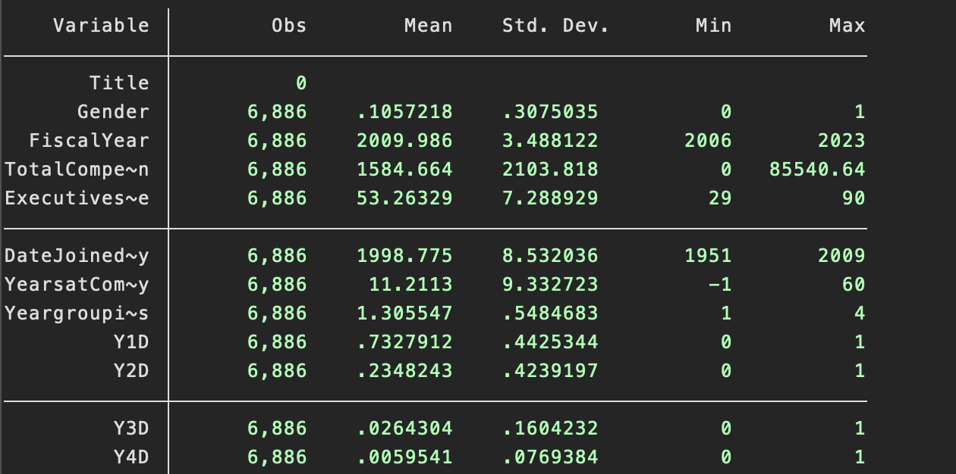

Appendix B-CFO Summary Stats
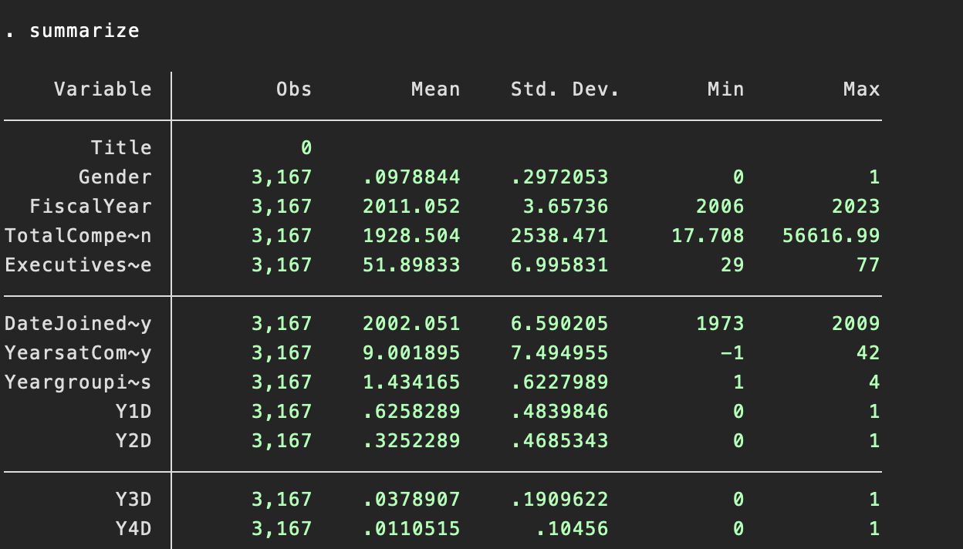

Appendix C- CEO Summary stats
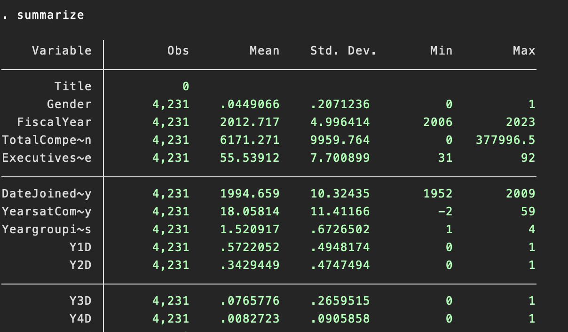

Appendix D- VP Log regression
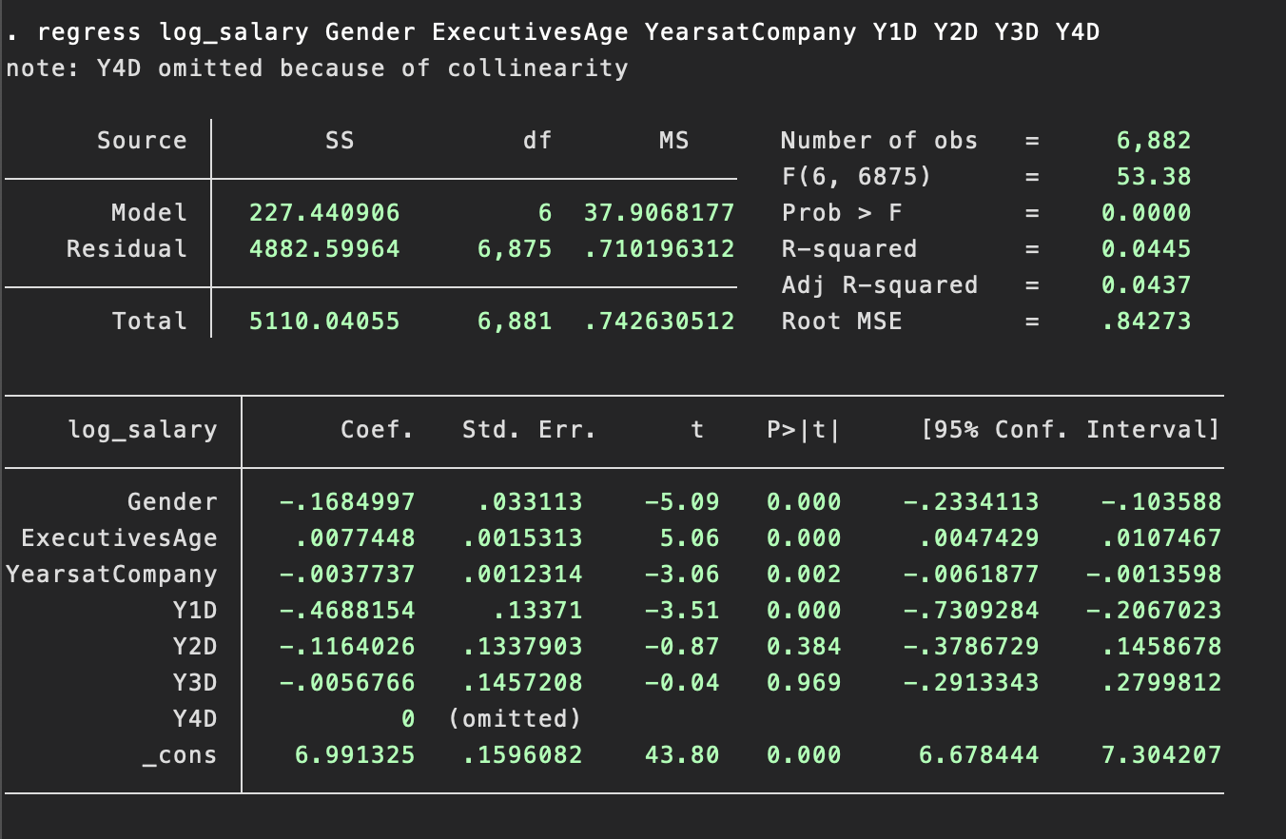

Appendix E- CFO log regression
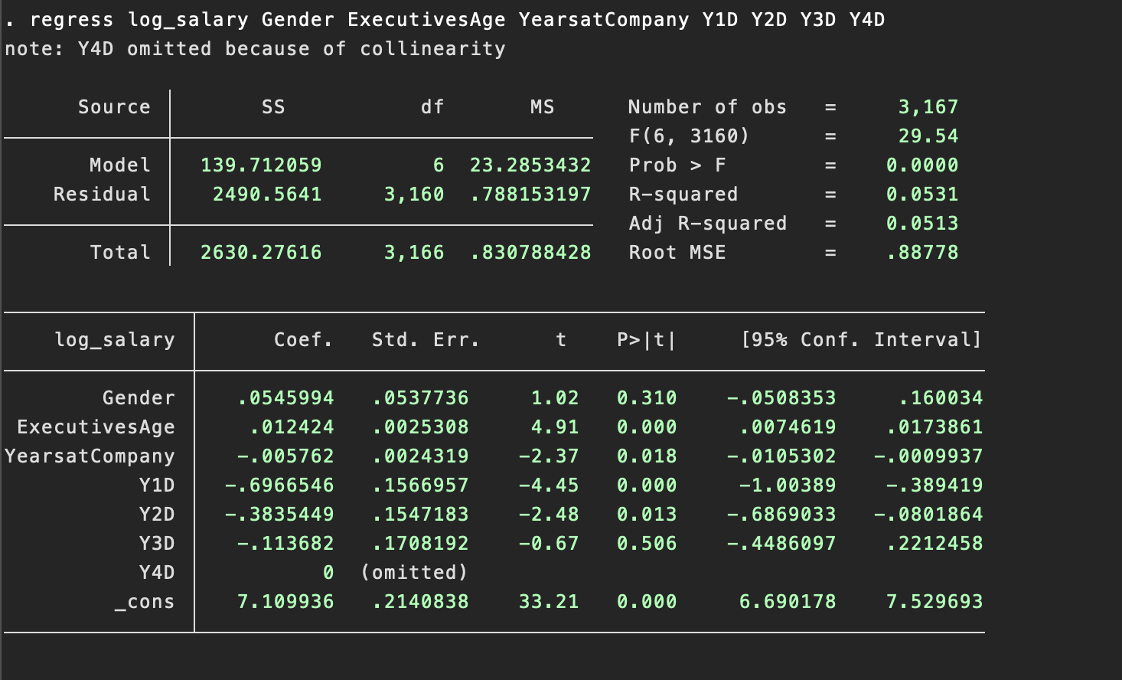
Appendix F- CEO log regression 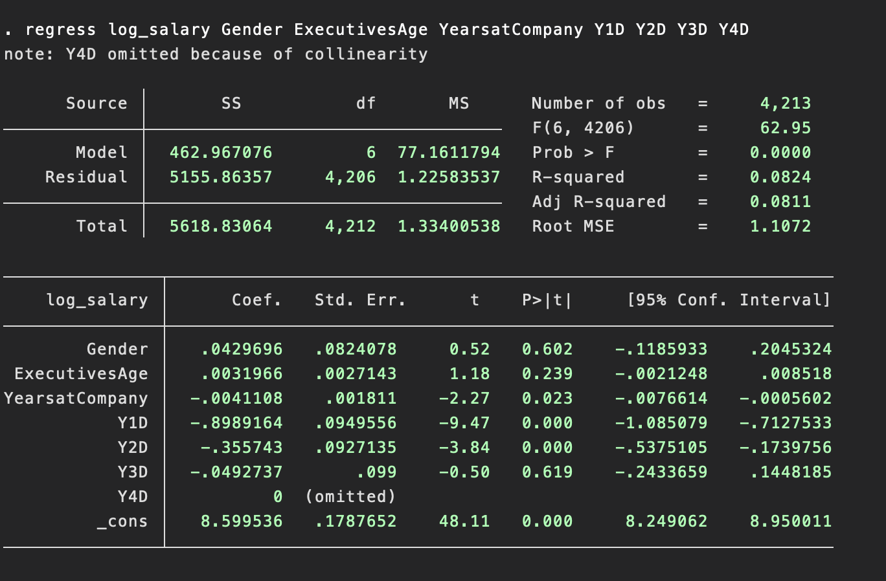

Aragão, C. (2023, March 1). Gender pay gap in U.S. hasn’t changed much in two decades. Pew Research Center. https://www.pewresearch.org/short-reads/2023/03/01/gender-pay-gap-facts/
Miller, S. (2023, December 21). Gender pay gap for executives grew during pandemic. SHRM. https://www.shrm.org/topics-tools/news/benefits-compensation/gender-pay-gap-executives-grew-pandemic
U.S. Government Accountability Office. (2022, December 15). Women in the workforce: The gender pay gap is greater for certain racial and ethnic groups and varies by education level. Women in the Workforce: The Gender Pay Gap Is Greater for Certain Racial and Ethnic Groups and Varies by Education Level | U.S. GAO. https://www.gao.gov/products/gao-23-106041
Blau, F. D., & Kahn, L. M. (2017, September). The gender wage gap: Extent, trends, and explanations. Journal of Economic Literature. https://www.aeaweb.org/articles?id=10.1257%2Fjel.20160995
Schieder, J., & Gould, E. (2016, July 20). “Women’s work” and the gender pay gap: How discrimination, societal norms, and other forces affect women’s occupational choices-and their pay. Economic Policy Institute. https://www.epi.org/publication/womens-work-and-the-gender-pay-gap-how-discrimination-societal-norms-and-other-forces-affect-womens-occupational-choices-and-their-pay/
Blau, F. D., & Kahn, L. M. (2017, September). The gender wage gap: Extent, trends, and explanations. Journal of Economic Literature. https://www.aeaweb.org/articles?id=10.1257%2Fjel.20160995
National Partnership for Women & Families. (2023, September). America’s women and the wage gap. National Partnership. https://nationalpartnership.org/wp-content/uploads/2023/02/americas-women-and-the-wage-gap.pdf
Kochhar, R. (2023, March 1). The enduring grip of the gender pay gap. Pew Research Center’s Social & Demographic Trends Project. https://www.pewresearch.org/social-trends/2023/03/01/the-enduring-grip-of-the-gender-pay-gap/
Schieder, J., & Gould, E. (2016, July 20). “Women’s work” and the gender pay gap: How discrimination, societal norms, and other forces affect women’s occupational choices-and their pay. Economic Policy Institute. https://www.epi.org/publication/womens-work-and-the-gender-pay-gap-how-discrimination-societal-norms-and-other-forces-affect-womens-occupational-choices-and-their-pay/
Schieder, J., & Gould, E. (2016, July 20). “Women’s work” and the gender pay gap: How discrimination, societal norms, and other forces affect women’s occupational choices-and their pay. Economic Policy Institute. https://www.epi.org/publication/womens-work-and-the-gender-pay-gap-how-discrimination-societal-norms-and-other-forces-affect-womens-occupational-choices-and-their-pay/
Bisesti, E., & García, M. (2022, October 18). How race and education affect the gender pay gap. Syracuse University . https://surface.syr.edu/cgi/viewcontent.cgi?article=1194&context=lerner
Blau, F. D., & Kahn, L. M. (2017, September). The gender wage gap: Extent, trends, and explanations. Journal of Economic Literature. https://www.aeaweb.org/articles?id=10.1257%2Fjel.20160995
Schaeffer, K. (2023, September 27). The data on women leaders. Pew Research Center’s Social & Demographic Trends Project. https://www.pewresearch.org/social-trends/fact-sheet/the-data-on-women-leaders/
Wilson, V., Miller, E., & Kassa, M. (2021a, June 8). Racial representation in professional occupations: By the numbers. Economic Policy Institute. https://www.epi.org/publication/racial-representation-prof-occ/
Tani, M., Valentine, A., & Kieran Sharpe, K. (2022, December). The gender pay gap in the Ceos’ labor market. IZA Institute of Labor Economics. https://docs.iza.org/dp15781.pdf
Keller, W., Molina, T., & Olney, W. (2020). The gender gap among top business executives. NBER. https://www.nber.org/system/files/working_papers/w28216/w28216.pdf
Gayle, G.-L., Golan, L., & Miller, R. A. (2012). Gender differences in executive compensation and job mobility. Journal of Labor Economics, 30(4), 829–872. https://doi.org/10.1086/666615
Baltrunaite, A., Bovini, G., & Mocetti, S. (2023). Managerial Talent and managerial practices: Are they complements? Journal of Corporate Finance, 79, 102348. https://doi.org/10.1016/j.jcorpfin.2022.102348
Laing, D. (2011). Labor Economics: Introduction to classic and the new Labor Economics. W.W. Norton & Company.
Gabaix, X., & Landier, A. (2006). Why Has CEO Pay Increased so Much? https://doi.org/10.3386/w12365
Garen, J. E. (1994). Executive compensation and principal-agent theory. Journal of Political Economy, 102(6), 1175–1199. https://doi.org/10.1086/261967
Garen, J. E. (1994). Executive compensation and principal-agent theory. Journal of Political Economy, 102(6), 1175–1199. https://doi.org/10.1086/261967
Laing, D. (2011). Labor Economics: Introduction to classic and the new Labor Economics. W.W. Norton & Company.
Jensen, M. C., & Murphy, K. (2001). Performance pay and top management incentives. SSRN Electronic Journal. https://doi.org/10.2139/ssrn.94009
Schaeffer, K. (2023, September 27). The data on women leaders. Pew Research Center’s Social & Demographic Trends Project. https://www.pewresearch.org/social-trends/fact-sheet/the-data-on-women-leaders/
U.S. EEOC. (n.d.). 3. who is protected from employment discrimination?. US EEOC. https://www.eeoc.gov/employers/small-business/3-who-protected-employment-discrimination

