Pathogenic Variants in Circular RNA of PSEN1 and PSEN2

Senior Thesis
Presented to
The Faculty of the Department of Molecular Biology
Colorado College

In addition to the Requirements for the Degree
Bachelor of Arts

By
Tia Peterson
May 2024

Honor Code Signature:



Primary Thesis Advisor
Meredith Course, Ph.D.


Second Thesis Reader
Darrell J. Killian, Ph.D.

Abstract
Alzheimer Disease (AD) is the most common form of neurodegeneration in humans, currently affecting over 6 million Americans. In this study, we examined circular RNAs (circRNAs) of two AD-related genes, presenilin 1 (PSEN1) and presenilin 2 (PSEN2), for the presence of pathogenic variants. Previous research suggests that circRNA are heavily implicated in neuronal gene regulation; however, their precise role in AD pathogenesis has yet to be established. cDNA from individuals with pathogenic variants in these genes was PCR amplified using divergent primers to target back-spliced regions specific to circRNAs, and the purified PCR product was subsequently Sanger sequenced. Four variants, I143T, S212Y, M146L in PSEN1, and N141I in PSEN2, were identified in circRNAs. The presence of pathogenic variation in circRNAs marks a crucial first step in determining their role in AD pathogenesis. To our knowledge, this research is the first of its kind to identify pathogenic variants in circRNAs of AD risk genes.

Introduction
Alzheimer Disease
Neurodegeneration and dementia are characterized by the process of steady neuronal cell death, resulting in the increased loss of brain function and in many cases, fatality. The most common form of dementia is Alzheimer disease (AD), which currently affects around six million Americans (Course, M. et al., 2023). Numbers continue to increase as the population ages, yet limited amounts of effective therapies or medications exist, and there is no cure. AD symptoms vary, but the main indicator is a decline in cognitive function. This can manifest as delusion, disorientation, confusion, forgetfulness, and the inability to remember past events or create new memories. Other symptoms include changes in mood, behavior, and psychological issues such as depression or hallucinations. These symptoms tend to increase with disease progression.
Considered an age-related disease, AD typically presents in older individuals. Autosomal dominant AD (ADAD) is an early onset form that occurs before the age of 60. ADAD is rare, accounting for less than 1% of all AD cases, and is typically caused by inherited variants in either genes presenilin 1 (PSEN1) or presenilin 2 (PSEN2) (Course, M. et al., 2023). Variants in these genes can also increase the chances of developing AD later in life (>60 years). PSEN1 and PSEN2 are high-risk AD genes, as pathogenic variants in these regions have almost 100% penetrance. PSEN1/2 variants are the most common cause of ADAD development, accounting for up to 70% of all cases. PSEN1 variants are more commonly studied, with over 200 identified pathogenic variants to date (Lanoiselée, HM. et al., 2017). Variants are less likely to occur in PSEN2; so far researchers have identified only 19. Individuals who present with PSEN1 variants make up for about 5% of all AD cases whereas PSEN2 accounts for less than 1% of AD cases (Lanoiselée, HM. et al., 2017).

Presenilin 1 and 2 in Alzheimer Disease
PSEN1 and PSEN2 encode a large part of the γ-secretase complex (Bagaria, J. et al., 2022). The amyloid precursor protein (APP) is another gene in the γ-secretase complex which encodes for the amyloid-β precursor protein, finally leading to the production of amyloid-β peptides, an extracellular product (Lanoiselée, HM. et al., 2017). PSEN1/2 regulate the cleavage of APP, when a variant is present in one of the PSEN genes, improper cleavage of APP occurs, resulting in the improper cleavage of amyloid-β peptides (Lu Y. et al.,2019). The resulting form of the amyloid-β peptides is prone to aggregation and creates neurotoxic amyloid plaques which are a hallmark pathology of AD. The neurotoxic plaques cause neuronal cell death, resulting in neurodegeneration (Gorman, A., 2008).
Neurofibrillary tangles (NFTs), that are found in neurons, are another hallmark pathology of AD. In healthy neurons, tau protein binds to microtubules to enhance the stability and structure of the axon. Nutrients and other important molecules travel along microtubules to ensure the health of the neuron. In individuals with AD, tau detaches from microtubules and instead, binds to itself. This is hypothesized to be a product of Amyloid-β plaques’ ability to alter cellular metabolism, leading to modifications in tau protein through changes in phosphorylation (Oddo, S. et al., 2003). Through this process, chains of tau proteins combine to form tangles in neurons, resulting in ineffective nutrient transport, therefore, decreasing neuronal health (Kuchibhotla, K. et al., 2013). Amyloid-β plaques have been found prior to that of tau pathology, suggesting that a variant in PSEN 1/2 can lead to NFT.
In this study, we focused on three variants in PSEN1 (M146L, I143T, S212Y), and one variant in PSEN2 (N141I) (Figure 1). The M146L variant is on exon 5 of PSEN1 and is a base pair change from ATG to CTG. This changes the amino acid from methionine (Met) to leucine (Leu). This is the most common PSEN1 variant, found in more than half of individuals with PSEN1 ADAD (Hurley, M. et al., 2023). I143T is a variant found also on exon 5 of PSEN1, changing ATT to ACT. This changes the amino acid from an isoleucine (Ile) to a threonine (Thr). The S212Y variant is found on exon 7 of PSEN1 and is a change from TCC to TAC. This changes the amino acid from a serine (Ser) to a tyrosine (Tyr). Each of these variants demonstrates onset occurring in 30-50 years of age. PSEN1 variants are more common than those in PSEN2 and have more rapid disease progression (Bagaria, J. et al., 2022).
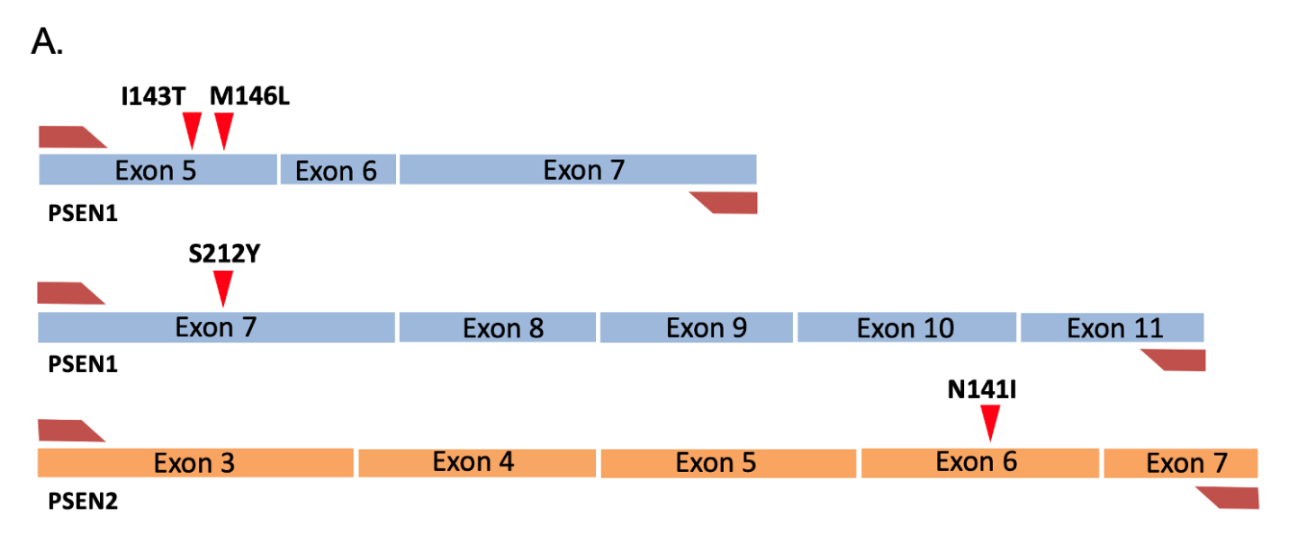
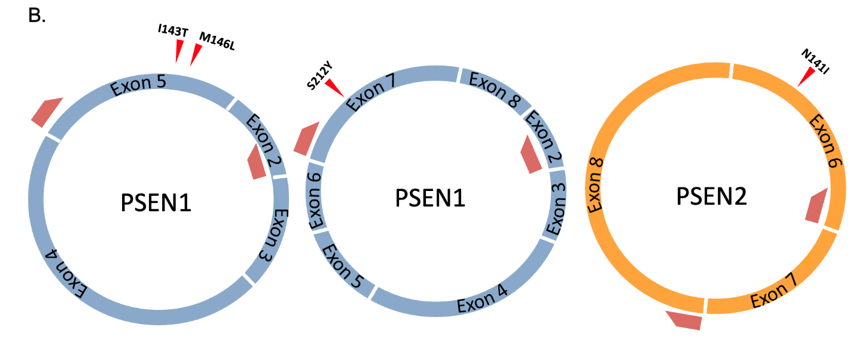
Figure 1. Schematics of linear and circular RNA.
Representative images of linear and circular RNA. The variant location is designated by red triangles and primers by trapezoids. A. Linear transcripts of PSEN1 and PSEN2. B. Circular transcripts of PSEN1 and PSEN2 with primers used in this study, designed to amplify backspliced regions specific to circular RNA.

The N141I variant is on exon 6 of PSEN2. This variant changes a single base pair from AAC to ATC. This changes the amino acid from an asparagine (Asn) to an isoleucine (Ile). Known as the Volga German variant, this was the first variant discovered in PSEN2 and is also the most common variant in the gene. The progression of AD with this variant is slower than that of typical AD cases, especially those in PSEN1. The mean age of onset is 53.7 years, and the mean length of disease is 10.6 years (Jayadev, S. et al., 2010).
These four ADAD variants were also confirmed in linear RNA (Figures 2 & 3). Each variant is a substitution that results in a missense protein consequence, that interferes with the ability of PSEN1 or PSEN2 to correctly encode for the γ-secretase complex. The goal of this research was to confirm the presence of these four variants in circRNA.

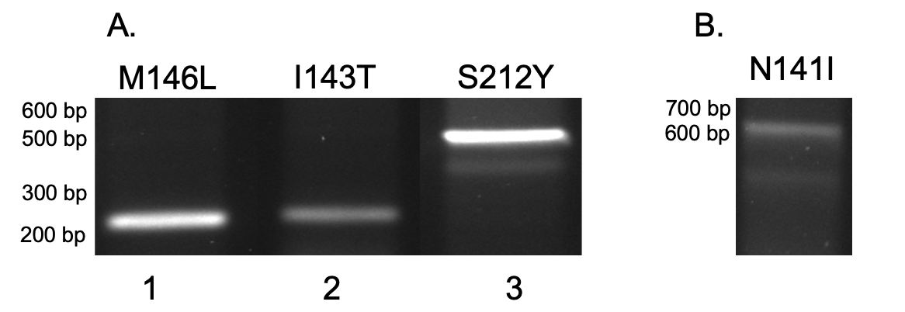
Figure 2. Linear RNA amplification. (A) Lanes 1 and 2 are 235 bp and lane 3 is 560 bp. (B) A band is shown at 630 bp.

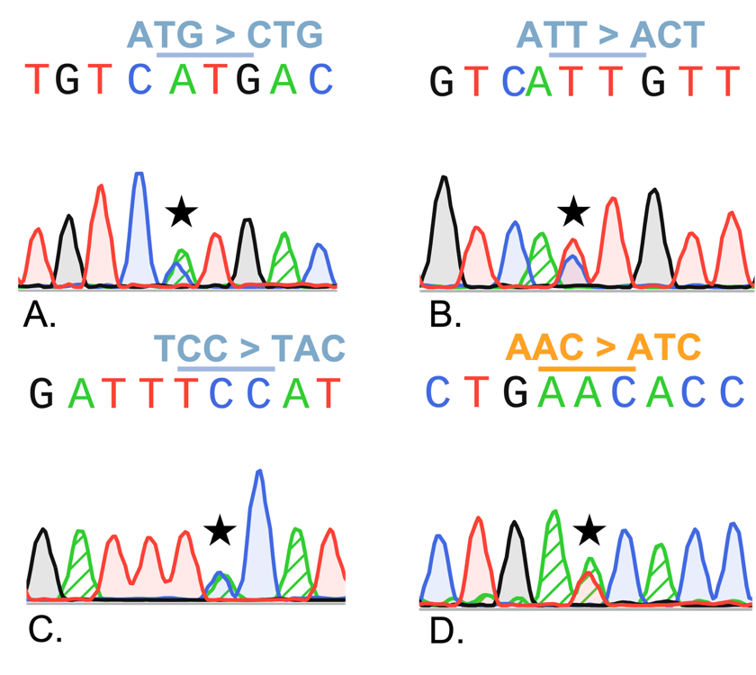
Figure 3. Electropherograms showing the presence of risk variants in linear RNA.
Each sanger trace exhibits the location of a previously determined AD risk variant. Here, they are found in linear RNA transcripts, indicated by a star at the variant location.

Circular RNA in AD
Circular RNA (circRNA) is a single-stranded non-coding form of conserved RNA molecule formed through alternative mRNA splicing, or backsplicing, to form a covalently closed loop (Figure 1B & 4). circRNA lacks both a 5′ cap and 3′ polyadenylated tail because they do not have ends, increasing resistance to exonucleases, more so than linear RNA as exonucleases work to degrade the 5′ cap and 3′ tail (Meng, X. et al., 2017). This is made possible by the upstream 5′ end binding to the downstream 3′ end of the same RNA strand, resulting in two exons next to each other that would not be adjacent in any other known form of RNA. For example, in the circRNA that we studied, we observed examples of exon 2 next to exon 8, exon 2 next to exon 5, and exon 6 next to exon 8 (Figure 4).
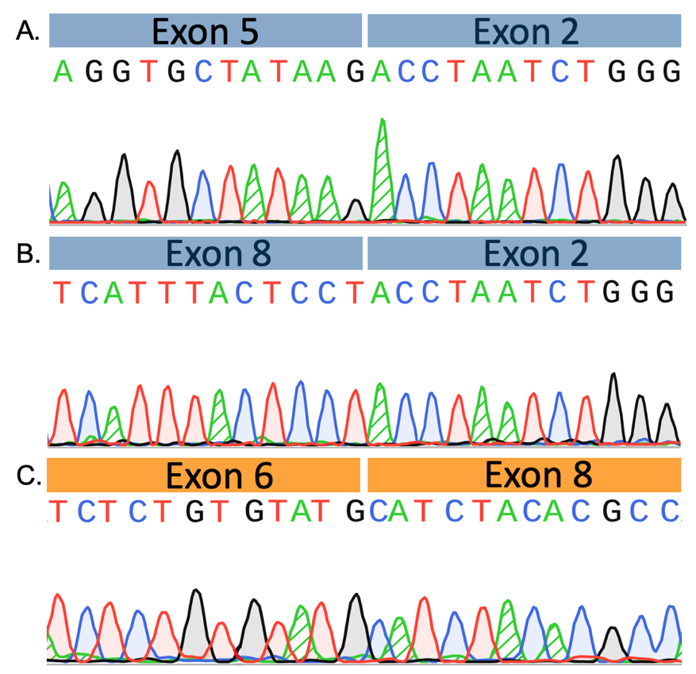
Figure 4. Backspliced region alignment to non-adjacent exons with Sanger traces.
Sequencing data for each circular RNA has been put into the UCSC Genome Brower’s BLAT function to determine which exons each read aligns with.

circRNA is of interest as it is found in high concentration at the synapse (Yu, X. et al., 2023). Further, there has been evidence linking circRNA to AD pathogenesis (Cervera-Carles, L. et al., 2020). Previous research has shown that one of the main functions of circRNA is the regulation of neuronal activity at a post-translational level, made possible by circRNA’s ability to sponge up proteins and miRNAs – resulting in a loss of function (Lukiw, W., 2013). Additionally, circRNA can bind to RNA binding proteins (RBPs), influence protein expression, interact with specific microRNAs (miRNAs), and change with disease progression (Wu, D. P. et al., 2022). Finally, circRNA has also been shown to have a role in neuroplasticity and synapse function (Gu, A. et al., 2023). This possesses implications for early diagnosis and treatment options. Recently, it has been observed that there is a significant association between circRNA expression and AD diagnosis (Dube, U. et al., 2019).
circRNA is infrequently studied because of the difficulty it poses and because it is a newly discovered molecule. Furthermore, most RNA to cDNA conversion protocols only convert linear RNAs, not circular RNAs, so they weren’t identified until recently. circRNA is also difficult to amplify. Despite the molecule’s stability when compared to other forms of RNA, it is still subjected to several degrative processes. The potential roles that circular RNA plays in Alzheimer’s pathogenesis pose great significance to investigate in hopes of gaining a deeper understanding of this disease. To our knowledge, no one has before confirmed the presence of a pathogenic variant – in any disease – in circular RNA.
Originally discovered in the 1990s and dismissed as transcriptional background noise and byproducts of splicing errors, circRNA has only recently resurfaced with next-generation sequencing technology and bioinformatics (Meng, X. et al., 2017). Most circRNA arise from exons, though they are also created in lower abundance from introns, and a combination of exons and introns, and even rarely, circRNA can form from tRNA introns and once formed, will either stay in the nucleus or move to the cytoplasm (Ebbesen, K. et al., 2016). circRNA is classified as noncoding because of the lack of start and stop codons.
Previous research has shown that different circRNAs are present at different ages, therefore regulating brain function in unique ways. This is implicated to be region or species-specific as circRNA levels increase or decrease based on the organism (Wu, D. P. et al., 2022). Notably, splicing patterns change with aging, which accounts for the amount and change of cricRNA in the brain. circRNA is of interest as it can regulate brain function at the transcriptional, translational, and protein levels. circRNA also has been shown to act as a protein sponge, influence protein translation, act as a regulatory mechanism for the intracellular transport of RNA binding proteins (RBPs), and regulate mRNA levels. This has potential implications for early diagnostic tools as it can act as a biomarker. Potential therapies and treatments for individuals with AD also have the potential to originate from circRNA studies.

Research Goals
In this study, we aim to locate and identify known pathogenic variants in circRNA from prefrontal cortex tissue of individuals who had ADAD. Not much is known about the function of circRNA, however, once detected, this finding suggests that circRNA could play a more involved role in AD pathogenesis than previously determined. Further, this is the first time that a pathogenic variant has been found in circRNA transcripts, an exciting discovery not only for AD research but in other diseases as well. In the future, further research is necessary to confirm the specific role of circRNA. Finally, this could lead to early diagnostic and treatment tools that could lead to more AD research, increase the quality of life for individuals with AD, and decrease disease progression.

Methods
Samples Used
The University of Washington Alzheimer Disease Research Center (UW ADRC) provided post-mortem prefrontal cortex samples from the four cases listed in Table 1. Tissues were collected during rapid brain autopsy and flash-frozen in liquid nitrogen. Samples in this study were previously converted to cDNA using both a random hexamer and oligo(dT) approach.

Table 1. Samples used in study.
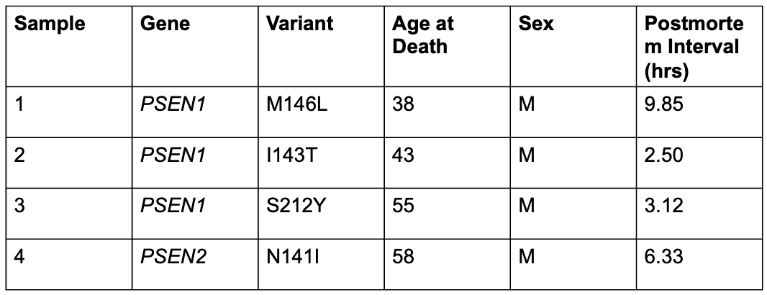

PCR Amplification
Divergent primers for circRNA were designed and ordered from IDT to amplify regions of interest in each observed circular RNA along with linear controls listed in Table 2 (Figure 2). PCR reaction was performed using OneTaq 2X Master Mix with Standard Buffer (NEB), 0.2μM of forward and reverse primer, and 6-8ng of template DNA. PCR was optimized by quadrupling the manufacturer's recommended extension time, slightly increasing annealing time, decreasing annealing to 7ºC below T_{m}, and increasing the cycle number. Linear transcripts followed the manufacturer’s PCR protocol. PCR was repeated three times for each sample to confirm the findings.

Table 2. Primers used in study. 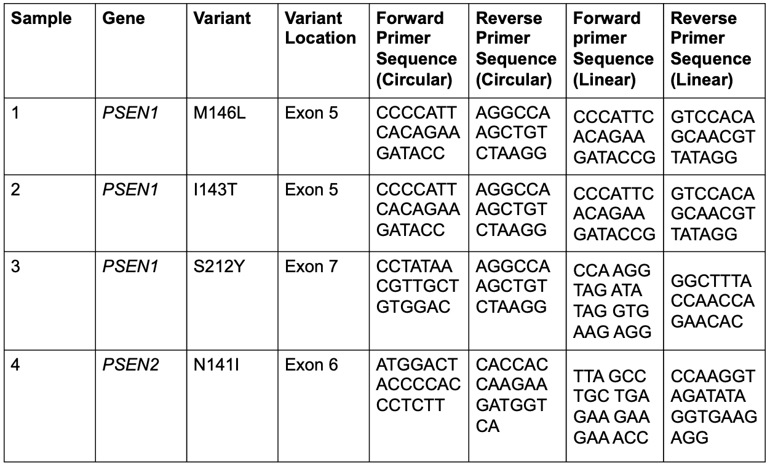

Gel Electrophoresis and Extraction
The PCR product was run on a 1% w/v agarose gel with SYBR Safe DNA Gel stain (Thermo Fisher Scientific), 1X TAE Buffer, and 1kb plus DNA ladder (NEB) at 130V for 60 minutes. Gels were imaged using the iBright FL1500 Imaging System and DNA of interest was excised using Invitrogen Blue/White Light Transilluminator and extracted using New England BioLabs Monarch DNA Extraction Kit (NEB). DNA was prepared and sent for Sanger sequencing following GENEWIZ (Azenta) sample submission guidelines protocol.

Sequencing and Alignment
Sanger sequencing was performed by GENEWIZ (Azenta). SnapGene Viewer (Dotmatics) was then used to visualize sequence traces. Alignment to the genes of interest was confirmed using the UCSC Genome Browser BLAT function.

Results
Amplification of PSEN1 and PSEN2 variants
The four samples used in this study were composed of the prefrontal cortex tissue of donors diagnosed with familial AD. Of these samples, three contained different PSEN1 variants (M146L, I143T, S212Y) and one contained the N141I Volga German PSEN2 variant. Samples were obtained within 12 hours post-mortem and were flash-frozen to minimize RNA degradation. The samples were sex-matched but because of the inherent early-onset nature of familial AD, we were unable to age-match the samples. To observe variants in PSEN1 and PSEN2 in both linear and circular RNA, cDNA for the four samples of interest had been previously converted. The samples were specifically converted using both random hexamer and oligo(dT) approaches. The random hexamer amplification approach binds randomly to all sections of cDNA, while oligo(dT) amplifies through poly-A tail recognition, which circRNA does not contain. Therefore, the oligo(dT) group is referred to as the ‘control’, where we expect no bands to be present.
Through PCR amplification using primers we had designed specifically to capture each variant; we obtained the expected band length calculated by adding the lengths of the exons between the specific primers. This was determined based on known circRNA transcripts that can be found in the circRNA database (circBASE). Bands were first amplified in a control cDNA that did not contain ADAD variants, and then subsequently in cDNA from individuals that did contain ADAD variants. PCR was followed by extraction and purification of the bands of interest. The product was sent for sequencing to confirm both the presence of the variant location, variant and the presence of circRNA.

Confirmation of the presence of circular RNA
Once the sequencing data was obtained from the four samples of interest, each was analyzed to confirm amplification of the circRNA. We examined exon alignment using the UCSC Genome Browser BLAT function to confirm the presence of circRNA. In Figure 5A, the M146L variant in exon 5 of PSEN1 is present. Here, the variant transcript is of higher abundance than the wild type transcript, as shown by the difference in peak heights. In Figure 5B, the I143T variant in exon 5 of PSEN1 and in Figure 5C, the S212Y variant in exon 7 of PSEN1 where gain, the variant transcript is of higher abundance than the wild type transcript. Finally, in Figure 5D, we see the presence of the N141I variant on exon 6 of PSEN2. All variants are visible as a double peak (Figure 5). Sequencing was repeated three times for each sample to confirm the findings (Figure 6). Once circRNA presence and variant location in the control group were successful, the same protocol was followed for the random hexamer group to confirm variant presence.
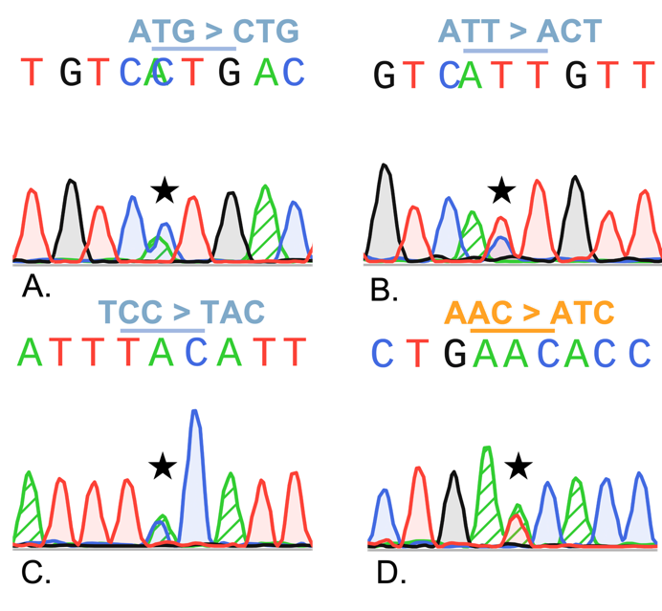
Figure 5. Electropherograms showing the presence of risk variants in circular RNA.
Each Sanger sequencing trace exhibits the location of a previously determined AD risk variant. Here, they are found in circular RNA transcripts, indicated by a star at the variant location.

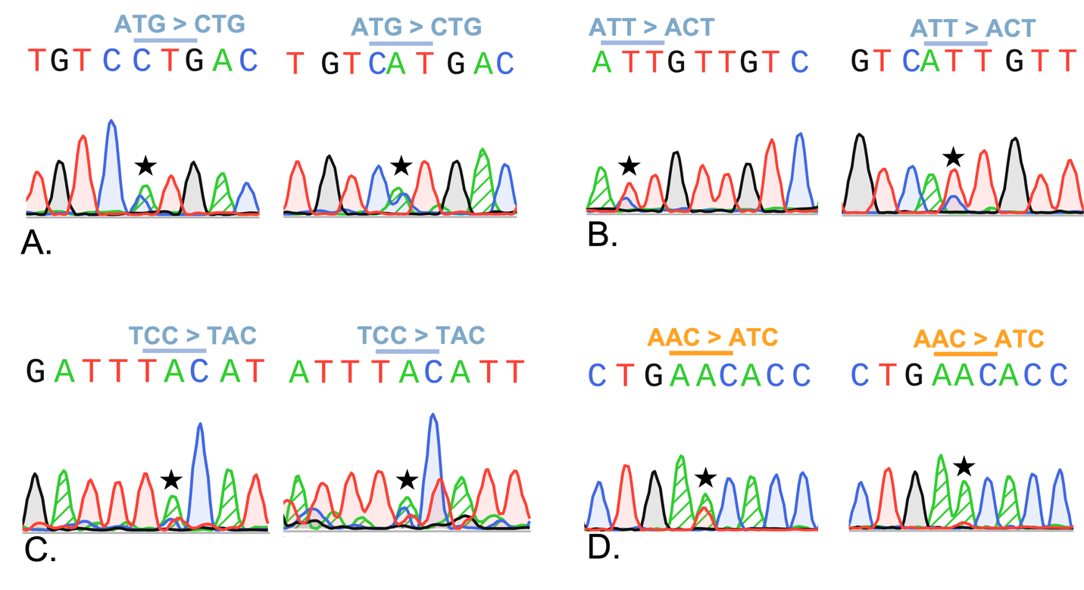
Figure 6. Electropherograms showing the presence of risk variants in circular RNA.
To confirm that our results were able to uphold statistical integrity, we performed each experiment three times (n=3). All reads were sequenced for a second and third time. Variant location indicated by a star.

Confirmation of PSEN1 and PSEN2 variants in circular RNA
Sequencing data was then analyzed to confirm the presence of PSEN 1/2 variants and to determine the quality of the reads. Once a clean read was captured, the variant of interest presence was confirmed by a double peak. This indicates that two different transcripts have been amplified: the wild type transcript and the variant transcript, due to the heterozygous nature of the variants. In all four samples of interest, known pathogenic variants of ADAD were discovered for the first time in circRNA (Figure 7 & 5). Lanes 1 and 2 show successful amplification of the M146L and I143T variants on exon 5 in PSEN1 indicated by the expected band length of 193bp. Lane 3 shows amplification of the S212Y variant located on exon 7 of PSEN1. The expected band length is 365 bp, note that the correct amplification is the top band; indicated by a red arrow. The bottom band is a product of nonspecific binding during PCR. Lane 4 shows successful amplification of the N141I variant on exon 6 of PSEN2, the expected band length is 311bp. Finally, lanes 5-8 do not contain bands equivalent to those in random hexamer samples, indicating that what we have amplified is circular RNA (Figure 7).
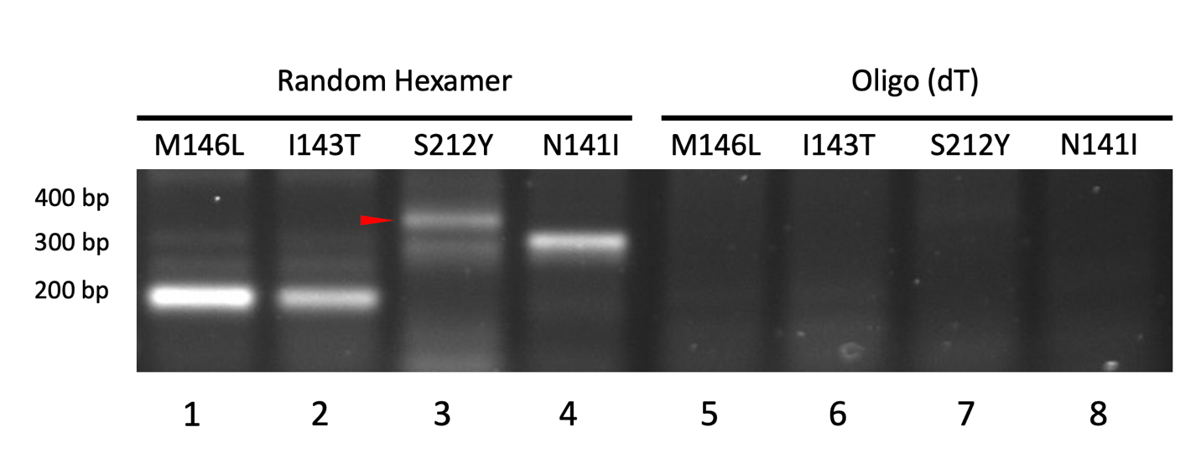
Figure 7. Circular RNA amplification.
PCR using a random hexamer (lanes 1-4) and a Poly-A tail dependent oligo(dT) approach (lanes 5-8) and subsequent gel electrophoresis of PCR product. The red arrow indicates the correct band.

Variants are not present in Sporadic AD samples
Sporadic AD is the most common form of AD and is caused by random variants based mostly on an individual’s lifestyle, but the most common risk factor is age (Eid, A. et al., 2019). Sporadic AD is caused by a complex interaction between people and their environment, though it is said that aging is the biggest risk factor for developing sporadic AD, usually occurring later in life (>60 years) (Eid, A. et al., 2019). To confirm that the presence of the four variants was unique to individuals with ADAD, the same method was enacted using sporadic AD samples. Four samples of sporadic AD were PCR amplified and sequenced. We confirmed that there is no presence of known ADAD-causing variants present in these transcripts (Figure 8).

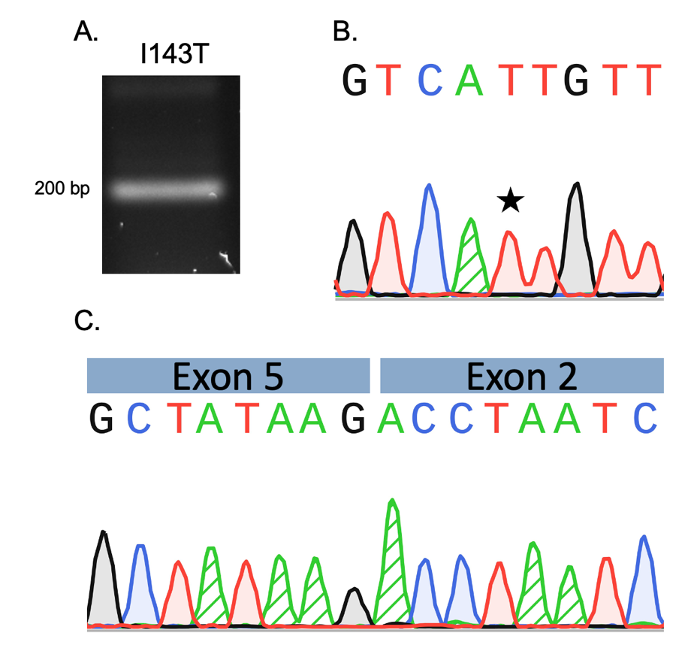
Figure 8. Sporadic AD transcripts.
The potential presence of variants was investigated in sporadic circRNA. This is an example of the I143T variant. (A) Gel electrophoresis with a band at about 200 bp. (B) Sequence of variant location indicated by a star. (C) Backspliced transcript indicating the presence of circRNA in the sample.

Discussion
This study has shown the presence of pathogenic variants in circRNA, indicating that this noncoding form of RNA could play a larger role in AD development and pathogenesis than previously thought. Through the optimization of PCR parameters and sequencing technology, we were able to confidently determine the presence of pathogenic variants in circRNA. The visibility of the double peaks at the location of the variant confirms this finding (Figures 6 & 7). Additionally, the alignment of the sequencing reads to backspliced exons confirms that these variants are present in circRNA and that we are not observing a linear form of RNA (Figure 7).
Despite circRNA’s elusive nature, more research must be conducted surrounding this topic because of this molecule’s high concentration in the synapse and due to its role in brain function regulation at all levels.
The improper cleavage of APP by PSEN1 and PSEN2 genes leads to neurotoxic amyloid-β plaques that stimulate neuronal cell death, leading to neurodegeneration that can manifest as different forms of dementia. In previous studies, it has been shown that circRNA expression correlates to AD diagnosis. circRNA is an intriguing research target not only because of its versatility but also on account of its more recent discovery. circRNA could be vital to understanding AD development and pathogenesis.
The significance of the role that circRNA plays in AD development and pathogenesis remains mostly unknown. However, this novel discovery opens new pathways for potential therapies, medications, and early diagnostic tools for individuals with AD and those who are at risk. Additionally, this finding can inspire research of circRNA concerning other diseases, potentially spreading past the field of neurology.
circRNA was previously concluded to be a noncoding form of RNA. However, recent evidence shows that some forms of circRNA can encode for proteins. Additionally, circRNAs have been shown to facilitate cell proliferation, differentiation, pyroptosis, and autophagy (Gu, A. et al., 2023). circRNA levels in the brain have been seen to increase with age, suggesting that they play a role in the aging process and cellular senescence (Kim, E. et al., 2021). Therefore, it can be hypothesized that circRNA health positively correlates to overall brain health. Therefore, in AD, lower amounts of healthy circRNA at a younger age may be responsible for the early onset nature of ADAD. Taking a closer look, a decrease in circRNA health could result in a loss of circRNA function, disrupting many of the cellular processes that circRNA is implicated in. To name a few, these include miRNA sponging, RBP binding, and the ability to influence protein binding.
circRNA has remained hidden for years, but now that we have the proper technology and tools to detect and classify circRNAs, it is important that we do so. This study is especially crucial as it looks at familial ADAD where onset begins at about 30-50 years of age. The earlier that AD is detected in the body, the quicker treatment can start. If there is a way to predict what stage the individual is presenting based on family history and peripheral blood samples, lifespan could be increased for those at risk.
circRNA are more stable than that of linear RNA due to their protection from exonucleases and, therefore, circRNA are an interesting target as a biomarker in peripheral blood samples for disease (Wen, G. et al., 2022). This is a non-invasive way that could potentially be used for early disease prognosis. Further, certain circRNAs have been strongly associated with AD risk factors. These, once identified, could have positive implications concerning an individual’s disease progression and quality of life. Among the specific circRNAs that are indicated in AD pathogenesis, ciRS-7 is the best known and is implicated in AD (Huang, J. L. et al., 2020). Additionally, ciRS-7 is highly implicated in AD longevity (Kim, E. et al., 2021). Currently, in the circBASE database, different types of circRNA have been reported by many researchers in an effort to catalog the different types and their functions.
We are confident in the findings of our research. Three clean sequencing reads were obtained for each variant that shows the presence of both the wild type and pathogenic transcript. In the future, it will be important for multiple tissue samples from different individuals with the same known variant to be tested in this same way, as we had only one sample for each of the four variants in this study, allowing for uniform results across cases with the same pathogenic variant. Additionally, circRNA research concerning other types of AD will be necessary to deepen comprehension of the many ways that neurodegeneration presents in individuals.
Using Sanger sequencing technology, we have substantially increased our knowledge of the presence of circRNA, an elusive molecule whose primary function in AD pathogenesis remains a mystery. We specifically found that known AD pathogenic variants of PSEN1 and PSEN2 are present in circRNA transcripts. Though ADAD accounts for approximately 1% of all AD cases, understanding the mechanism behind this early-onset lethal form of neurodegeneration is crucial to early detection and treatment processes.
Acknowledgments
I would like to thank Dr. Meredith Course for her support and guidance over the past two years concerning this research project and as my academic advisor and mentor throughout my entire college career. I truly could not have done this without her. I would like to thank Dr. Darrell Killian for reviewing this thesis and providing valuable feedback. Finally, I would like to thank Colorado College and the entire Molecular Biology Department for providing me with the facilities and skills required for this research.

References
Bagaria J, Bagyinszky E, An SSA. Genetics, Functions, and Clinical Impact of Presenilin-1 (PSEN1) Gene. Int J Mol Sci. 2022 Sep 19;23(18):10970. doi: 10.3390/ijms231810970. PMID: 36142879; PMCID: PMC9504248.

Cervera-Carles L, Dols-Icardo O, Molina-Porcel L, Alcolea D, Cervantes-Gonzalez A, Muñoz-Llahuna L, Clarimon J. Assessing circular RNAs in Alzheimer's disease and frontotemporal lobar degeneration. Neurobiol Aging. 2020 Aug;92:7-11. doi: 10.1016/j.neurobiolaging.2020.03.017. Epub 2020 Apr 1. PMID: 32335360.

Course MM, Gudsnuk K, Keene CD, Bird TD, Jayadev S, Valdmanis PN. Aberrant splicing of PSEN2, but not PSEN1, in individuals with sporadic Alzheimer's disease. Brain. 2023 Feb 13;146(2):507-518. doi: 10.1093/brain/awac294. PMID: 35949106; PMCID: PMC10169283.

Dube U, Del-Aguila JL, Li Z, Budde JP, Jiang S, Hsu S, Ibanez L, Fernandez MV, Farias F, Norton J, Gentsch J, Wang F; Dominantly Inherited Alzheimer Network (DIAN); Salloway S, Masters CL, Lee JH, Graff-Radford NR, Chhatwal JP, Bateman RJ, Morris JC, Karch CM, Harari O, Cruchaga C. An atlas of cortical circular RNA expression in Alzheimer disease brains demonstrates clinical and pathological associations. Nat Neurosci. 2019 Nov;22(11):1903-1912. doi: 10.1038/s41593-019-0501-5. Epub 2019 Oct 7. PMID: 31591557; PMCID: PMC6858549.

Ebbesen KK, Hansen TB, Kjems J. Insights into circular RNA biology. RNA Biol. 2017 Aug 3;14(8):1035-1045. doi: 10.1080/15476286.2016.1271524. Epub 2016 Dec 16. PMID: 27982727; PMCID: PMC5680708.

Eid A, Mhatre I, Richardson JR. Gene-environment interactions in Alzheimer's disease: A potential path to precision medicine. Pharmacol Ther. 2019 Jul;199:173-187. doi: 10.1016/j.pharmthera.2019.03.005. Epub 2019 Mar 12. PMID: 30877021; PMCID: PMC6827882.

Gorman AM. Neuronal cell death in neurodegenerative diseases: recurring themes around protein handling. J Cell Mol Med. 2008 Dec;12(6A):2263-80. doi: 10.1111/j.1582-4934.2008.00402.x. Epub 2008 Jun 27. PMID: 18624755; PMCID: PMC4514105.

Gu A, Jaijyan DK, Yang S, Zeng M, Pei S, Zhu H. Functions of Circular RNA in Human Diseases and Illnesses. Noncoding RNA. 2023 Jul 4;9(4):38. doi: 10.3390/ncrna9040038. PMID: 37489458; PMCID: PMC10366867.

Huang JL, Su M, Wu DP. Functional roles of circular RNAs in Alzheimer's disease. Ageing Res Rev. 2020 Jul;60:101058. doi: 10.1016/j.arr.2020.101058. Epub 2020 Mar 29. PMID: 32234545.

Hurley EM, Mozolewski P, Dobrowolski R, Hsieh J. Familial Alzheimer's disease-associated PSEN1 mutations affect neurodevelopment through increased Notch signaling. Stem Cell Reports. 2023 Jul 11;18(7):1516-1533. doi: 10.1016/j.stemcr.2023.05.018. Epub 2023 Jun 22. PMID: 37352850; PMCID: PMC10362499.

Jayadev S, Leverenz JB, Steinbart E, Stahl J, Klunk W, Yu CE, Bird TD. Alzheimer's disease phenotypes and genotypes associated with mutations in presenilin 2. Brain. 2010 Apr;133(Pt 4):1143-54. doi: 10.1093/brain/awq033. PMID: 20375137; PMCID: PMC2850581.

Kim E, Kim YK, Lee SV. Emerging functions of circular RNA in aging. Trends Genet. 2021 Sep;37(9):819-829. doi: 10.1016/j.tig.2021.04.014. Epub 2021 May 17. PMID: 34016449.

Kuchibhotla KV, Wegmann S, Kopeikina KJ, Hawkes J, Rudinskiy N, Andermann ML, Spires-Jones TL, Bacskai BJ, Hyman BT. Neurofibrillary tangle-bearing neurons are functionally integrated in cortical circuits in vivo. Proc Natl Acad Sci U S A. 2014 Jan 7;111(1):510-4. doi: 10.1073/pnas.1318807111. Epub 2013 Dec 24. PMID: 24368848; PMCID: PMC3890777.

Lanoiselée HM, Nicolas G, Wallon D, Rovelet-Lecrux A, Lacour M, Rousseau S, Richard AC, Pasquier F, Rollin-Sillaire A, Martinaud O, Quillard-Muraine M, de la Sayette V, Boutoleau-Bretonniere C, Etcharry-Bouyx F, Chauviré V, Sarazin M, le Ber I, Epelbaum S, Jonveaux T, Rouaud O, Ceccaldi M, Félician O, Godefroy O, Formaglio M, Croisile B, Auriacombe S, Chamard L, Vincent JL, Sauvée M, Marelli-Tosi C, Gabelle A, Ozsancak C, Pariente J, Paquet C, Hannequin D, Campion D; collaborators of the CNR-MAJ project. APP, PSEN1, and PSEN2 mutations in early-onset Alzheimer disease: A genetic screening study of familial and sporadic cases. PLoS Med. 2017 Mar 28;14(3):e1002270. doi: 10.1371/journal.pmed.1002270. PMID: 28350801; PMCID: PMC5370101.

Lu Y, Tan L, Wang X. Circular HDAC9/microRNA-138/Sirtuin-1 Pathway Mediates Synaptic and Amyloid Precursor Protein Processing Deficits in Alzheimer's Disease. Neurosci Bull. 2019 Oct;35(5):877-888. doi: 10.1007/s12264-019-00361-0. Epub 2019 Mar 18. PMID: 30887246; PMCID: PMC6754481.

Lukiw WJ. Circular RNA (circRNA) in Alzheimer's disease (AD). Front Genet. 2013 Dec 31;4:307. doi: 10.3389/fgene.2013.00307. PMID: 24427167; PMCID: PMC3875874.

Meng X, Li X, Zhang P, Wang J, Zhou Y, Chen M. Circular RNA: an emerging key player in RNA world. Brief Bioinform. 2017 Jul 1;18(4):547-557. doi: 10.1093/bib/bbw045. PMID: 27255916.

Oddo S, Caccamo A, Kitazawa M, Tseng BP, LaFerla FM. Amyloid deposition precedes tangle formation in a triple transgenic model of Alzheimer's disease. Neurobiol Aging. 2003 Dec;24(8):1063-70. doi: 10.1016/j.neurobiolaging.2003.08.012. PMID: 14643377.

Wen G, Gu W. Circular RNAs in peripheral blood mononuclear cells are more stable than linear RNAs upon sample processing delay. J Cell Mol Med. 2022 Oct;26(19):5021-5032. doi: 10.1111/jcmm.17525. Epub 2022 Aug 30. PMID: 36039821; PMCID: PMC9549506.

Wu DP, Zhao YD, Yan QQ, Liu LL, Wei YS, Huang JL. Circular RNAs: emerging players in brain aging and neurodegenerative diseases. J Pathol. 2023 Jan;259(1):1-9. doi: 10.1002/path.6021. Epub 2022 Nov 24. PMID: 36264226.

Yu X, Liu H, Chang N, Fu W, Guo Z, Wang Y. Circular RNAs: New players involved in the regulation of cognition and cognitive diseases. Front Neurosci. 2023 Feb 2;17:1097878. doi: 10.3389/fnins.2023.1097878. PMID: 36816112; PMCID: PMC9932922.

